UNITED STATES
SECURITIES AND EXCHANGE COMMISSION
Washington, D.C. 20549

Form 10-Q

(Mark One)

☒ | QUARTERLY REPORT PURSUANT TO SECTION 13 OR 15(d) OF THE SECURITIES EXCHANGE ACT OF 1934
 | FOR THE QUARTERLY PERIOD ENDED June 30, 2026 OR

☐ | TRANSITION REPORT PURSUANT TO SECTION 13 OR 15(d) OF THE SECURITIES EXCHANGE ACT OF 1934
 | FOR THE TRANSITION PERIOD FROM TO

Commission file number 1-3701

AVISTA CORPORATION
(Exact name of Registrant as specified in its charter)

Washington |  | 91-0462470
(State or other jurisdiction of  incorporation or organization) |  | (I.R.S. Employer  Identification No.)

1411 East Mission Avenue, Spokane, Washington 99202-2600
(Address of principal executive offices, including zip code)
Registrant’s telephone number, including area code: 509-489-0500
None
(Former name, former address and former fiscal year, if changed since last report)
Securities registered pursuant to Section 12(b) of the Act:

Title of Each Class |  | Trading Symbol(s) |  | Name of Each Exchange on Which Registered
Common Stock |  | AVA |  | New York Stock Exchange

Indicate by check mark whether the registrant (1) has filed all reports required to be filed by Section 13 or 15(d) of the Securities Exchange Act of 1934 during the preceding 12 months (or for such shorter period that the Registrant was required to file such reports), and (2) has been subject to such filing requirements for the past 90 days: Yes ☒ No ☐
Indicate by check mark whether the registrant has submitted electronically every Interactive Data File required to be submitted pursuant to Rule 405 of Regulation S-T (§232.405 of this chapter) during the preceding 12 months (or for such shorter period that the registrant was required to submit and post such files). Yes ☒ No ☐
Indicate by check mark whether the registrant is a large accelerated filer, an accelerated filer, a non-accelerated filer, a smaller reporting company, or an emerging growth company. See the definitions of “large accelerated filer,” “accelerated filer,” “smaller reporting company,” and "emerging growth company" in Rule 12b-2 of the Exchange Act.

Large accelerated filer | ☒ | Accelerated filer | ☐
Non-accelerated filer | ☐ | Smaller reporting company | ☐
Emerging growth company | ☐

If an emerging growth company, indicate by check mark if the registrant has elected not to use the extended transition period for complying with any new or revised financial accounting standards provided pursuant to Section 13(a) of the Exchange Act ☐
Indicate by check mark whether the Registrant is a shell company (as defined in Rule 12b-2 of the Exchange Act): Yes ☐ No ☒
As of July 24, 2026, 83,752,830 shares of Registrant’s Common Stock, no par value (the only class of common stock), were outstanding.

Table of Contents

AVISTA CORPORATION

AVISTA CORPORATION
INDEX
Item No. |  |  | Page No.
 | Acronyms and Terms |  | iii
 | Forward-Looking Statements |  | 1
 | Available Information |  | 6
Part I. Financial Information
Item 1. | Condensed Consolidated Financial Statements (unaudited) |  | 7
 | Condensed Consolidated Statements of Income and Comprehensive Income -  Three and Six Months Ended June 30, 2026 and 2025 |  | 7
 | Condensed Consolidated Balance Sheets -  June 30, 2026 and December 31, 2025 |  | 8
 | Condensed Consolidated Statements of Cash Flows -  Six Months Ended June 30, 2026 and 2025 |  | 9
 | Condensed Consolidated Statements of Equity -  Three and Six Months Ended June 30, 2026 and 2025 |  | 11
 | Notes to Condensed Consolidated Financial Statements (unaudited) |  | 12
 | Note 1. Summary of Significant Accounting Policies |  | 12
 | Note 2. New Accounting Standards |  | 13
 | Note 3. Balance Sheet Components |  | 14
 | Note 4. Revenue |  | 17
 | Note 5. Equity Method Investments |  | 18
 | Note 6. Derivatives and Risk Management |  | 18
 | Note 7. Pension Plans and Other Postretirement Benefit Plans |  | 21
 | Note 8. Income Taxes |  | 22
 | Note 9. Short-Term Borrowings |  | 22
 | Note 10. Long-Term Debt |  | 24
 | Note 11. Long-Term Debt to Affiliated Trusts |  | 24
 | Note 12. Fair Value |  | 24
 | Note 13. Common Stock |  | 28
 | Note 14. Earnings per Common Share |  | 29
 | Note 15. Commitments and Contingencies |  | 29
 | Note 16. Information by Business Segments |  | 30
 | Report of Independent Registered Public Accounting Firm |  | 32
Item 2. | Management’s Discussion and Analysis of Financial Condition and Results of Operations |  | 33
 | Business Segments |  | 33
 | Executive Overview |  | 33
 | Regulatory Matters |  | 34
 | Results of Operations - Overall |  | 37
 | Results of Operations - Avista Utilities |  | 39
 | Results of Operations - Alaska Electric Light and Power Company |  | 51
 | Results of Operations - Other Businesses |  | 51
 | Critical Accounting Policies and Estimates |  | 52
i

Table of Contents

 | Liquidity and Capital Resources |  | 52
 | Overall Liquidity |  | 52
 | Review of Condensed Consolidated Cash Flow Statement |  | 52
 | Capital Resources |  | 53
 | Capital Expenditures |  | 54
 | Pension Plan |  | 54
 | Environmental Issues and Contingencies |  | 55
 | Enterprise Risk Management |  | 55
Item 3. | Quantitative and Qualitative Disclosures about Market Risk |  | 56
Item 4. | Controls and Procedures |  | 56
Part II. Other Information
Item 1. | Legal Proceedings |  | 58
Item 1A. | Risk Factors |  | 58
Item 5. | Other Information |  | 58
Item 6. | Exhibits |  | 59
 | Signature |  | 60

ii

Table of Contents

AVISTA CORPORATION

ACRONYMS AND TERMS
(The following acronyms and terms are found in multiple locations within the document)

Acronym/Term | Meaning
AEL&P | - | Alaska Electric Light and Power Company, the primary operating subsidiary of AERC, which provides electric services in Juneau, Alaska
AERC | - | Alaska Energy and Resources Company, the Company's wholly-owned subsidiary based in Juneau, Alaska
AFUDC | - | Allowance for Funds Used During Construction, represents the cost of both the debt and equity funds used to finance utility plant additions during the construction period
ASC | - | Accounting Standards Codification
ASU | - | Accounting Standards Update
Avista Capital | - | Parent company to the Company’s non-utility businesses, with the exception of AJT Mining Properties, Inc., which is a subsidiary of AERC.
Avista Corp. | - | Avista Corporation, the Company
Avista Utilities | - | Operating division of Avista Corp. (not a subsidiary) comprising the regulated utility operations in the Pacific Northwest
Capacity | - | The rate at which a particular generating source is capable of producing energy, measured in KW or MW
CCA | - | Climate Commitment Act
Colstrip | - | The coal-fired Colstrip Generating Plant in southeastern Montana
Cooling degree days | - | The measure of the warmness of weather experienced, based on the extent to which the average of high and low temperatures for a day is above 65 degrees Fahrenheit (annual degree days above historic indicate warmer than average temperatures)
Energy | - | The amount of electricity produced or consumed over a period of time, measured in KWh or MWh. Also, refers to natural gas consumed and is measured in dekatherms
ERM | - | The Energy Recovery Mechanism, a mechanism for accounting and rate recovery of certain power supply costs accepted by the utility commission in the state of Washington
FASB | - | Financial Accounting Standards Board
FCA | - | Fixed Cost Adjustment, the electric and natural gas decoupling mechanism in Idaho
FERC | - | Federal Energy Regulatory Commission
GAAP | - | Generally Accepted Accounting Principles
Heating degree days | - | The measure of the coldness of weather experienced, based on the extent to which the average of high and low temperatures for a day falls below 65 degrees Fahrenheit (annual degree days below historic indicate warmer than average temperatures)
IPUC | - | Idaho Public Utilities Commission
KW, KWh | - | Kilowatt (1000 watts): a measure of generating power or capability. Kilowatt-hour (1000 watt hours): a measure of energy produced over a period of time
mmBTU | - | One million British Thermal Units, a thermal unit of measurement for natural gas
MW, MWh | - | Megawatt: 1000 KW. Megawatt-hour: 1000 KWh
MYRP | - | Multi-year rate plan
OPUC | - | The Public Utility Commission of Oregon
PCA | - | The Power Cost Adjustment mechanism, a procedure for accounting and rate recovery of certain power supply costs accepted by the utility commission in the state of Idaho
PGA | - | Purchased Gas Adjustment
PPA | - | Power Purchase Agreement
ROE | - | Return on equity
iii

Table of Contents

AVISTA CORPORATION

ROR | - | Rate of return on rate base
ROU | - | Right-of-use lease asset
SEC | - | U.S. Securities and Exchange Commission
SOFR | - | Secured Overnight Financing Rate
Therm | - | Unit of measurement for natural gas; a therm is equal to approximately one hundred cubic feet (volume) or 100,000 BTUs (energy)
Watt | - | Unit of measurement of electric power or capability; a watt is equal to the rate of work represented by a current of one ampere under a pressure of one volt
WUTC | - | Washington Utilities and Transportation Commission
iv

Table of Contents

AVISTA CORPORATION

Forward-Looking Statements
From time to time, we make forward-looking statements such as statements regarding projected or future:
•
financial performance;
•
cash flows;
•
capital expenditures;
•
dividends;
•
capital structure;
•
other financial items;
•
strategic goals and objectives;
•
business environment; and
•
plans for operations.
These statements are based upon underlying assumptions (many of which are based, in turn, upon further assumptions). Such statements are made both in our reports filed under the Securities Exchange Act of 1934, as amended (including this Quarterly Report on Form 10-Q), and elsewhere. Forward-looking statements are all statements except those of historical fact including, without limitation, those identified by the use of words that include “will,” “may,” “could,” “should,” “intends,” “plans,” “aspires,” “assumes,” “targets,” “seeks,” “anticipates,” “estimates,” “expects,” “forecasts,” “projects,” “predicts,” and similar expressions.
Forward-looking statements (including those made in this Quarterly Report on Form 10-Q) are subject to a variety of risks, uncertainties and other factors. Most of these factors are beyond our control. Any of these factors may have a significant effect on our operations, results of operations, financial condition or cash flows, and could cause actual results to differ materially from those anticipated in our statements. Such risks, uncertainties and other factors include, among others:
Utility Regulatory Risk
•
state and federal regulatory decisions or related judicial decisions that affect our ability to recover costs and earn a reasonable return, including, but not limited to, disallowance or delay in the recovery of capital investments, operating costs, commodity costs, the ordering of refunds to customers and discretion over allowed return on investment;
•
the loss of regulatory accounting treatment, which could require the write-off of regulatory assets and the loss of regulatory deferral and recovery mechanisms;
Operational Risk
•
weather conditions, which affect both energy demand and electric generating capability, including the impact of precipitation and temperature on hydroelectric resources, the impact of wind patterns on wind-generated power, weather-sensitive customer demand, and similar impacts on supply and demand in the wholesale energy markets;
•
wildfires ignited, or allegedly ignited, by our equipment or facilities could cause significant loss of life and property or result in liability for resulting fire suppression costs and/or damages, thereby causing serious operational, reputational and financial harm;
•
severe weather or natural disasters, including, but not limited to, avalanches, wind storms, wildfires, earthquakes, floods, extreme temperature events, snow and ice storms that could disrupt energy generation, transmission and distribution, as well as the availability and costs of fuel, materials, equipment, supplies and support services;
•
political unrest and/or conflicts between foreign nation-states, which could disrupt the global, national and local economy, result in increases in operating and capital costs, impact energy commodity prices or our ability to access energy resources, create disruption in supply chains, disrupt, weaken or create volatility in capital markets, and increase cyber
1

Table of Contents

AVISTA CORPORATION

and physical security risks. In addition, any of these factors could negatively impact our liquidity and limit our access to capital, among other implications;
•
explosions, fires, accidents, mechanical breakdowns or other incidents that could impair assets and may disrupt operations of our generation facilities, transmission, and electric and natural gas distribution systems or other operations and may require us to purchase replacement power or incur costs to repair our facilities;
•
interruptions in the delivery of natural gas by our suppliers, including physical problems with pipelines themselves, can disrupt our service of natural gas to our customers and/or impair our ability to operate gas-fired electric generating facilities;
•
explosions, fires, accidents or other incidents arising from or allegedly arising from our operations that could cause injuries to the public or property damage;
•
dam failure at a company-owned hydroelectric facility;
•
blackouts or disruptions of interconnected transmission systems (the regional power grid);
•
terrorist attacks, cyberattacks or other malicious acts that could disrupt or cause damage to our utility assets or to the national or regional economy in general, including effects of terrorism, cyberattacks, ransomware, or vandalism that damage or disrupt information technology systems;
•
pandemics, which could disrupt our business, as well as the global, national and local economy, resulting in a decline in customer demand, deterioration in the creditworthiness of our customers, increases in operating and capital costs, workforce shortages, losses or disruptions in our workforce due to vaccine mandates, delays in capital projects, disruption in supply chains, and disruption, weakness and volatility in capital markets. In addition, any of these factors could negatively impact our liquidity and limit our access to capital, among other implications;
•
work-force issues, including changes in collective bargaining unit agreements, strikes, work stoppages, the loss of key executives, availability of workers in a variety of skill areas, and our ability to recruit and retain employees;
•
changes in the availability and price of purchased power, fuel and natural gas, as well as transmission capacity;
•
increasing costs of insurance, more restrictive coverage terms and our ability to obtain insurance;
•
delays or changes in construction costs, and/or our ability to obtain required permits and materials for present or prospective facilities;
•
increasing health care costs and cost of health insurance provided to our employees and retirees;
•
increasing operating costs, including effects of inflationary pressures;
•
third party construction of buildings, billboard signs, towers or other structures within our rights of way, or placement of fuel containers within close proximity to our transformers or other equipment, including overbuilding atop natural gas distribution lines;
•
the loss of key suppliers for materials or services or other disruptions to the supply chain;
•
adverse impacts to our Alaska electric utility (AEL&P) that could result from an extended outage of its hydroelectric generating resources or their inability to deliver energy, due to their lack of interconnectivity to other electrical grids and the availability or cost of replacement power (diesel);
•
changing river or reservoir regulation or operations at hydroelectric facilities not owned by us, which could impact our hydroelectric facilities downstream;
2

Table of Contents

AVISTA CORPORATION

Climate Change Risk
•
increasing frequency and intensity of severe weather or natural disasters resulting from climate change that could disrupt energy generation, transmission and distribution, as well as the availability and costs of fuel, materials, equipment, supplies and support services;
•
change in the use, availability or abundancy of water resources and/or rights needed for operation of our hydroelectric facilities, including impacts resulting from climate change;
•
changes in the long-term climate and weather could materially affect, among other things, customer demand, the volume and timing of streamflows required for hydroelectric generation, costs of generation, transmission and distribution. Increased or new risks may arise from severe weather or natural disasters, including wildfires as well as their increased occurrence and intensity related to changes in climate;
Cybersecurity Risk
•
cyberattacks on the operating systems used in the operation of our electric generation, transmission and distribution facilities and our natural gas distribution facilities, and cyberattacks on such systems of other energy companies with which we are interconnected, which could damage or destroy facilities or systems or disrupt operations for extended periods of time and result in the incurrence of liabilities and costs;
•
cyberattacks on the administrative systems used in the administration of our business, including customer billing and customer service, accounting, communications, compliance and other administrative functions, and cyberattacks on such systems of our vendors and other companies with which we do business, resulting in the disruption of business operations, the release of private information and the incurrence of liabilities and costs;
Technology Risk
•
changes in technologies, possibly making some of the current technology we utilize obsolete or introducing new cybersecurity risks and other new risks inherent in the use, by either us or our counterparties, of new technologies in the developmental stage including, without limitation, generative artificial intelligence;
•
changes in the use, perception, or regulation of generative artificial intelligence technologies, which could limit our ability to utilize such technology, create risk of enhanced regulatory scrutiny, generate uncertainty around intellectual property ownership, licensing or use, or which could otherwise result in risk of damage to our business, reputation or financial results;
•
changes in costs that impede our ability to implement new information technology systems or to operate and maintain current production technology;
•
insufficient technology skills, which could lead to the inability to develop, modify or maintain our information systems;
Strategic Risk
•
growth or decline of our customer base due to new uses for our services or decline in existing services, including, but not limited to, the effect of the trend toward distributed generation at customer sites;
•
the potential effects of negative publicity regarding our business practices, whether true or not, which could hurt our reputation and result in litigation or a decline in our common stock price;
•
changes in our strategic business plans, which could be affected by any or all of the foregoing, including the entry into new businesses and/or the exit from existing businesses and the extent of our business development efforts where potential future business is uncertain;
3

Table of Contents

AVISTA CORPORATION

•
wholesale and retail competition including alternative energy sources, growth in customer-owned power resource technologies that displace utility-supplied energy or may be sold back to the utility, and alternative energy suppliers and delivery arrangements;
•
non-regulated activities may increase earnings volatility and result in investment losses;
•
the risk of municipalization or other forms of service territory reduction;
External Mandates Risk
•
changes in environmental laws, regulations, decisions and policies, including, but not limited to, regulatory responses to concerns regarding climate change, efforts to restore anadromous fish in areas currently blocked by dams, more stringent requirements related to air quality, water quality and waste management, present and potential environmental remediation costs and our compliance with these matters;
•
the potential effects of initiatives, legislation or administrative rulemaking at the federal, state or local levels, including possible effects on our generating resources, prohibitions or restrictions on new or existing services, or restrictions on greenhouse gas emissions to mitigate concerns over climate changes, including future limitations on the usage and distribution of natural gas;
•
restrictions or changes in government grant programs and/or availability of other public funding used for capital projects;
•
political pressures or regulatory practices that could constrain or place additional cost burdens on our distribution systems through accelerated adoption of distributed generation or electric-powered transportation or on our energy supply sources, such as campaigns to halt fossil fuel-fired power generation and opposition to other thermal generation, wind turbines or hydroelectric facilities;
•
failure to identify changes in legislation, taxation and regulatory issues that could be detrimental or beneficial to our overall business;
•
policy and/or legislative changes in various regulated areas, including, but not limited to, environmental regulation, healthcare regulations and import/export regulations;
•
increasing costs due to potential tariffs applied to energy commodities and/or equipment and materials;
Financial Risk
•
our ability to obtain financing through the issuance of debt and/or equity securities and access to our funds held with financial institutions, which could be affected by various factors including our credit ratings, interest rates, other capital market conditions and global economic conditions;
•
changes in interest rates that affect borrowing costs, variable interest rate borrowing and the extent to which we recover interest costs through retail rates collected from customers;
•
volatility in energy commodity markets that affects our ability to effectively hedge energy commodity risks, including cash flow impacts and requirements for collateral;
•
volatility in the carbon emissions allowances market that could result in increased compliance costs;
•
changes in actuarial assumptions, interest rates and the actual return on plan assets for our pension and other postretirement benefit plans, which could affect future funding obligations, pension and other postretirement benefit expense and the related liabilities;
•
the outcome of legal proceedings and other contingencies;
•
economic conditions in our service areas, including the economy's effects on customer demand for utility services;
4

Table of Contents

AVISTA CORPORATION

•
economic conditions nationally may affect the valuation of our unregulated portfolio companies;
•
declining electricity demand related to customer energy efficiency, conservation measures and/or increased distributed generation and declining natural gas demand related to customer energy efficiency, conservation measures and/or increased electrification;
•
industry and geographic concentrations which could increase our exposure to credit risks due to counterparties, suppliers and customers being similarly affected by changing conditions;
•
deterioration in the creditworthiness of our customers;
•
activist shareholders may result in additional costs and resources required in response to activist actions;
Energy Commodity Risk
•
volatility and illiquidity in wholesale energy markets, including exchanges, the availability of willing buyers and sellers, changes in wholesale energy prices that could affect operating income, cash requirements to purchase electricity and natural gas, value received for wholesale sales, collateral required of us by individual counterparties and/or exchanges in wholesale energy transactions and credit risk from such transactions, and the market value of derivative assets and liabilities;
•
default or nonperformance on the part of parties from whom we purchase and/or sell capacity or energy;
•
potential environmental regulations or lawsuits affecting our ability to utilize or resulting in the obsolescence of our power supply resources;
•
explosions, fires, accidents, pipeline ruptures or other incidents that could limit energy supply to our facilities or our surrounding territory, which could result in a shortage of commodities in the market that could increase the cost of replacement commodities from other sources;
Compliance Risk
•
changes in laws, regulations, decisions and policies at the federal, state or local levels, which could impact both our electric and gas operations and costs of operations;
•
the ability to comply with the terms of the licenses and permits for our hydroelectric or thermal generating facilities at cost-effective levels;
Resource Adequacy Risk
•
the ability to source and deliver adequate energy to meet customer demand in periods of high demand or unplanned events; and
•
the potential effects of regional wholesale market strains, including during extreme weather events.
Our expectations, beliefs and projections are expressed in good faith. We believe they are reasonable based on, without limitation, an examination of historical operating trends, our records and other information available from third parties. However, there can be no assurance that our expectations, beliefs or projections will be achieved. Furthermore, any forward-looking statement speaks only as of the date on which such statement is made. We undertake no obligation to update any forward-looking statement or statements to reflect events or circumstances that occur after the date on which such statement is made or to reflect the occurrence of unanticipated events. New risks, uncertainties and other factors emerge from time to time, and it is not possible to predict all such factors, nor can we assess the effect of each such factor on our business or the extent that any such factor or combination of factors may cause actual results to differ materially from those contained in any forward-looking statement.
5

Table of Contents

AVISTA CORPORATION

Available Information
We file annual, quarterly and current reports and proxy statements with the SEC. The SEC maintains a website that contains these documents at www.sec.gov. We make annual, quarterly and current reports and proxy statements available on our website, https://investor.avistacorp.com, as soon as practicable after electronically filing these documents with the SEC. Except for SEC filings or portions thereof specifically referred to in this report, information contained on these websites is not part of this report.
6

Table of Contents

PART I. Financial Information
Item 1. Condensed Consolidated Financial Statements
CONDENSED CONSOLIDATED STATEMENTS OF INCOME AND COMPREHENSIVE INCOME
Avista Corporation

For the Three and Six Months Ended June 30
Dollars in millions, except per share amounts
(Unaudited)

 |  | Three Months Ended June 30, |  |  |  |  |  |  |  | Six Months Ended June 30,
 |  | 2026 |  |  |  | 2025 |  |  |  | 2026 |  |  |  | 2025
Operating Revenues:
Utility revenues, exclusive of alternative revenue programs |  | $ | 398 |  |  | $ | 399 |  |  | $ | 945 |  |  | $ | 1,024
Alternative revenue programs |  |  | 15 |  |  |  | 12 |  |  |  | 38 |  |  |  | 4
Total operating revenues |  |  | 413 |  |  |  | 411 |  |  |  | 983 |  |  |  | 1,028
Operating Expenses:
Utility operating expenses:
Resource costs |  |  | 127 |  |  |  | 130 |  |  |  | 333 |  |  |  | 386
Other operating expenses |  |  | 136 |  |  |  | 124 |  |  |  | 264 |  |  |  | 252
Depreciation and amortization |  |  | 68 |  |  |  | 72 |  |  |  | 135 |  |  |  | 143
Taxes other than income taxes |  |  | 27 |  |  |  | 28 |  |  |  | 62 |  |  |  | 64
Non-utility operating expenses |  |  | 1 |  |  |  | — |  |  |  | 1 |  |  |  | 1
Total operating expenses |  |  | 359 |  |  |  | 354 |  |  |  | 795 |  |  |  | 846
Income from operations |  |  | 54 |  |  |  | 57 |  |  |  | 188 |  |  |  | 182
Interest expense |  |  | 39 |  |  |  | 37 |  |  |  | 79 |  |  |  | 75
Interest expense to affiliated trusts |  |  | 1 |  |  |  | — |  |  |  | 1 |  |  |  | 1
Capitalized interest |  |  | (2 | ) |  |  | (1 | ) |  |  | (4 | ) |  |  | (3 | )
Other income-net |  |  | (4 | ) |  |  | (2 | ) |  |  | (11 | ) |  |  | (8 | )
Income before income taxes and equity method earnings (losses) |  |  | 20 |  |  |  | 23 |  |  |  | 123 |  |  |  | 117
Income tax expense |  |  | 6 |  |  |  | 1 |  |  |  | 19 |  |  |  | 13
Equity method earnings (losses) |  |  | 21 |  |  |  | (8 | ) |  |  | 23 |  |  |  | (11 | )
Net income and Comprehensive income |  | $ | 35 |  |  | $ | 14 |  |  | $ | 127 |  |  | $ | 93
Weighted-average common shares outstanding (thousands), basic |  |  | 83,060 |  |  |  | 80,715 |  |  |  | 82,700 |  |  |  | 80,466
Weighted-average common shares outstanding (thousands), diluted |  |  | 83,109 |  |  |  | 80,774 |  |  |  | 82,732 |  |  |  | 80,542
Earnings per common share:
Basic |  | $ | 0.43 |  |  | $ | 0.17 |  |  | $ | 1.54 |  |  | $ | 1.15
Diluted |  | $ | 0.43 |  |  | $ | 0.17 |  |  | $ | 1.54 |  |  | $ | 1.15

The Accompanying Notes are an Integral Part of These Statements.
7

Table of Contents

CONDENSED CONSOLIDATED BALANCE SHEETS
Avista Corporation
Dollars in millions
(Unaudited)

 |  | June 30, |  |  |  | December 31,
 |  | 2026 |  |  |  | 2025
Assets:
Current Assets:
Cash and cash equivalents |  | $ | 25 |  |  | $ | 19
Accounts receivable-less allowances of $6 and $5, respectively |  |  | 153 |  |  |  | 220
Inventory |  |  | 264 |  |  |  | 236
Regulatory assets |  |  | 179 |  |  |  | 135
Other current assets |  |  | 94 |  |  |  | 119
Total current assets |  |  | 715 |  |  |  | 729
Net utility property |  |  | 6,528 |  |  |  | 6,319
Goodwill |  |  | 52 |  |  |  | 52
Non-current regulatory assets |  |  | 858 |  |  |  | 871
Other property and investments-net and other non-current assets |  |  | 382 |  |  |  | 388
Total assets |  | $ | 8,535 |  |  | $ | 8,359
Liabilities and Equity:
Current Liabilities:
Accounts payable |  | $ | 130 |  |  | $ | 163
Short-term borrowings |  |  | 226 |  |  |  | 388
Regulatory liabilities |  |  | 93 |  |  |  | 126
Other current liabilities |  |  | 201 |  |  |  | 201
Total current liabilities |  |  | 650 |  |  |  | 878
Long-term debt |  |  | 2,982 |  |  |  | 2,754
Long-term debt to affiliated trusts |  |  | 52 |  |  |  | 52
Pensions and other postretirement benefits |  |  | 67 |  |  |  | 65
Deferred income taxes |  |  | 808 |  |  |  | 778
Non-current regulatory liabilities |  |  | 811 |  |  |  | 818
Other non-current liabilities and deferred credits |  |  | 344 |  |  |  | 305
Total liabilities |  |  | 5,714 |  |  |  | 5,650
Commitments and Contingencies (See Notes to Condensed Consolidated
Financial Statements)
Equity:
Shareholders’ Equity:
Common stock, no par value; 200,000 shares authorized; 83,752 and 82,193 shares issued and outstanding, respectively (shares in thousands) |  |  | 1,871 |  |  |  | 1,805
Accumulated other comprehensive loss |  |  | (1 | ) |  |  | (1 | )
Retained earnings |  |  | 951 |  |  |  | 905
Total shareholders’ equity |  |  | 2,821 |  |  |  | 2,709
Total liabilities and equity |  | $ | 8,535 |  |  | $ | 8,359

The Accompanying Notes are an Integral Part of These Statements.
8

Table of Contents

CONDENSED CONSOLIDATED STATEMENTS OF CASH FLOWS
Avista Corporation
For the Six Months Ended June 30
Dollars in millions
(Unaudited)

 |  | 2026 |  |  |  | 2025
Operating Activities:
Net income |  | $ | 127 |  |  | $ | 93
Non-cash items included in net income:
Depreciation and amortization |  |  | 135 |  |  |  | 143
Provision for (benefit from) deferred income taxes |  |  | 14 |  |  |  | (5 | )
Power and natural gas cost deferrals, net |  |  | (13 | ) |  |  | (6 | )
Amortization of debt expense |  |  | 1 |  |  |  | 1
Stock-based compensation expense |  |  | 9 |  |  |  | 7
Equity-related AFUDC |  |  | (7 | ) |  |  | (5 | )
Pension and other postretirement benefit expense |  |  | 7 |  |  |  | 7
Other regulatory assets and liabilities |  |  | 16 |  |  |  | 30
Other deferred debits and credits |  |  | 41 |  |  |  | 33
Change in decoupling regulatory deferral |  |  | (40 | ) |  |  | (4 | )
Realized and unrealized (gains) losses on assets and investments |  |  | 5 |  |  |  | 2
Equity method (earnings) losses |  |  | (23 | ) |  |  | 11
Other |  |  | 9 |  |  |  | —
Distributions from equity method investments |  |  | 14 |  |  |  | —
Contributions to defined benefit pension plan |  |  | (7 | ) |  |  | (7 | )
Changes in certain current assets and liabilities:
Accounts and notes receivable |  |  | 62 |  |  |  | 28
Inventory |  |  | (28 | ) |  |  | (24 | )
Collateral for derivative instruments |  |  | (1 | ) |  |  | (1 | )
Income taxes receivable |  |  | 23 |  |  |  | (3 | )
Other current assets |  |  | (1 | ) |  |  | (44 | )
Accounts payable |  |  | (36 | ) |  |  | (19 | )
Other current liabilities |  |  | (6 | ) |  |  | (13 | )
Net cash provided by operating activities |  |  | 301 |  |  |  | 224
Investing Activities:
Utility property capital expenditures (excluding equity-related AFUDC) |  |  | (326 | ) |  |  | (246 | )
Issuance of notes receivable |  |  | (3 | ) |  |  | —
Investments made in equity investments and property |  |  | (9 | ) |  |  | (3 | )
Other |  |  | 4 |  |  |  | 1
Net cash used in investing activities |  |  | (334 | ) |  |  | (248 | )

The Accompanying Notes are an Integral Part of These Statements.

9

Table of Contents

CONDENSED CONSOLIDATED STATEMENTS OF CASH FLOWS (continued)
Avista Corporation
For the Six Months Ended June 30
Dollars in millions
(Unaudited)

 |  | 2026 |  |  |  | 2025
Financing Activities:
Net (decrease) increase in short-term borrowings |  | $ | (92 | ) |  | $ | 51
Proceeds from issuance of long-term debt |  |  | 160 |  |  |  | —
Maturity of long-term debt and finance leases |  |  | (2 | ) |  |  | (2 | )
Issuance of common stock, net of issuance costs |  |  | 58 |  |  |  | 35
Cash dividends paid |  |  | (81 | ) |  |  | (79 | )
Other |  |  | (4 | ) |  |  | (2 | )
Net cash provided by financing activities |  |  | 39 |  |  |  | 3
Net increase (decrease) in cash and cash equivalents |  |  | 6 |  |  |  | (21 | )
Cash and cash equivalents at beginning of period |  |  | 19 |  |  |  | 30
Cash and cash equivalents at end of period |  | $ | 25 |  |  | $ | 9

The Accompanying Notes are an Integral Part of These Statements.
10

Table of Contents

CONDENSED CONSOLIDATED STATEMENTS OF EQUITY
Avista Corporation
For the Three and Six Months Ended June 30
Dollars in millions, except per share amounts
(Unaudited)

 |  | Three Months Ended June 30, |  |  |  |  |  |  |  | Six Months Ended June 30,
 |  | 2026 |  |  |  | 2025 |  |  |  | 2026 |  |  |  | 2025
Common Stock, Shares (in thousands):
Shares outstanding at beginning of period |  |  | 82,638 |  |  |  | 80,561 |  |  |  | 82,193 |  |  |  | 80,039
Shares issued |  |  | 1,114 |  |  |  | 548 |  |  |  | 1,559 |  |  |  | 1,070
Shares outstanding at end of period |  |  | 83,752 |  |  |  | 81,109 |  |  |  | 83,752 |  |  |  | 81,109
Common Stock, Amount:
Balance at beginning of period |  | $ | 1,821 |  |  | $ | 1,737 |  |  | $ | 1,805 |  |  | $ | 1,720
Equity compensation expense |  |  | 6 |  |  |  | 4 |  |  |  | 9 |  |  |  | 7
Issuance of common stock, net of issuance costs |  |  | 44 |  |  |  | 19 |  |  |  | 58 |  |  |  | 35
Payment of minimum tax withholdings for share-based payment awards |  |  | — |  |  |  | — |  |  |  | (1 | ) |  |  | (2 | )
Balance at end of period |  |  | 1,871 |  |  |  | 1,760 |  |  |  | 1,871 |  |  |  | 1,760
Accumulated Other Comprehensive Loss:
Balance at beginning of period |  |  | (1 | ) |  |  | — |  |  |  | (1 | ) |  |  | —
Other comprehensive loss |  |  | — |  |  |  | — |  |  |  | — |  |  |  | —
Balance at end of period |  |  | (1 | ) |  |  | — |  |  |  | (1 | ) |  |  | —
Retained Earnings:
Balance at beginning of period |  |  | 956 |  |  |  | 912 |  |  |  | 905 |  |  |  | 871
Net income |  |  | 35 |  |  |  | 14 |  |  |  | 127 |  |  |  | 93
Dividends on common stock |  |  | (40 | ) |  |  | (41 | ) |  |  | (81 | ) |  |  | (79 | )
Balance at end of period |  |  | 951 |  |  |  | 885 |  |  |  | 951 |  |  |  | 885
Total equity |  | $ | 2,821 |  |  | $ | 2,645 |  |  | $ | 2,821 |  |  | $ | 2,645
Dividends declared per common share |  | $ | 0.493 |  |  | $ | 0.490 |  |  | $ | 0.985 |  |  | $ | 0.980

The Accompanying Notes are an Integral Part of These Statements.
11

Table of Contents

AVISTA CORPORATION

NOTES TO CONDENSED CONSOLIDATED FINANCIAL STATEMENTS (Unaudited)
The accompanying condensed consolidated financial statements of Avista Corp. as of and for the interim periods ended June 30, 2026 and June 30, 2025 are unaudited; however, in the opinion of management, the statements reflect all adjustments necessary for a fair statement of the results for the interim periods. All such adjustments are of a normal recurring nature. The condensed consolidated financial statements have been prepared in accordance with GAAP for interim financial information and with the instructions to Form 10-Q and Rule 10-01 of Regulation S-X. The Condensed Consolidated Statements of Income and Comprehensive Income for the interim periods are not necessarily indicative of the results expected for the full year. These condensed consolidated financial statements do not contain the detail or footnote disclosure concerning accounting policies and other matters which would be included in full fiscal year consolidated financial statements; therefore, they should be read in conjunction with the Company's audited consolidated financial statements included in the Company's Annual Report on Form 10-K for the year ended December 31, 2025 (2025 Form 10-K).
NOTE 1. SUMMARY OF SIGNIFICANT ACCOUNTING POLICIES
Nature of Business
Avista Corp. is primarily an electric and natural gas utility with certain other business ventures. Avista Utilities is an operating division of Avista Corp., comprising its regulated utility operations in the Pacific Northwest. Avista Utilities provides electric distribution and transmission, and natural gas distribution services in parts of eastern Washington and northern Idaho. Avista Utilities also provides natural gas distribution service in parts of northeastern and southwestern Oregon. Avista Utilities has electric generating facilities in Washington, Idaho, Oregon and Montana. Avista Utilities also supplies electricity to a small number of customers in Montana.
AERC is a wholly-owned subsidiary of Avista Corp. The primary subsidiary of AERC is AEL&P, which comprises Avista Corp.'s regulated utility operations in Alaska.
Avista Capital, a wholly owned non-regulated subsidiary of Avista Corp., is the parent company of the subsidiary companies in the non-utility businesses, except AJT Mining Properties, Inc., which is a subsidiary of AERC. See Note 16 for business segment information.
Basis of Reporting
The condensed consolidated financial statements include the assets, liabilities, revenues and expenses of the Company and its subsidiaries and other majority owned subsidiaries and variable interest entities for which the Company or its subsidiaries are the primary beneficiaries. Intercompany balances are eliminated in consolidation. The accompanying condensed consolidated financial statements include the Company’s proportionate share of utility plant and related operations associated with its interests in jointly owned plants.
Regulation
The Company is subject to state regulation in Washington, Idaho, Montana, Oregon and Alaska. The Company is subject to federal regulation primarily by the FERC, as well as various other federal agencies with regulatory oversight of particular aspects of its operations.
Derivative Assets and Liabilities
Derivatives are recorded as either assets or liabilities on the Condensed Consolidated Balance Sheets measured at estimated fair value.
The WUTC and the IPUC issued accounting orders authorizing Avista Corp. to offset energy commodity derivative assets or liabilities with a regulatory liability or asset. This accounting treatment is intended to defer the recognition of mark-to-market gains and losses on energy commodity transactions until the period of delivery. Realized benefits and costs result in adjustments to retail rates through the ERM in Washington, the PCA mechanism in Idaho, PGAs, and periodic general rate cases. The resulting regulatory assets associated with energy commodity derivative instruments are probable of recovery through future rates.
12

Table of Contents

AVISTA CORPORATION

Substantially all forward contracts to purchase or sell power and natural gas are recorded as derivative assets or liabilities at estimated fair value with an offsetting regulatory liability or asset. Contracts not considered derivatives are accounted for on the accrual basis until they are settled or realized unless there is a decline in the fair value of the contract determined to be other-than-temporary.
The Company previously entered interest rate swap derivatives as risk management tools and has associated regulatory assets and liabilities. The regulatory asset or liability is amortized as a component of interest expense over the term of the associated debt.
The Company has multiple master agreements with a variety of entities allowing for cross-commodity netting of derivative agreements with the same counterparty (e.g. power derivatives can be netted with natural gas derivatives under certain conditions). In addition, some master agreements allow for the netting of commodity derivatives and interest rate swap derivatives for the same counterparty. The Company does not have agreements which allow for cross-affiliate netting among multiple affiliated legal entities. The Company nets all derivative instruments when allowed by the agreement for presentation in the Condensed Consolidated Balance Sheets.
Fair Value Measurements
Fair value represents the price that would be received when selling an asset or paid to transfer a liability (an exit price) in an orderly transaction between market participants at the measurement date. Derivative assets and liabilities, deferred compensation assets, and some equity investments are reported at estimated fair value on the Condensed Consolidated Balance Sheets. See Note 12 for the Company’s fair value disclosures.
Contingencies
The Company has unresolved regulatory, legal and tax issues which have inherently uncertain outcomes. The Company accrues a loss contingency if it is probable that a liability has been incurred and the amount of the loss or impairment can be reasonably estimated. The Company also discloses loss contingencies that do not meet these conditions for accrual if there is a reasonable possibility that a material loss may be incurred. See Note 15 for further discussion of the Company's commitments and contingencies.
NOTE 2. NEW ACCOUNTING STANDARDS
ASU 2023-06 "Disclosure Improvements - Codification Amendments in Response to the SEC's Disclosure Update and Simplification Initiative"
In October 2023, the FASB issued ASU 2023-06, which incorporates a variety of SEC required disclosures into the FASB Accounting Standards Codification (ASC). For entities subject to SEC's existing disclosure requirements, the effective date for each amendment will be the date on which the SEC removes the related disclosure from Regulation S-X or Regulation S-K, with early adoption permitted. If the SEC has not removed the applicable requirement from Regulation S-X or Regulation S-K by June 30, 2027, the disclosure requirements will be removed from the Codification. The requirements of the ASU will not have a material impact on the Company's financial statements.
ASU 2024-03 "Disaggregation of Income Statement Expenses"
In November 2024, the FASB issued ASU 2024-03, requiring additional footnote disclosures disaggregating certain expenses included on the income statement. The ASU is effective for annual reporting periods beginning after December 15, 2026 and interim reporting periods beginning after December 15, 2027, and early adoption is permitted. The Company is in the process of evaluating the impact of the ASU; however, it has determined it will not early adopt in 2026.
ASU 2025-05 "Measurement of Credit Losses for Accounts Receivable and Contract Assets"
In July 2025, the FASB issued ASU 2025-05, providing a practical expedient that may be elected to assume current conditions as of the balance sheet date will remain unchanged for the remaining life of the receivable when developing an estimate of expected credit losses on accounts receivable arising from contracts with customers. The ASU is effective for annual reporting periods beginning after December 15, 2025 and interim reporting periods within those annual periods, and early adoption is permitted. The Company elected to utilize the practical expedient, effective January 1, 2026, which did not have a material impact on the financial statements.
13

Table of Contents

AVISTA CORPORATION

ASU 2025-06 "Targeted Improvements to the Accounting for Internal-Use Software"
In September 2025, the FASB issued ASU 2025-06, which updates the capitalization criteria for internally developed software projects. The ASU is effective for annual reporting periods beginning after December 15, 2027 and interim reporting periods within those annual periods, and early adoption is permitted. The Company is in the process of evaluating the impact of the ASU; however, it has determined it will not early adopt in 2026.
ASU 2025-10 "Accounting for Government Grants Received by Business Entities"
In December 2025, the FASB issued ASU 2025-10, which establishes authoritative accounting guidance for government grants received by a business entity. The ASU is effective for annual reporting periods beginning after December 15, 2028 and interim reporting periods within those annual periods, and early adoption is permitted. The Company is in the process of evaluating the impact of the ASU; however, it has determined it will not early adopt in 2026.
ASU 2026-02 "Environmental Credits and Environmental Credit Obligations (Topic 818)"
In May 2026, the FASB issued ASU 2026-02, which establishes specific authoritative guidance for environmental credits and environmental credit obligations. The ASU is effective for annual reporting periods beginning after December 15, 2027 and interim reporting periods within those annual periods, and early adoption is permitted. The Company is in the process of evaluating the impact of the ASU; however, it has determined it will not early adopt in 2026.
NOTE 3. BALANCE SHEET COMPONENTS
Inventory
Inventories of materials and supplies, emission allowances, stored natural gas, and fuel stock are recorded at average cost and consisted of the following as of June 30, 2026 and December 31, 2025 (dollars in millions):
 |  | June 30, |  |  |  | December 31,
 |  | 2026 |  |  |  | 2025
Materials and supplies |  | $ | 90 |  |  | $ | 87
Emission allowances |  |  | 160 |  |  |  | 136
Stored natural gas |  |  | 8 |  |  |  | 8
Fuel stock |  |  | 6 |  |  |  | 5
Total |  | $ | 264 |  |  | $ | 236
Other Current Assets
Other current assets consisted of the following as of June 30, 2026 and December 31, 2025 (dollars in millions):
 |  | June 30, |  |  |  | December 31,
 |  | 2026 |  |  |  | 2025
Prepayments |  | $ | 61 |  |  | $ | 56
Income taxes receivable |  |  | 16 |  |  |  | 39
Derivative assets net of collateral |  |  | 5 |  |  |  | 8
Other |  |  | 12 |  |  |  | 16
Total |  | $ | 94 |  |  | $ | 119

14

Table of Contents

AVISTA CORPORATION

Net Utility Property
Net utility property, which is recorded at original cost, net of accumulated depreciation, consisted of the following as of June 30, 2026 and December 31, 2025 (dollars in millions):
 |  | June 30, |  |  |  | December 31,
 |  | 2026 |  |  |  | 2025
Utility plant in service |  | $ | 8,554 |  |  | $ | 8,591
Construction work in progress |  |  | 405 |  |  |  | 303
Total |  |  | 8,959 |  |  |  | 8,894
Less: Accumulated depreciation and amortization |  |  | 2,431 |  |  |  | 2,575
Total |  | $ | 6,528 |  |  | $ | 6,319
Other Property and Investments-Net and Other Non-Current Assets
Other property and investments-net and other non-current assets consisted of the following as of June 30, 2026 and December 31, 2025 (dollars in millions):
 |  | June 30, |  |  |  | December 31,
 |  | 2026 |  |  |  | 2025
Equity investments |  | $ | 160 |  |  | $ | 148
Operating lease ROU assets |  |  | 64 |  |  |  | 64
Finance lease ROU assets |  |  | 27 |  |  |  | 29
Non-utility property |  |  | 12 |  |  |  | 12
Notes receivable |  |  | 10 |  |  |  | 12
Long-term prepaid license fees |  |  | 13 |  |  |  | 18
Pension asset |  |  | 66 |  |  |  | 61
Investment in affiliated trust |  |  | 12 |  |  |  | 12
Deferred compensation assets |  |  | 10 |  |  |  | 9
Other |  |  | 8 |  |  |  | 23
Total |  | $ | 382 |  |  | $ | 388
Other Current Liabilities
Other current liabilities consisted of the following as of June 30, 2026 and December 31, 2025 (dollars in millions):
 |  | June 30,  2026 |  |  |  | December 31,  2025
Accrued taxes other than income taxes |  | $ | 31 |  |  | $ | 33
Derivative liabilities |  |  | 22 |  |  |  | 18
Employee paid time off accruals |  |  | 41 |  |  |  | 34
Accrued interest |  |  | 29 |  |  |  | 27
Pensions and other postretirement benefits |  |  | 13 |  |  |  | 16
Customer deposits |  |  | 22 |  |  |  | 19
Other |  |  | 43 |  |  |  | 54
Total |  | $ | 201 |  |  | $ | 201

15

Table of Contents

AVISTA CORPORATION

Other Non-Current Liabilities and Deferred Credits
Other non-current liabilities and deferred credits consisted of the following as of June 30, 2026 and December 31, 2025 (dollars in millions):
 |  | June 30,  2026 |  |  |  | December 31,  2025
Operating lease liabilities |  | $ | 61 |  |  | $ | 60
Finance lease liabilities |  |  | 30 |  |  |  | 32
Deferred investment tax credits |  |  | 27 |  |  |  | 27
Climate Commitment Act obligations |  |  | 161 |  |  |  | 131
Asset retirement obligations |  |  | 17 |  |  |  | 16
Derivative liabilities |  |  | 13 |  |  |  | 10
Other |  |  | 35 |  |  |  | 29
Total |  | $ | 344 |  |  | $ | 305
Regulatory Assets and Liabilities
Regulatory assets and liabilities consisted of the following as of June 30, 2026 and December 31, 2025 (dollars in millions):
 |  | June 30, 2026 |  |  |  |  |  |  |  | December 31, 2025
 |  | Current |  |  |  | Non-Current |  |  |  | Current |  |  |  | Non-Current
Regulatory Assets
Energy commodity derivatives |  | $ | 28 |  |  | $ | 14 |  |  | $ | 18 |  |  | $ | 12
Deferred Climate Commitment Act costs |  |  | 9 |  |  |  | — |  |  |  | 24 |  |  |  | —
Deferred power costs |  |  | 54 |  |  |  | 39 |  |  |  | 17 |  |  |  | 71
Decoupling surcharge |  |  | 38 |  |  |  | 51 |  |  |  | 27 |  |  |  | 21
Unamortized debt repurchase costs |  |  | — |  |  |  | 5 |  |  |  | — |  |  |  | 5
Income tax related assets |  |  | — |  |  |  | 252 |  |  |  | — |  |  |  | 246
Pension and other postretirement benefit plans |  |  | 1 |  |  |  | 72 |  |  |  | 1 |  |  |  | 72
Interest rate swaps |  |  | — |  |  |  | 162 |  |  |  | — |  |  |  | 165
AFUDC above FERC allowed rate |  |  | — |  |  |  | 52 |  |  |  | — |  |  |  | 51
Settlement with Coeur d'Alene Tribe |  |  | — |  |  |  | 34 |  |  |  | — |  |  |  | 34
Advanced meter infrastructure |  |  | 3 |  |  |  | 19 |  |  |  | 3 |  |  |  | 20
Utility plant abandoned |  |  | 2 |  |  |  | 11 |  |  |  | 2 |  |  |  | 31
Demand side management programs |  |  | — |  |  |  | 50 |  |  |  | — |  |  |  | 57
Colstrip |  |  | 2 |  |  |  | 32 |  |  |  | 2 |  |  |  | 31
Wildfire resiliency |  |  | 14 |  |  |  | 21 |  |  |  | 9 |  |  |  | 17
Insurance deferrals |  |  | 7 |  |  |  | 7 |  |  |  | 8 |  |  |  | 8
Other regulatory assets |  |  | 21 |  |  |  | 37 |  |  |  | 24 |  |  |  | 30
Total regulatory assets |  | $ | 179 |  |  | $ | 858 |  |  | $ | 135 |  |  | $ | 871
Regulatory Liabilities
Other income tax related liabilities |  | $ | 6 |  |  | $ | 48 |  |  | $ | 7 |  |  | $ | 51
Excess deferred income taxes |  |  | 13 |  |  |  | 260 |  |  |  | 13 |  |  |  | 266
Deferred Climate Commitment Act revenues |  |  | 4 |  |  |  | — |  |  |  | 34 |  |  |  | —
Deferred power costs |  |  | 3 |  |  |  | 5 |  |  |  | 7 |  |  |  | —
Deferred natural gas costs |  |  | 25 |  |  |  | — |  |  |  | 33 |  |  |  | —
Decoupling rebate |  |  | 5 |  |  |  | — |  |  |  | 1 |  |  |  | 3
Utility plant retirement costs |  |  | — |  |  |  | 467 |  |  |  | — |  |  |  | 468
Interest rate swaps |  |  | — |  |  |  | 22 |  |  |  | — |  |  |  | 23
Provision for rate refund |  |  | 16 |  |  |  | — |  |  |  | 13 |  |  |  | —
Other regulatory liabilities |  |  | 21 |  |  |  | 9 |  |  |  | 18 |  |  |  | 7
Total regulatory liabilities |  | $ | 93 |  |  | $ | 811 |  |  | $ | 126 |  |  | $ | 818

16

Table of Contents

AVISTA CORPORATION

NOTE 4. REVENUE
Disaggregation of Total Operating Revenue
The following table disaggregates total operating revenue by segment and source for the three and six months ended June 30 (dollars in millions):
 |  | Three months ended June 30, |  |  |  |  |  |  |  | Six months ended June 30,
 |  | 2026 |  |  |  | 2025 |  |  |  | 2026 |  |  |  | 2025
Avista Utilities
Revenue from contracts with customers |  | $ | 335 |  |  | $ | 330 |  |  | $ | 798 |  |  | $ | 856
Derivative revenues |  |  | 42 |  |  |  | 52 |  |  |  | 75 |  |  |  | 113
Alternative revenue programs |  |  | 15 |  |  |  | 12 |  |  |  | 38 |  |  |  | 4
Deferrals and amortizations for rate refunds to customers |  |  | (1 | ) |  |  | (2 | ) |  |  | (4 | ) |  |  | (2 | )
Other utility revenues |  |  | 10 |  |  |  | 8 |  |  |  | 49 |  |  |  | 33
Total Avista Utilities |  |  | 401 |  |  |  | 400 |  |  |  | 956 |  |  |  | 1,004
AEL&P
Revenue from contracts with customers |  |  | 12 |  |  |  | 11 |  |  |  | 27 |  |  |  | 24
Total operating revenues |  | $ | 413 |  |  | $ | 411 |  |  | $ | 983 |  |  | $ | 1,028
Utility Revenue from Contracts with Customers by Type and Service
The following table disaggregates revenue from contracts with customers associated with the Company's electric operations for the three and six months ended June 30 (dollars in millions):
 |  | 2026 |  |  |  |  |  |  |  |  |  |  |  | 2025
 |  | Avista  Utilities |  |  |  | AEL&P |  |  |  | Total Utility |  |  |  | Avista  Utilities |  |  |  | AEL&P |  |  |  | Total Utility
Three months ended June 30:
ELECTRIC OPERATIONS
Revenue from contracts with customers
Residential |  | $ | 114 |  |  | $ | 5 |  |  | $ | 119 |  |  | $ | 111 |  |  | $ | 5 |  |  | $ | 116
Commercial |  |  | 100 |  |  |  | 7 |  |  |  | 107 |  |  |  | 94 |  |  |  | 6 |  |  |  | 100
Industrial |  |  | 31 |  |  |  | — |  |  |  | 31 |  |  |  | 35 |  |  |  | — |  |  |  | 35
Public street and highway lighting |  |  | 3 |  |  |  | — |  |  |  | 3 |  |  |  | 3 |  |  |  | — |  |  |  | 3
Total retail revenue |  |  | 248 |  |  |  | 12 |  |  |  | 260 |  |  |  | 243 |  |  |  | 11 |  |  |  | 254
Transmission |  |  | 9 |  |  |  | — |  |  |  | 9 |  |  |  | 7 |  |  |  | — |  |  |  | 7
Other revenue from contracts with  customers |  |  | 2 |  |  |  | — |  |  |  | 2 |  |  |  | 6 |  |  |  | — |  |  |  | 6
Total electric revenue from contracts  with customers |  | $ | 259 |  |  | $ | 12 |  |  | $ | 271 |  |  | $ | 256 |  |  | $ | 11 |  |  | $ | 267
Six months ended June 30:
ELECTRIC OPERATIONS
Revenue from contracts with customers
Residential |  | $ | 275 |  |  | $ | 13 |  |  | $ | 288 |  |  | $ | 276 |  |  | $ | 12 |  |  | $ | 288
Commercial |  |  | 201 |  |  |  | 14 |  |  |  | 215 |  |  |  | 197 |  |  |  | 12 |  |  |  | 209
Industrial |  |  | 67 |  |  |  | — |  |  |  | 67 |  |  |  | 70 |  |  |  | — |  |  |  | 70
Public street and highway lighting |  |  | 5 |  |  |  | — |  |  |  | 5 |  |  |  | 5 |  |  |  | — |  |  |  | 5
Total retail revenue |  |  | 548 |  |  |  | 27 |  |  |  | 575 |  |  |  | 548 |  |  |  | 24 |  |  |  | 572
Transmission |  |  | 17 |  |  |  | — |  |  |  | 17 |  |  |  | 16 |  |  |  | — |  |  |  | 16
Other revenue from contracts with  customers |  |  | 6 |  |  |  | — |  |  |  | 6 |  |  |  | 14 |  |  |  | — |  |  |  | 14
Total electric revenue from contracts  with customers |  | $ | 571 |  |  | $ | 27 |  |  | $ | 598 |  |  | $ | 578 |  |  | $ | 24 |  |  | $ | 602

17

Table of Contents

AVISTA CORPORATION

The following table disaggregates revenue from contracts with customers associated with the Company's natural gas operations for the three and six months ended June 30 (dollars in millions):
 |  | Three months ended June 30, |  |  |  |  |  |  |  | Six months ended June 30,
 |  | 2026 |  |  |  | 2025 |  |  |  | 2026 |  |  |  | 2025
 |  | Avista Utilities |  |  |  | Avista Utilities |  |  |  | Avista Utilities |  |  |  | Avista Utilities
NATURAL GAS OPERATIONS
Revenue from contracts with customers
Residential |  | $ | 45 |  |  | $ | 45 |  |  | $ | 146 |  |  | $ | 174
Commercial |  |  | 22 |  |  |  | 22 |  |  |  | 65 |  |  |  | 87
Industrial and interruptible |  |  | 4 |  |  |  | 3 |  |  |  | 7 |  |  |  | 7
Total retail revenue |  |  | 71 |  |  |  | 70 |  |  |  | 218 |  |  |  | 268
Transportation |  |  | 3 |  |  |  | 1 |  |  |  | 4 |  |  |  | 6
Other revenue from contracts with customers |  |  | 2 |  |  |  | 3 |  |  |  | 5 |  |  |  | 4
Total natural gas revenue from contracts with customers |  | $ | 76 |  |  | $ | 74 |  |  | $ | 227 |  |  | $ | 278
Unsatisfied Performance Obligations
The Company has certain capacity arrangements under which the Company has a contractual obligation to provide either electric or natural gas capacity to a customer for a fixed fee. Most of these arrangements are paid for in arrears by the customers and do not result in deferred revenue and only result in receivables from the customers. The Company has one capacity agreement under which the customer makes payments throughout the year. As of June 30, 2026, the Company estimates it had unsatisfied capacity performance obligations of $19 million, which will be recognized as revenue in future periods as the capacity is provided to the customers. These performance obligations are not reflected in the financial statements, as the Company has not received payment for these services.

NOTE 5. EQUITY METHOD INVESTMENTS
The Company holds a 4.71% interest in Energy Impact Partners I (EIP I), an investment fund, and records activity on a quarter lag using the equity method. In June 2026, ERock, Inc., one of the companies included in the underlying holdings of EIP I, conducted an initial public offering (IPO) and is now publicly traded on the New York Stock Exchange.
In the three months ended June 30, 2026, the Company recorded equity in earnings of $22 million for its holdings of EIP I, primarily associated with a fair market increase of ERock, Inc. in the first quarter of 2026 while it prepared for the IPO. Based on its ownership percentage of ERock, Inc., the Company estimates its portion of the fair value increase from March 31, 2026 to June 30, 2026 to be recognized in the third quarter of 2026 to be $17 million. Subsequent to June 30, 2026, the underlying investment's stock price has decreased. While actual results for the fourth quarter will reflect the fair value on September 30, 2026, the Company estimates a loss of $13 million based on the fair value on July 31, 2026. This activity will be recognized in these future periods along with any other activity reported by EIP I.

NOTE 6. DERIVATIVES AND RISK MANAGEMENT
Energy Commodity Derivatives
Avista Corp. is exposed to market risks relating to changes in electricity and natural gas commodity prices and certain other fuel prices. Market risk is, in general, the risk of fluctuation in the market price of the commodity being traded and is influenced primarily by supply and demand. Market risk includes the fluctuation in the market price of associated commodity derivative instruments. Avista Corp. utilizes instruments that meet the definition of a derivative under U.S. GAAP, such as forwards, futures, swaps and options, to manage the various risks relating to these commodity price exposures. Avista Corp. has an energy resources risk policy and control procedures to manage these risks.
As part of Avista Corp.'s resource procurement and management operations in the electric business, Avista Corp. engages in an ongoing process of resource optimization, which involves the economic selection from available energy resources to serve Avista Corp.'s load obligations and the use of these resources to capture available economic value through wholesale market transactions.
18

Table of Contents

AVISTA CORPORATION

These include sales and purchases of electric capacity and energy, fuel for electric generation, and derivative contracts related to capacity, energy and fuel. Such transactions are part of the process of matching resources with load obligations and hedging a portion of the related financial risks. These transactions range from terms of intra-hour periods up to multiple years.
As part of its resource procurement and management of its natural gas business, Avista Corp. makes continuing projections of its natural gas loads and assesses available natural gas resources including natural gas storage availability. Natural gas resource planning typically includes peak requirements, low and average monthly requirements and delivery constraints from natural gas supply locations to Avista Corp.’s distribution system. However, daily variations in natural gas demand can be significantly different than monthly demand projections. Based on these projections, Avista Corp. plans and executes a series of transactions to hedge a portion of its projected natural gas requirements through forward market transactions and derivative instruments. These transactions may extend as much as three natural gas operating years (November through October) into the future. Avista Corp. also leaves a significant portion of its natural gas supply requirements unhedged for purchase in short-term and spot markets.
Avista Corp. plans for sufficient natural gas delivery capacity to serve its retail customers for a theoretical peak-day event. Avista Corp. generally has more pipeline and storage capacity than is needed during periods other than a peak-day. Avista Corp. optimizes its natural gas resources by using market opportunities to generate economic value that mitigates the fixed costs. Avista Corp. also optimizes its natural gas storage capacity by purchasing and storing natural gas when prices are traditionally lower, typically in the summer, and withdrawing during higher priced months, typically during the winter. However, if market conditions and prices indicate that Avista Corp. should buy or sell natural gas at other times during the year, Avista Corp. engages in optimization transactions to capture value in the marketplace. Natural gas optimization activities include, but are not limited to, wholesale market sales of surplus natural gas supplies, purchases and sales of natural gas to optimize use of pipeline and storage capacity, and participation in the transportation capacity release market.
The following table presents the underlying energy commodity derivative volumes as of June 30, 2026 expected to be settled in each respective year (in thousands of MWhs and mmBTUs):
 |  | Purchases |  |  |  |  |  |  |  |  |  |  |  |  |  |  |  | Sales
 |  | Electric Derivatives |  |  |  |  |  |  |  | Gas Derivatives |  |  |  |  |  |  |  | Electric Derivatives |  |  |  |  |  |  |  | Gas Derivatives
Year |  | Physical  (1)  MWh |  |  |  | Financial  (1)  MWh |  |  |  | Physical  (1)  mmBTUs |  |  |  | Financial  (1)  mmBTUs |  |  |  | Physical  (1)  MWh |  |  |  | Financial  (1)  MWh |  |  |  | Physical  (1)  mmBTUs |  |  |  | Financial  (1)  mmBTUs
Remainder 2026 |  |  | 3 |  |  |  | — |  |  |  | 14,374 |  |  |  | 16,323 |  |  |  | 256 |  |  |  | 135 |  |  |  | 669 |  |  |  | 230
2027 |  |  | — |  |  |  | — |  |  |  | 18,050 |  |  |  | 22,008 |  |  |  | — |  |  |  | — |  |  |  | 1,393 |  |  |  | —
2028 |  |  | — |  |  |  | — |  |  |  | 7,923 |  |  |  | 10,263 |  |  |  | — |  |  |  | — |  |  |  | 1,013 |  |  |  | —
2029 |  |  | — |  |  |  | — |  |  |  | 1,125 |  |  |  | 2,250 |  |  |  | — |  |  |  | — |  |  |  | — |  |  |  | —
As of June 30, 2026, there are no energy commodity derivative contracts outstanding with expected settlements after 2029.
The following table presents the underlying energy commodity derivative volumes as of December 31, 2025 expected to be settled in each respective year (in thousands of MWhs and mmBTUs):
 |  | Purchases |  |  |  |  |  |  |  |  |  |  |  |  |  |  |  | Sales
 |  | Electric Derivatives |  |  |  |  |  |  |  | Gas Derivatives |  |  |  |  |  |  |  | Electric Derivatives |  |  |  |  |  |  |  | Gas Derivatives
Year |  | Physical  (1)  MWh |  |  |  | Financial  (1)  MWh |  |  |  | Physical  (1)  mmBTUs |  |  |  | Financial  (1)  mmBTUs |  |  |  | Physical  (1)  MWh |  |  |  | Financial  (1)  MWh |  |  |  | Physical  (1)  mmBTUs |  |  |  | Financial  (1)  mmBTUs
2026 |  |  | 6 |  |  |  | — |  |  |  | 30,523 |  |  |  | 30,535 |  |  |  | 373 |  |  |  | 328 |  |  |  | 2,325 |  |  |  | 543
2027 |  |  | — |  |  |  | — |  |  |  | 14,558 |  |  |  | 14,443 |  |  |  | — |  |  |  | — |  |  |  | 1,393 |  |  |  | —
2028 |  |  | — |  |  |  | — |  |  |  | 4,413 |  |  |  | 5,393 |  |  |  | — |  |  |  | — |  |  |  | 1,013 |  |  |  | —
As of December 31, 2025, there were no energy commodity derivative contracts outstanding with expected settlements after 2028.
(1)
Physical transactions represent commodity derivative transactions in which Avista Corp. will take or make delivery of either electricity or natural gas; financial transactions represent financial derivative instruments that are settled in cash with no physical delivery of the underlying commodity, such as futures, swaps, or options contracts.
19

Table of Contents

AVISTA CORPORATION

The electric and natural gas derivative contracts above will be included in either power supply costs or natural gas supply costs during the period they are scheduled to be delivered and will be included in the various deferral and recovery mechanisms (ERM, PCA and PGAs), or in the general rate case process, and are expected to be recovered through retail rates from customers.
Foreign Currency Exchange Derivatives
A significant portion of Avista Corp.’s natural gas supply (including fuel for power generation) is obtained from Canadian sources. Most of those transactions are executed in U.S. dollars, which avoids foreign currency risk. A portion of Avista Corp.’s short-term natural gas transactions and long-term Canadian transportation contracts are committed based on Canadian currency prices. The short-term natural gas transactions are settled within 60 days with U.S. dollars. Avista Corp. hedges a portion of the foreign currency risk by purchasing Canadian currency exchange derivatives when such commodity transactions are initiated. The foreign currency exchange derivatives and the unhedged foreign currency risk have not had a material effect on Avista Corp.’s financial condition, results of operations or cash flows and these differences in cost related to currency fluctuations are included with natural gas supply costs for ratemaking.
The following table summarizes the foreign currency exchange derivatives outstanding as of June 30, 2026 and December 31, 2025 (dollars in millions):
 |  | June 30, |  |  |  | December 31,
 |  | 2026 |  |  |  | 2025
Number of contracts |  |  | 23 |  |  |  | 26
Notional amount (in United States dollars) |  | $ | 3 |  |  | $ | 6
Notional amount (in Canadian dollars) |  |  | 4 |  |  |  | 4
Summary of Outstanding Derivative Instruments
The amounts recorded on the Condensed Consolidated Balance Sheet as of June 30, 2026 and December 31, 2025 reflect the offsetting of derivative assets and liabilities where a legal right of offset exists.
The following table presents the fair values and locations of energy commodity derivative instruments recorded on the Condensed Consolidated Balance Sheet as of June 30, 2026 (dollars in millions):
 |  | Fair Value
Derivative and Balance Sheet Location |  | Gross  Asset |  |  |  | Gross  Liability |  |  |  | Collateral  Netted |  |  |  | Net Asset  (Liability)  on Balance  Sheet
Other current assets |  | $ | 5 |  |  | $ | — |  |  | $ | — |  |  | $ | 5
Other current liabilities |  |  | 3 |  |  |  | (36 | ) |  |  | 11 |  |  |  | (22 | )
Other non-current liabilities and deferred credits |  |  | 2 |  |  |  | (16 | ) |  |  | 1 |  |  |  | (13 | )
Total derivative instruments recorded on the balance sheet |  | $ | 10 |  |  | $ | (52 | ) |  | $ | 12 |  |  | $ | (30 | )
The following table presents the fair values and locations of derivative instruments recorded on the Condensed Consolidated Balance Sheet as of December 31, 2025 (dollars in millions):
 |  | Fair Value
Derivative and Balance Sheet Location |  | Gross  Asset |  |  |  | Gross  Liability |  |  |  | Collateral  Netted |  |  |  | Net Asset  (Liability)  on Balance  Sheet
Other current assets |  | $ | 8 |  |  | $ | — |  |  | $ | — |  |  | $ | 8
Other current liabilities |  |  | 7 |  |  |  | (33 | ) |  |  | 8 |  |  |  | (18 | )
Other non-current liabilities and deferred credits |  |  | 2 |  |  |  | (14 | ) |  |  | 2 |  |  |  | (10 | )
Total derivative instruments recorded on the balance sheet |  | $ | 17 |  |  | $ | (47 | ) |  | $ | 10 |  |  | $ | (20 | )

20

Table of Contents

AVISTA CORPORATION

Exposure to Demands for Collateral
Avista Corp.'s derivative contracts often require collateral (in the form of cash or letters of credit) or other credit enhancements, or reductions or terminations of a portion of the contract through cash settlement. The following table presents collateral outstanding related to its energy commodity derivative instruments as of June 30, 2026 and December 31, 2025 (dollars in millions):
 |  | June 30, |  |  |  | December 31,
 |  | 2026 |  |  |  | 2025
Cash collateral posted |  | $ | 13 |  |  | $ | 12
Letters of credit outstanding |  | $ | 6 |  |  | $ | 14
In the event of changes in market prices or a downgrade in Avista Corp.'s credit ratings (including maintaining "investment grade" credit rating) or other established credit criteria, or, in some cases, if the counterparty has reasonable grounds to believe that there has been a material change in Avista Corp.'s creditworthiness, additional collateral may be required. Counterparties could request immediate payment or demand immediate and ongoing collateralization on derivative instruments in net liability positions.
In periods of price volatility, the level of exposure can change significantly. In addition, these contracts contain customary events of default (including cross-defaults to indebtedness and other obligations) and termination provisions. As a result, sudden and significant demands may be made against Avista Corp.'s credit facilities and cash. See Note 9 for further discussion of these credit facilities, including the immediate reimbursement obligation associated with outstanding letters of credit.
The following table presents the aggregate fair value of energy commodity derivative instruments with credit-risk-related contingent features in a liability position, and the amount of additional collateral (in cash or letters of credit) Avista Corp. could be required to post as of June 30, 2026 (dollars in millions):
 |  | June 30,
 |  | 2026
Liabilities with credit-risk-related contingent features |  | $ | 25
Additional collateral to post |  |  | 25

NOTE 7. PENSION PLANS AND OTHER POSTRETIREMENT BENEFIT PLANS
Avista Utilities
The Company contributed $7 million in cash to the pension plan during the six months ended June 30, 2026. The Company expects to contribute $10 million in total in 2026.
The Company uses a December 31 measurement date for its defined benefit pension and other postretirement benefit plans. The following table sets forth the components of net periodic benefit costs for the three and six months ended June 30 (dollars in millions):
 |  | Pension Benefits |  |  |  |  |  |  |  | Other Postretirement Benefits
 |  | 2026 |  |  |  | 2025 |  |  |  | 2026 |  |  |  | 2025
Three months ended June 30:
Service cost |  | $ | 4 |  |  | $ | 4 |  |  | $ | 1 |  |  | $ | 1
Interest cost |  |  | 9 |  |  |  | 9 |  |  |  | 2 |  |  |  | 1
Expected return on plan assets |  |  | (11 | ) |  |  | (11 | ) |  |  | (1 | ) |  |  | (1 | )
Net periodic benefit cost |  | $ | 2 |  |  | $ | 2 |  |  | $ | 2 |  |  | $ | 1
Six months ended June 30:
Service cost |  | $ | 8 |  |  | $ | 8 |  |  | $ | 1 |  |  | $ | 1
Interest cost |  |  | 18 |  |  |  | 18 |  |  |  | 4 |  |  |  | 3
Expected return on plan assets |  |  | (22 | ) |  |  | (22 | ) |  |  | (2 | ) |  |  | (2 | )
Net loss recognition |  |  | — |  |  |  | 1 |  |  |  | — |  |  |  | —
Net periodic benefit cost |  | $ | 4 |  |  | $ | 5 |  |  | $ | 3 |  |  | $ | 2

21

Table of Contents

AVISTA CORPORATION

Total service costs in the table above are recorded to the same accounts as labor expense. Labor and benefits expense is recorded to various projects based on whether the work is a capital project or an operating expense. Approximately 45 percent of all labor and benefits is capitalized to utility property and 55 percent is expensed to utility other operating expenses.
The non-service portion of costs in the table above are recorded to other expense below income from operations in the Condensed Consolidated Statements of Income and Comprehensive Income or capitalized as a regulatory asset. Approximately 45 percent of the costs are capitalized to regulatory assets and 55 percent is expensed to the income statement.
NOTE 8. INCOME TAXES
In accordance with interim reporting requirements, the Company uses an estimated annual effective tax rate for computing its provisions for income taxes. An estimate of annual income tax expense (or benefit) is made each interim period using estimates for annual pre-tax income, income tax adjustments and tax credits. The estimated annual effective tax rates do not include discrete events such as tax law changes, examination settlements, accounting method changes or adjustments to tax expense or benefits attributable to prior years. Discrete events are recorded in the interim period in which they occur or become known. The estimated annual tax rate is applied to year-to-date pre-tax income to determine income tax expense (or benefit) for the interim period consistent with the annual estimate. In subsequent interim periods, income tax expense (or benefit) for the period is computed as the difference between the year-to-date amount reported for the previous interim period and the current period’s year-to-date amount.
The following table reconciles the difference between the Company's effective tax rate and the federal statutory rate on income from continuing operations, including equity method earnings (losses), for the three and six months ended June 30 (dollars in millions):
 |  | Three months ended June 30, |  |  |  |  |  |  |  |  |  |  |  |  |  |  |  | Six months ended June 30,
 |  | 2026 |  |  |  |  |  |  |  | 2025 |  |  |  |  |  |  |  | 2026 |  |  |  |  |  |  |  | 2025
Income from continuing operations before income tax expense |  | $ | 41 |  |  | N/A |  |  |  | $ | 15 |  |  | N/A |  |  |  | $ | 146 |  |  | N/A |  |  |  | $ | 106 |  |  | N/A
U.S. federal statutory tax rate |  |  | 9 |  |  |  | 21.0 | % |  |  | 3 |  |  |  | 21.0 | % |  |  | 31 |  |  |  | 21.0 | % |  |  | 22 |  |  |  | 21.0 | %
State income taxes, net of federal income tax effect |  |  | — |  |  |  | — |  |  |  | — |  |  |  | — |  |  |  | 1 |  |  |  | 0.7 |  |  |  | 1 |  |  |  | 0.9
Other adjustments:
Flow through related to deduction of meters and mixed service costs (1) |  |  | (1 | ) |  |  | (2.4 | ) |  |  | (1 | ) |  |  | (7.1 | ) |  |  | (4 | ) |  |  | (2.7 | ) |  |  | (4 | ) |  |  | (3.8 | )
Excess deferred tax amortization |  |  | (1 | ) |  |  | (2.4 | ) |  |  | (1 | ) |  |  | (7.2 | ) |  |  | (5 | ) |  |  | (3.4 | ) |  |  | (5 | ) |  |  | (4.8 | )
Other |  |  | (1 | ) |  |  | (1.9 | ) |  |  | — |  |  |  | — |  |  |  | (4 | ) |  |  | (2.6 | ) |  |  | (1 | ) |  |  | (1.0 | )
Total other adjustments |  |  | (3 | ) |  |  | (6.7 | ) |  |  | (2 | ) |  |  | (14.3 | ) |  |  | (13 | ) |  |  | (8.7 | ) |  |  | (10 | ) |  |  | (9.6 | )
Effective tax rate |  | $ | 6 |  |  |  | 14.3 | % |  | $ | 1 |  |  |  | 6.7 | % |  | $ | 19 |  |  |  | 13.0 | % |  | $ | 13 |  |  |  | 12.3 | %
(1)
The Company's general rate cases included approval of base rate increases, offset by tax customer credits. As the tax customer credits are returned to customers, this results in a decrease to income tax expense as a result of flowing through the benefits related to meters and mixed service costs.
In June 2026, the Company purchased $10 million of 2025 transferable tax credits from another taxable entity for $9 million. These tax credits are expected to be utilized in the Company's 2025 federal tax return, to be filed in the fall of 2026. There were no other federal taxes paid in the first half of 2026.
NOTE 9. SHORT-TERM BORROWINGS
Avista Corp.
Lines of Credit
Avista Corp. has a committed line of credit in the total amount of $500 million, with an expiration date of June 2029. The Company may request that the lenders extend their commitments for an additional one-year period (subject to customary conditions). The
22

Table of Contents

AVISTA CORPORATION

committed line of credit is secured by non-transferable first mortgage bonds of Avista Corp. issued to the agent bank that are payable only to the extent that Avista Corp. defaults on its obligations under the committed line of credit.
Balances outstanding and interest rates on borrowings (excluding letters of credit) under Avista Corp.’s revolving committed line of credit were as follows as of June 30, 2026 and December 31, 2025 (dollars in millions):
 |  | June 30, |  |  |  | December 31,
 |  | 2026 |  |  |  | 2025
Borrowings outstanding at end of period (1) |  | $ | 296 |  |  | $ | 385
Letters of credit outstanding at end of period |  | $ | 5 |  |  | $ | 5
Average interest rate on borrowings at end of period |  |  | 4.74 | % |  |  | 4.84 | %
(1) As of June 30, 2026, there was $296 million outstanding under the committed line of credit; however, $226 million was classified as short-term borrowings and $70 million was classified as long-term on the Condensed Consolidated Balance Sheet due to the Company's intention to refinance such amount on a long-term basis. The amount classified as long-term debt will be refinanced through the issuance and sale of first mortgage bonds in August 2026, pursuant to a bond purchase agreement entered into in May 2026. See Note 10 for further discussion of the first mortgage bonds and the refinancing of short-term debt on a long-term basis. The entire outstanding amount of the committed line of credit as of December 31, 2025 was classified as short-term borrowings on the Condensed Consolidated Balance Sheet.
Letter of Credit Facility
Avista Corp. has a letter of credit agreement in the aggregate amount of $65 million, which was increased from $50 million in June 2026. Either party may terminate the agreement at any time.
Avista Corp. had $6 million and $14 million in letters of credit outstanding under this agreement as of June 30, 2026 and December 31, 2025, respectively. Letters of credit are not reflected on the Condensed Consolidated Balance Sheets. If a letter of credit were drawn upon by the holder, Avista Corp. would have an immediate obligation to reimburse the bank that issued the letter of credit.
Covenants and Default Provisions
The short-term borrowing agreements contain customary covenants and default provisions, including a change in control (as defined in the agreements). The events of default under each of the credit facilities also include a cross default from other indebtedness (as defined) and, in the case of the letter of credit agreement, other obligations. The committed line of credit agreement also includes a covenant which does not permit the ratio of “consolidated total debt” to “consolidated total capitalization” of Avista Corp. to be greater than 65 percent at any time. As of June 30, 2026, the Company complied with this covenant.
AEL&P
AEL&P has a committed line of credit in the amount of $25 million that expires in June 2028. The committed line of credit is secured by non-transferable first mortgage bonds of AEL&P issued to the agent bank that would only become due and payable in the event, and then only to the extent, that AEL&P defaults on its obligations under the committed line of credit.
AEL&P’s revolving committed line of credit had a balance of $3 million outstanding as of December 31, 2025, with an average interest rate of 5.33 percent. There were no borrowings outstanding under the agreement as of June 30, 2026.
The committed line of credit agreement contains customary covenants and default provisions, including a cross default from other indebtedness (as defined). The credit agreement has a covenant which does not permit the ratio of "consolidated total debt at AEL&P" to "consolidated total capitalization at AEL&P," including the impact of the Snettisham bonds to be greater than 67.5 percent at any time. As of June 30, 2026, AEL&P complied with this covenant.
23

Table of Contents

AVISTA CORPORATION

NOTE 10. LONG-TERM DEBT
Avista Corp.
On May 14, 2026, the Company issued and sold $90.0 million of 4.77 percent first mortgage bonds due in 2029 and $70.0 million of 6.10 percent first mortgage bonds due in 2056 pursuant to a bond purchase agreement with institutional investors in the private placement market. The Company expects to issue and sell an additional $70.0 million of 6.10 percent first mortgage bonds under this bond purchase agreement in August 2026.
The net proceeds from the sale of the new bonds were and will be used to refinance existing indebtedness and pay for utility capital expenditures.
NOTE 11. LONG-TERM DEBT TO AFFILIATED TRUSTS
In 1997, the Company issued Floating Rate Junior Subordinated Deferrable Interest Debentures, Series B, with a principal amount of $52 million to Avista Capital II, an affiliated business trust formed by the Company. Avista Capital II issued $50 million of Preferred Trust Securities. The distribution rate on the Preferred Trust Securities is three-month CME Term SOFR plus 1.137 percent.
The distribution rates were as follows during the six months ended June 30, 2026 and the year ended December 31, 2025:
 |  | June 30, |  |  |  | December 31,
 |  | 2026 |  |  |  | 2025
Low distribution rate |  |  | 4.80 | % |  |  | 4.93 | %
High distribution rate |  |  | 4.93 | % |  |  | 5.64 | %
Distribution rate at the end of the period |  |  | 4.80 | % |  |  | 4.93 | %
Concurrent with the issuance of the Preferred Trust Securities, Avista Capital II issued $2 million of Common Trust Securities to the Company. The Preferred Trust Securities may be redeemed at the option of Avista Capital II at any time and mature on June 1, 2037. In 2000, the Company purchased $10 million of these Preferred Trust Securities.
The Company owns 100 percent of Avista Capital II and has solely and unconditionally guaranteed the payment of distributions on, and redemption price and liquidation amount for, the Preferred Trust Securities to the extent Avista Capital II has funds available for such payments from the respective debt securities. Upon maturity or prior redemption of such debt securities, the Preferred Trust Securities will be mandatorily redeemed. The Company does not include these capital trusts in its condensed consolidated financial statements as Avista Corp. is not the primary beneficiary. As such, the sole assets of the capital trusts are $52 million of junior subordinated deferrable interest debentures of Avista Corp., which are reflected on the Condensed Consolidated Balance Sheets. Interest expense to affiliated trusts in the Condensed Consolidated Statements of Income and Comprehensive Income represents interest expense on these debentures.
NOTE 12. FAIR VALUE
The carrying values of cash and cash equivalents, accounts and notes receivable, accounts payable, and short-term borrowings as shown on the Condensed Consolidated Balance Sheets are reasonable estimates of their fair values. The carrying values of long-term debt (including current portion and material finance leases) and long-term debt to affiliated trusts as shown on the Condensed Consolidated Balance Sheets may be different from the estimated fair value. See below for the estimated fair value of long-term debt and long-term debt to affiliated trusts.
The fair value hierarchy prioritizes the inputs used to measure fair value. The hierarchy gives the highest priority to unadjusted quoted prices in active markets for identical assets or liabilities (Level 1 measurements) and the lowest priority to fair values derived from unobservable inputs (Level 3 measurements).
The three levels of the fair value hierarchy are defined as follows:
Level 1 – Quoted prices are available in active markets for identical assets or liabilities. Active markets are those in which transactions for the asset or liability occur with sufficient frequency and volume to provide pricing information on an ongoing basis.
24

Table of Contents

AVISTA CORPORATION

Level 2 – Pricing inputs are other than quoted prices in active markets included in Level 1, but which are either directly or indirectly observable as of the reporting date. Level 2 includes financial instruments valued using models or other valuation methodologies. These models are primarily industry-standard models that consider various assumptions, including quoted forward prices for commodities, time value, volatility factors, and current market and contractual prices for the underlying instruments, as well as other relevant economic measures. Substantially all of these assumptions are observable in the marketplace throughout the full term of the instrument, can be derived from observable data or are supported by observable levels at which transactions are executed in the marketplace.
Level 3 – Pricing inputs include significant inputs generally unobservable from objective sources. These inputs may be used with internally developed methodologies that result in management’s best estimate of fair value.
Financial assets and liabilities are classified in their entirety based on the lowest level of input that is significant to the fair value measurement. The Company’s assessment of the significance of a particular input to the fair value measurement requires judgment, and may affect the valuation of fair value assets and liabilities and their placement within the fair value hierarchy levels. The determination of the fair values incorporates various factors including the credit standing of the counterparties involved and the impact of credit enhancements (such as cash deposits and letters of credit), and the impact of Avista Corp.’s nonperformance risk on its liabilities.
The following table sets forth the carrying value and estimated fair value of the Company’s financial instruments not reported at estimated fair value on the Condensed Consolidated Balance Sheets as of June 30, 2026 and December 31, 2025 (dollars in millions):
 |  | June 30, 2026 |  |  |  |  |  |  |  | December 31, 2025
 |  | Carrying  Value |  |  |  | Estimated  Fair Value |  |  |  | Carrying  Value |  |  |  | Estimated  Fair Value
Long-term debt (Level 2) |  | $ | 1,100 |  |  | $ | 941 |  |  | $ | 1,100 |  |  | $ | 953
Long-term debt (Level 3) |  |  | 1,834 |  |  |  | 1,500 |  |  |  | 1,674 |  |  |  | 1,326
Snettisham finance lease obligation (Level 3) |  |  | 34 |  |  |  | 31 |  |  |  | 36 |  |  |  | 33
Long-term debt to affiliated trusts (Level 3) |  |  | 52 |  |  |  | 47 |  |  |  | 52 |  |  |  | 46
These estimates of fair value of long-term debt and long-term debt to affiliated trusts were primarily based on available market information, which generally consists of estimated market prices from third party brokers for debt with similar risk and terms. The price ranges obtained from the third party brokers consisted of market prices of 59.87 percent to 105.44 percent of the principal amount, where 100.0 percent of the principal amount (adjusted for unamortized discount or premium) represents the carrying value recorded on the Condensed Consolidated Balance Sheets. Level 2 long-term debt represents publicly issued bonds with quoted market prices; however, due to their limited trading activity, they are classified as Level 2 because brokers must generate quotes and make estimates if there is no trading activity near a period end. Level 3 long-term debt consists of private placement bonds and debt to affiliated trusts, which typically have no secondary trading activity. Fair values in Level 3 are estimated based on market prices from third party brokers using secondary market quotes for debt with similar risk and terms to generate quotes for Avista Corp. bonds. Due to the unique nature of the Snettisham finance lease obligation, the estimated fair value of these items was determined based on a discounted cash flow model using available market information. The Snettisham finance lease obligation fair value is determined using the Morgan Markets A Ex-Fin discount rate as published on June 30, 2026 and December 31, 2025.
25

Table of Contents

AVISTA CORPORATION

The following table discloses by level within the fair value hierarchy the Company’s assets and liabilities measured and reported on the Condensed Consolidated Balance Sheets as of June 30, 2026 and December 31, 2025 at fair value on a recurring basis (dollars in millions):
 |  | Level 1 |  |  |  | Level 2 |  |  |  | Level 3 |  |  |  | Counterparty  and Cash  Collateral  Netting (1) |  |  |  | Total
June 30, 2026
Assets:
Energy commodity derivatives |  | $ | — |  |  | $ | 10 |  |  | $ | — |  |  | $ | (5 | ) |  | $ | 5
Equity Investments |  |  | — |  |  |  | — |  |  |  | 46 |  |  |  | — |  |  |  | 46
Deferred compensation assets
Mutual Funds:
Fixed income securities (3) |  |  | 2 |  |  |  | — |  |  |  | — |  |  |  | — |  |  |  | 2
Equity securities (3) |  |  | 7 |  |  |  | — |  |  |  | — |  |  |  | — |  |  |  | 7
Total |  | $ | 9 |  |  | $ | 10 |  |  | $ | 46 |  |  | $ | (5 | ) |  | $ | 60
Liabilities:
Energy commodity derivatives (2) |  | $ | — |  |  | $ | 44 |  |  | $ | 8 |  |  | $ | (17 | ) |  | $ | 35
Total |  | $ | — |  |  | $ | 44 |  |  | $ | 8 |  |  | $ | (17 | ) |  | $ | 35
December 31, 2025
Assets:
Energy commodity derivatives |  | $ | — |  |  | $ | 17 |  |  | $ | — |  |  | $ | (9 | ) |  | $ | 8
Equity Investments |  |  | — |  |  |  | — |  |  |  | 49 |  |  |  | — |  |  |  | 49
Deferred compensation assets
Mutual Funds:
Fixed income securities (3) |  |  | 2 |  |  |  | — |  |  |  | — |  |  |  | — |  |  |  | 2
Equity securities (3) |  |  | 7 |  |  |  | — |  |  |  | — |  |  |  | — |  |  |  | 7
Total |  | $ | 9 |  |  | $ | 17 |  |  | $ | 49 |  |  | $ | (9 | ) |  | $ | 66
Liabilities:
Energy commodity derivatives (2) |  | $ | — |  |  | $ | 37 |  |  | $ | 10 |  |  | $ | (19 | ) |  | $ | 28
Total |  | $ | — |  |  | $ | 37 |  |  | $ | 10 |  |  | $ | (19 | ) |  | $ | 28
(1)
The Company is permitted to net derivative assets and derivative liabilities with the same counterparty when a legally enforceable master netting agreement exists. In addition, the Company nets derivative assets and derivative liabilities against any payables and receivables for cash collateral held or placed with these same counterparties.
(2)
The Level 3 energy commodity derivative balances are associated with a natural gas exchange agreement.
(3)
Included in other property and investments-net and other non-current assets on the Condensed Consolidated Balance Sheets.
The difference between the amount of derivative assets and liabilities disclosed in respective levels in the table above and the amount of derivative assets and liabilities disclosed on the Condensed Consolidated Balance Sheets is due to netting arrangements with certain counterparties. See Note 6 for additional discussion of derivative netting.
To establish fair value for energy commodity derivatives, the Company uses quoted market prices and forward price curves to estimate the fair value of energy commodity derivative instruments included in Level 2. Electric derivative valuations are performed using market quotes, adjusted for periods in between quotable periods. Natural gas derivative valuations are estimated using New York Mercantile Exchange pricing for similar instruments, adjusted for basin differences, using market quotes. Where observable inputs are available for substantially the full term of the contract, the derivative asset or liability is included in Level 2.
Deferred compensation assets and liabilities represent funds held by the Company in a Rabbi Trust for an executive deferral plan. These funds consist of actively traded equity and bond funds with quoted prices in active markets.
26

Table of Contents

AVISTA CORPORATION

Level 3 Fair Value
Natural Gas Exchange Agreement
For the natural gas commodity exchange agreement, the Company uses the same Level 2 market quotes described above; however, the Company also estimates the purchase and sales volumes (within contractual limits) as well as the timing of those transactions. Changing the timing of volume estimates changes the timing of purchases and sales, impacting which brokered quote is used. Because the brokered quotes can vary significantly from period to period, the unobservable estimates of the timing and volume of transactions can have a significant impact on the calculated fair value. The Company currently estimates volumes and timing of transactions based on a most likely scenario using historical data. Historically, the timing and volume of transactions are not highly correlated with market prices and market volatility.
The following table presents the quantitative information which was used to estimate the fair values of the Level 3 assets and liabilities above as of June 30, 2026 (dollars in millions, except for per mmBTU amounts):
 |  | Fair Value  (Net) at |  |  |  | Valuation |  | Unobservable |  | Range and Weighted
 |  | June 30, 2026 |  |  |  | Technique |  | Input |  | Average Price
Natural gas exchange agreement |  | $ | (8 | ) |  | Internally derived weighted average cost of gas |  | Forward purchase prices |  | $1.40 - $2.56/mmBTU  $2.09 Weighted Average
 |  |  |  |  |  |  |  | Forward sales prices |  | $1.75 - $6.56/mmBTU  $4.54 Weighted Average
 |  |  |  |  |  |  |  | Purchase volumes |  | 9,000 - 310,000 mmBTUs
 |  |  |  |  |  |  |  | Sales volumes |  | 75,000 - 310,000 mmBTUs
The valuation methods, significant inputs and resulting fair values described above were developed by the Company and are reviewed on at least a quarterly basis to ensure they provide a reasonable estimate of fair value each reporting period.
Equity Investments
The Company has two equity investments measured at fair value on a recurring basis. For one investment, fair value is determined using a market approach, starting with enterprise values from recent market transaction data for comparable companies with similar equity instruments. The market transaction data was used to estimate an enterprise value of the underlying investment and that value was allocated to the various classes of equity via an option pricing model and a waterfall approach. The selection of appropriate comparable companies and the expected time to a liquidation event requires management judgment. The significant assumptions in the analysis include comparable market transactions and related enterprise values and time to liquidity event. In the event there were relevant market transactions for the same or similar securities of the subject company or there were a reasonable possibility of a transaction occurring, these transactions would be utilized as an input to the valuation with a probability weight applied to the valuation.
For the second investment, fair value is determined using an income approach utilizing a discounted cash flow model. The model is based on income statement forecasts from the underlying company to determine cash flows for the period of ownership. The model then utilizes market multiples from publicly traded comparable companies in similar industries and projects to estimate the terminal fair value. The market multiples are reduced to reflect the difference in the life cycle between the publicly traded comparable companies and the start-up nature of the investment company. The selection of appropriate comparable companies, market multiples and the reduction to those market multiples requires management judgment. The significant assumptions in the model include the discount rate representing the risk associated with the investment, market multiples and the related reduction to those multiples, revenue forecasts, and the estimated terminal date for the investment. In the event there were relevant market transactions for the same or similar securities of the subject company or there were a reasonable possibility of a transaction occurring, those transactions would be used to determine the fair value of Avista Corp.’s investment under a market approach instead of utilizing a discounted cash flow model. The market transactions are considered Level 3 inputs because they are not publicly available observable transactions.
27

Table of Contents

AVISTA CORPORATION

The following table presents the quantitative information and assumptions which were used to estimate the fair values of the Level 3 equity investments as of June 30, 2026 (dollars in millions):
 |  | Fair Value at
 |  | June 30, 2026 |  |  |  | Valuation Technique |  | Unobservable Input |  | Range
Equity investments |  | $ | 46 |  |  | Market approach |  | Comparable enterprise values |  | $45-$560  $282 Average
 |  |  |  |  |  |  |  | Time to liquidity event |  | 1.50 years
 |  |  |  |  |  | Discounted cash flows |  | Revenue market multiples |  | 3.40x to 7.28x Revenue  5.16x Average
 |  |  |  |  |  |  |  | Market multiple exit reduction |  | 60%
 |  |  |  |  |  |  |  | Discount rate |  | 20%
 |  |  |  |  |  |  |  | Annual revenues |  | $12 - 104
 |  |  |  |  |  |  |  | Terminal date |  | 2031
The following table presents activity for assets and liabilities measured at fair value using significant unobservable inputs (Level 3) for the three and six months ended June 30 (dollars in millions):
 |  | Natural Gas Exchange Agreement |  |  |  | Equity Investments |  |  |  | Total
Three Months Ended June 30, 2026:
Beginning balance |  | $ | (7 | ) |  | $ | 49 |  |  | $ | 42
Total gains or (losses) (realized/unrealized):
Included in regulatory assets/liabilities |  |  | (1 | ) |  |  | — |  |  |  | (1 | )
Recognized in net income |  |  | — |  |  |  | (3 | ) |  |  | (3 | )
Ending balance as of June 30, 2026 |  | $ | (8 | ) |  | $ | 46 |  |  | $ | 38
Three Months Ended June 30, 2025:
Beginning balance |  | $ | (13 | ) |  | $ | 52 |  |  | $ | 39
Total gains or (losses) (realized/unrealized):
Included in regulatory assets/liabilities |  |  | (2 | ) |  |  | — |  |  |  | (2 | )
Recognized in net income |  |  | — |  |  |  | (3 | ) |  |  | (3 | )
Ending balance as of June 30, 2025 |  | $ | (15 | ) |  | $ | 49 |  |  | $ | 34
Six Months Ended June 30, 2026:
Beginning balance |  | $ | (10 | ) |  | $ | 49 |  |  | $ | 39
Total gains or (losses) (realized/unrealized):
Included in regulatory assets/liabilities |  |  | 2 |  |  |  | — |  |  |  | 2
Recognized in net income |  |  | — |  |  |  | (3 | ) |  |  | (3 | )
Ending balance as of June 30, 2026 |  | $ | (8 | ) |  | $ | 46 |  |  | $ | 38
Six Months Ended June 30, 2025:
Beginning balance |  | $ | (3 | ) |  | $ | 53 |  |  | $ | 50
Total gains or (losses) (realized/unrealized):
Included in regulatory assets/liabilities |  |  | (11 | ) |  |  | — |  |  |  | (11 | )
Recognized in net income |  |  | — |  |  |  | (4 | ) |  |  | (4 | )
Settlements |  |  | (1 | ) |  |  | — |  |  |  | (1 | )
Ending balance as of June 30, 2025 |  | $ | (15 | ) |  | $ | 49 |  |  | $ | 34

There were no transfers into or out of Level 3 fair value measurements during the period.
NOTE 13. COMMON STOCK
The Company issued shares of common stock for total net proceeds of $44 million and $58 million during the three and six months ended June 30, 2026. Most of these shares were issued in at-the-market transactions pursuant to the Company's sales agency agreements under which the Company may offer and sell new shares of common stock through its sales agents from time to time.
28

Table of Contents

AVISTA CORPORATION

Under these sales agency agreements, the Company issued 1.0 million and 1.4 million shares during the three and six months ended June 30, 2026.
NOTE 14. EARNINGS PER COMMON SHARE
The following table presents the computation of basic and diluted earnings per common share for the three and six months ended June 30 (dollars in millions, except per share amounts, and shares in thousands):
 |  | Three months ended June 30, |  |  |  |  |  |  |  | Six months ended June 30,
 |  | 2026 |  |  |  | 2025 |  |  |  | 2026 |  |  |  | 2025
Numerator:
Net income |  | $ | 35 |  |  | $ | 14 |  |  | $ | 127 |  |  | $ | 93
Denominator:
Weighted-average number of common shares outstanding-basic |  |  | 83,060 |  |  |  | 80,715 |  |  |  | 82,700 |  |  |  | 80,466
Effect of dilutive securities:
Performance and restricted stock awards |  |  | 49 |  |  |  | 59 |  |  |  | 32 |  |  |  | 76
Weighted-average number of common shares outstanding-diluted |  |  | 83,109 |  |  |  | 80,774 |  |  |  | 82,732 |  |  |  | 80,542
Earnings per common share:
Basic |  | $ | 0.43 |  |  | $ | 0.17 |  |  | $ | 1.54 |  |  | $ | 1.15
Diluted |  | $ | 0.43 |  |  | $ | 0.17 |  |  | $ | 1.54 |  |  | $ | 1.15
There were no shares excluded from the calculation because they were antidilutive.
NOTE 15. COMMITMENTS AND CONTINGENCIES
In the course of its business, the Company becomes involved in various claims, controversies, disputes and other contingent matters, including the items described in this Note. Some of these claims, controversies, disputes and other contingent matters involve litigation or other contested proceedings. For all such matters, the Company will vigorously protect and defend its interests and pursue its rights. However, no assurance can be given as to the outcome of any matter because litigation and other contested proceedings are subject to numerous uncertainties. For matters affecting Avista Utilities’ or AEL&P's operations, the Company intends to seek, to the extent appropriate, recovery of costs through the ratemaking process.
Collective Bargaining Agreements
The Company's collective bargaining agreement with the IBEW represents 35 percent of all Avista Utilities' employees. The Company's largest represented group, representing approximately 90 percent of Avista Utilities' bargaining unit employees in Washington, Idaho and Montana, are covered under a four-year agreement which expires in 2029.
In April 2025, the Company's System Operators voted to unionize, and the National Labor Relations Board certified the IBEW Local 77 as their exclusive collective bargaining representative. We are in the process of negotiating a separate contract with the IBEW for the System Operator group, which is comprised of approximately 20 employees.
Orofino Fire
In August 2023, a fire started in windy conditions near Orofino, Idaho, burning 53 acres and seven primary residences, as well as several outbuildings. The Idaho Department of Lands investigated and has issued a report in which it concluded the fire was caused by an electrical fault igniting three separate spots which then spread uphill. The Company has a distribution line in the area near the ignition point. The Company has to date found no evidence suggesting negligence on its part. Three minor claims for damage to personal property were received in connection with the fire, which were resolved. The Company has received one additional claim in connection with the fire for suppression costs from the Idaho Department of Lands seeking $0.2 million. The Company will vigorously defend itself in the event any additional claims are asserted; however, at this time, it is unable to estimate the likelihood of an adverse outcome or the amount or range of a potential loss in the event of an adverse outcome.
29

Table of Contents

AVISTA CORPORATION

Rathdrum, Idaho Natural Gas Incident
In October 2021, there was an incident in Rathdrum, Idaho involving the Company’s natural gas infrastructure. The incident occurred after a third party damaged those facilities during excavation work. The incident resulted in a fire which destroyed one residence and resulted in minor injuries to the occupants. In January 2023, the Company was served with a lawsuit filed in the District Court of Kootenai County, Idaho by one property owner, seeking unspecified damages. In February 2024, the Company received a second lawsuit filed by the owners of the adjacent property, seeking damages for personal injury and emotional distress from having witnessed the incident. On motions for summary judgment, the Court dismissed the party that had originally contracted for the excavation work, as well as claims brought on behalf of the children of the property owners whose home was damaged. In July 2026, the Company entered into a settlement agreement with the remaining parties in the case for $1.3 million.
Complaint of Consumers for Independent Regional Transmission Planning for All FERC-Jurisdictional Transmission Facilities at 100kV and Above
In December 2024, the Company received notice of a complaint filed with the FERC by Consumers for Independent Regional Transmission Planning against all FERC-jurisdictional Transmission providers with local planning tariffs utilizing facilities at 100 kV and above, which includes the Company. The complaint alleges that the local transmission planning process allows individual transmission owners to plan FERC-jurisdictional transmission facilities without regard to whether that planning is the more efficient or cost-effective project for the interconnected grid and cost effective for customers. The Company intends to vigorously defend itself in this action; however, at this time, the Company is unable to predict the likelihood of an adverse outcome or estimate a range of potential loss in the event of such an outcome.
Other Contingencies
In the normal course of business, the Company has various other legal claims and contingent matters outstanding. The Company believes any liability arising from these actions will not have a material impact on its financial condition, results of operations or cash flows. It is possible a change could occur in the Company’s estimates of the probability or amount of a liability being incurred. Such a change, should it occur, could be significant. See "Note 22 of the Notes to Consolidated Financial Statements" in the 2025 Form 10-K for additional discussion regarding other contingencies.
NOTE 16. INFORMATION BY BUSINESS SEGMENTS
The business segment presentation reflects the information reviewed by the Company's Chief Operating Decision Maker (CODM, the Company's President and Chief Executive Officer). Such information is the basis for the analysis of segment performance and the allocation of resources. Performance is evaluated based on net income (loss) and variances of actual performance from the Company's budget and/or forecast when making decisions. The accounting policies of the segments are the same as those described in the summary of significant accounting policies. Avista Utilities' business is managed based on the total regulated utility operation; therefore, it is considered one segment. AEL&P is a separate reportable business segment since it has separate financial information and its operations and risks are sufficiently different from Avista Utilities and the other businesses at AERC that it cannot be aggregated with other operating segments. The Other category, which is not a reportable segment, includes other investments and operations of various subsidiaries, as well as certain other operations of Avista Capital. Decisions by the CODM are made in consultation with other members of management, as appropriate, and are subject to the general oversight and strategic direction of the Board of Directors.
30

Table of Contents

AVISTA CORPORATION

The following table presents information for each of the Company’s business segments (dollars in millions):
 |  | Reportable Segments
 |  | Avista  Utilities |  |  |  | Alaska  Electric  Light and  Power  Company |  |  |  | Total Utility |  |  |  | Other Non-Reportable Segment Items |  |  |  | Eliminations (1) |  |  |  | Total
For the three months ended June 30, 2026:
Operating revenues |  | $ | 401 |  |  | $ | 12 |  |  | $ | 413 |  |  | $ | — |  |  | $ | — |  |  | $ | 413
Resource costs |  |  | 125 |  |  |  | 2 |  |  |  | 127 |  |  |  | — |  |  |  | — |  |  |  | 127
Other operating expenses |  |  | 132 |  |  |  | 4 |  |  |  | 136 |  |  |  | 1 |  |  |  | — |  |  |  | 137
Depreciation and amortization |  |  | 65 |  |  |  | 3 |  |  |  | 68 |  |  |  | — |  |  |  | — |  |  |  | 68
Interest income |  |  | 3 |  |  |  | — |  |  |  | 3 |  |  |  | — |  |  |  | (1 | ) |  |  | 2
Interest expense (2) |  |  | 40 |  |  |  | 1 |  |  |  | 41 |  |  |  | — |  |  |  | (1 | ) |  |  | 40
Other segment expenses (3) |  |  | 17 |  |  |  | 1 |  |  |  | 18 |  |  |  | 5 |  |  |  | — |  |  |  | 23
Income tax expense |  |  | 3 |  |  |  | — |  |  |  | 3 |  |  |  | 3 |  |  |  | — |  |  |  | 6
Equity method earnings |  |  | — |  |  |  | — |  |  |  | — |  |  |  | 21 |  |  |  | — |  |  |  | 21
Net income |  |  | 22 |  |  |  | 1 |  |  |  | 23 |  |  |  | 12 |  |  |  | — |  |  |  | 35
Capital expenditures (4) |  |  | 167 |  |  |  | 9 |  |  |  | 176 |  |  |  | — |  |  |  | — |  |  |  | 176
For the three months ended June 30, 2025:
Operating revenues |  | $ | 400 |  |  | $ | 11 |  |  | $ | 411 |  |  | $ | — |  |  | $ | — |  |  | $ | 411
Resource costs |  |  | 129 |  |  |  | 1 |  |  |  | 130 |  |  |  | — |  |  |  | — |  |  |  | 130
Other operating expenses |  |  | 120 |  |  |  | 4 |  |  |  | 124 |  |  |  | — |  |  |  | — |  |  |  | 124
Depreciation and amortization |  |  | 69 |  |  |  | 3 |  |  |  | 72 |  |  |  | — |  |  |  | — |  |  |  | 72
Interest income |  |  | 3 |  |  |  | — |  |  |  | 3 |  |  |  | — |  |  |  | — |  |  |  | 3
Interest expense (2) |  |  | 35 |  |  |  | 1 |  |  |  | 36 |  |  |  | 1 |  |  |  | — |  |  |  | 37
Other segment expenses (3) |  |  | 24 |  |  |  | 1 |  |  |  | 25 |  |  |  | 3 |  |  |  | — |  |  |  | 28
Income tax expense (benefit) |  |  | 3 |  |  |  | — |  |  |  | 3 |  |  |  | (2 | ) |  |  | — |  |  |  | 1
Equity method losses |  |  | — |  |  |  | — |  |  |  | — |  |  |  | (8 | ) |  |  |  |  |  |  | (8 | )
Net income (loss) |  |  | 23 |  |  |  | 1 |  |  |  | 24 |  |  |  | (10 | ) |  |  | — |  |  |  | 14
Capital expenditures (4) |  |  | 136 |  |  |  | 7 |  |  |  | 143 |  |  |  | — |  |  |  | — |  |  |  | 143
For the six months ended June 30, 2026:
Operating revenues |  | $ | 956 |  |  | $ | 27 |  |  | $ | 983 |  |  | $ | — |  |  | $ | — |  |  | $ | 983
Resource costs |  |  | 331 |  |  |  | 2 |  |  |  | 333 |  |  |  | — |  |  |  | — |  |  |  | 333
Other operating expenses |  |  | 255 |  |  |  | 9 |  |  |  | 264 |  |  |  | 1 |  |  |  | — |  |  |  | 265
Depreciation and amortization |  |  | 129 |  |  |  | 6 |  |  |  | 135 |  |  |  | — |  |  |  | — |  |  |  | 135
Interest income |  |  | 7 |  |  |  | — |  |  |  | 7 |  |  |  | — |  |  |  | (1 | ) |  |  | 6
Interest expense (2) |  |  | 77 |  |  |  | 3 |  |  |  | 80 |  |  |  | 1 |  |  |  | (1 | ) |  |  | 80
Other segment expenses (3) |  |  | 48 |  |  |  | — |  |  |  | 48 |  |  |  | 5 |  |  |  | — |  |  |  | 53
Income tax expense |  |  | 14 |  |  |  | 2 |  |  |  | 16 |  |  |  | 3 |  |  |  | — |  |  |  | 19
Equity method earnings |  |  | — |  |  |  | — |  |  |  | — |  |  |  | 23 |  |  |  | — |  |  |  | 23
Net income |  |  | 109 |  |  |  | 5 |  |  |  | 114 |  |  |  | 13 |  |  |  | — |  |  |  | 127
Capital expenditures (4) |  |  | 314 |  |  |  | 12 |  |  |  | 326 |  |  |  | — |  |  |  | — |  |  |  | 326
For the six months ended June 30, 2025:
Operating revenues |  | $ | 1,004 |  |  | $ | 24 |  |  | $ | 1,028 |  |  | $ | — |  |  | $ | — |  |  | $ | 1,028
Resource costs |  |  | 385 |  |  |  | 1 |  |  |  | 386 |  |  |  | — |  |  |  | — |  |  |  | 386
Other operating expenses |  |  | 244 |  |  |  | 8 |  |  |  | 252 |  |  |  | 1 |  |  |  | — |  |  |  | 253
Depreciation and amortization |  |  | 137 |  |  |  | 6 |  |  |  | 143 |  |  |  | — |  |  |  | — |  |  |  | 143
Interest income |  |  | 6 |  |  |  | — |  |  |  | 6 |  |  |  | — |  |  |  | (1 | ) |  |  | 5
Interest expense (2) |  |  | 72 |  |  |  | 3 |  |  |  | 75 |  |  |  | 2 |  |  |  | (1 | ) |  |  | 76
Other segment expenses (3) |  |  | 57 |  |  |  | — |  |  |  | 57 |  |  |  | 1 |  |  |  | — |  |  |  | 58
Income tax expense (benefit) |  |  | 14 |  |  |  | 2 |  |  |  | 16 |  |  |  | (3 | ) |  |  | — |  |  |  | 13
Equity method losses |  |  | — |  |  |  | — |  |  |  | — |  |  |  | (11 | ) |  |  | — |  |  |  | (11 | )
Net income (loss) |  |  | 101 |  |  |  | 4 |  |  |  | 105 |  |  |  | (12 | ) |  |  | — |  |  |  | 93
Capital expenditures (4) |  |  | 236 |  |  |  | 10 |  |  |  | 246 |  |  |  | — |  |  |  | — |  |  |  | 246
Total Assets:
As of June 30, 2026: |  | $ | 8,076 |  |  | $ | 292 |  |  | $ | 8,368 |  |  | $ | 193 |  |  | $ | (26 | ) |  | $ | 8,535
As of December 31, 2025: |  | $ | 7,917 |  |  | $ | 289 |  |  | $ | 8,206 |  |  | $ | 177 |  |  | $ | (24 | ) |  | $ | 8,359
(1)
Intersegment eliminations reported as interest expense represent intercompany interest.
(2)
Including interest expense to affiliated trusts.
(3)
Other segment items include taxes other than income tax, AFUDC equity, and other miscellaneous expenses.
(4)
The capital expenditures for the other businesses are included in other investing activities on the Condensed Consolidated Statements of Cash Flows.
31

Table of Contents

AVISTA CORPORATION

REPORT OF INDEPENDENT REGISTERED PUBLIC ACCOUNTING FIRM
To the shareholders and the Board of Directors of
Avista Corporation
Results of Review of Interim Financial Information
We have reviewed the accompanying condensed consolidated balance sheet of Avista Corporation and subsidiaries (the "Company") as of June 30, 2026, the related condensed consolidated statements of income and comprehensive income and equity for the three-month and six-month periods ended June 30, 2026 and 2025, and of cash flows for the six-month periods ended June 30, 2026 and 2025, and the related notes (collectively referred to as the "interim financial information"). Based on our reviews, we are not aware of any material modifications that should be made to the accompanying interim financial information for it to be in conformity with accounting principles generally accepted in the United States of America.
We have previously audited, in accordance with the standards of the Public Company Accounting Oversight Board (United States) (PCAOB), the consolidated balance sheet of the Company as of December 31, 2025, and the related consolidated statements of income, comprehensive income, equity, and cash flows for the year then ended (not presented herein); and in our report dated February 24, 2026, we expressed an unqualified opinion on those consolidated financial statements. In our opinion, the information set forth in the accompanying condensed consolidated balance sheet as of December 31, 2025, is fairly stated, in all material respects, in relation to the consolidated balance sheet from which it has been derived.
Basis for Review Results
This interim financial information is the responsibility of the Company's management. We are a public accounting firm registered with the PCAOB and are required to be independent with respect to the Company in accordance with the U.S. federal securities laws and the applicable rules and regulations of the Securities and Exchange Commission and the PCAOB.
We conducted our reviews in accordance with standards of the PCAOB. A review of interim financial information consists principally of applying analytical procedures and making inquiries of persons responsible for financial and accounting matters. It is substantially less in scope than an audit conducted in accordance with the standards of the PCAOB, the objective of which is the expression of an opinion regarding the financial statements taken as a whole. Accordingly, we do not express such an opinion.
/s/ Deloitte & Touche LLP
Portland, Oregon
July 31, 2026

32

Table of Contents

AVISTA CORPORATION

Item 2. Management’s Discussion and Analysis of Financial Condition and Results of Operations
Management’s Discussion and Analysis of Financial Condition and Results of Operations (MD&A) was prepared in accordance with the SEC’s Regulation S-K for interim financial information and with the instructions to Form 10-Q. Accordingly, this MD&A does not contain the full detail or analysis, or the full discussion of trends and uncertainties, that are required to accompany financial statements for a full fiscal year and are contained in the Company's 2025 Form 10-K. Therefore, this MD&A should be read in conjunction with the Company's 2025 Form 10-K for full detail and analysis of the Company's financial condition, and results of operations, and a full discussion of trends and uncertainties that the Company faces.
Business Segments
Our business segments have not changed during the six months ended June 30, 2026. See the 2025 Form 10-K as well as “Note 16 of the Notes to Condensed Consolidated Financial Statements” for further information regarding our business segments.
The following table presents net income (loss) for each of our business segments and the other businesses for the three and six months ended June 30 (dollars in millions):
 |  | Three months ended June 30, |  |  |  |  |  |  |  | Six months ended June 30,
 |  | 2026 |  |  |  | 2025 |  |  |  | 2026 |  |  |  | 2025
Avista Utilities |  | $ | 22 |  |  | $ | 23 |  |  | $ | 109 |  |  | $ | 101
AEL&P |  |  | 1 |  |  |  | 1 |  |  |  | 5 |  |  |  | 4
Other non-reportable segment income (loss) |  |  | 12 |  |  |  | (10 | ) |  |  | 13 |  |  |  | (12 | )
Net income |  | $ | 35 |  |  | $ | 14 |  |  | $ | 127 |  |  | $ | 93

Executive Overview
Overall Results
Net income for the three and six months ended June 30, 2026 increased compared to the three and six months ended June 30, 2025, primarily due to net investment gains at our other businesses, compared to net investment losses in the respective periods of 2025. See “Note 5 of the Notes to Condensed Consolidated Financial Statements” for additional information regarding the gain recorded in the second quarter of 2026, as well as expected gains and losses during the remainder of 2026.
The effects of our general rate cases also increased net income in 2026.
When comparing results from the first half of 2026 to the first half of 2025, the transfer of our ownership of Colstrip (effective January 1, 2026) has resulted in fluctuations in multiple line items on the income statement, which ultimately net to an immaterial impact on net income. The removal of Colstrip from our generation portfolio resulted in an increase in authorized power supply cost and increases in both electric utility revenues and electric resource costs (resulting in no impact on net income). In addition, other operating costs and depreciation expense have decreased, with a corresponding decrease in electric utility revenues associated with recovery of these costs.
More detailed explanations of the fluctuations in revenues and expenses are provided in the results of operations and business segment discussions (Avista Utilities, AEL&P, and the other businesses) that follow this summary.
See the summary of key developments and issues that are the focus of management under the heading “Executive Overview” in the MD&A of our 2025 10-K. The following developments have occurred since that report:
2026 Wildfire Conditions
A number of wildfires have occurred within our service territory in 2026, impacting our operations. While the causes of some fires remain under investigation, virtually all have been attributed to human activity or lightning. Two fires ignited near our facilities but have since been fully contained. One fire damaged a small storage facility. No structures were impacted by the other fire. We do not believe either of these ignitions resulted from the improper operation or maintenance of our facilities. In response to an increased
33

Table of Contents

AVISTA CORPORATION

wildfire risk driven primarily by high winds and drier-than-normal conditions, we have proactively implemented enhanced system protections and public safety power shutoffs. We continue to monitor conditions closely and respond as needed to mitigate this elevated risk.
Hydroelectric Conditions and Outlook
Our hydroelectric generation year-to-date has been above normal. The amount of hydroelectric generation is affected not only by snowpack levels but also by prevailing temperatures (which affect the timing and speed of run-off) and the volume, timing and form of precipitation. On balance, we expect hydroelectric generation for the entire year will be above normal. While our current hydroelectric forecast shows above normal levels of generation for the full year, whether actual results are above or below normal, there would be no material change to our net income, based upon our forecast surcharge position in the 90 percent customer, 10 percent company sharing band of the ERM.
Potential Large Load Growth
In May 2026, we entered into a non-binding memorandum of understanding (MOU) with a data center developer seeking interconnection and energy supply in our Washington service territory. The developer is seeking an initial load demand of 125 MW starting in 2029, with a pathway to expand to 500 MW by 2032.
In June 2026, we announced that we will take additional time to evaluate the processing of energy requests from data center developers, and have paused negotiations associated with the MOU. This decision followed community interest and concern surrounding the MOU. We are seeking to partner with governmental agencies on creating a clear and coordinated planning process as we consider additional stakeholder feedback associated with large load requests.
Enterprise Resource Planning (ERP) Project
We are planning to implement an ERP system, replacing certain existing technology tools currently in use. The system will be designed to accurately maintain our financial records, enhance operational functionality, and provide timely information to our management team related to business operations. We expect the ERP system to be implemented in 2028, with capital expenditures of approximately $130 million.
Regulatory Matters
General Rate Cases
We regularly review the need for electric and natural gas rate changes in each state in which we provide service. We expect to continue to file for rate adjustments to:
•
seek recovery of operating costs and capital investments, and
•
seek the opportunity to earn reasonable returns as allowed by regulators.
With regard to the timing and plans for future filings, the assessment of our need for rate relief and the development of rate case plans takes into consideration short-term and long-term needs, as well as specific factors including, but not limited to, in-service dates of major capital investments and the timing of changes in major revenue and expense items.
Avista Utilities
Washington General Rate Cases
2024 General Rate Cases
In December 2024, the WUTC issued orders related to our multi-year electric and natural gas general rate cases filed with the WUTC in January 2024.
34

Table of Contents

AVISTA CORPORATION

The approved rates within the orders are designed to increase annual electric base revenues by $12 million (or 2.0 percent), effective January 1, 2025 (Rate Year 1), and $69 million (or 11.4 percent), effective January 1, 2026 (Rate Year 2). The Rate Year 2 increase includes $54 million related to higher authorized power supply costs resulting from the removal of Colstrip from our generation portfolio. This base increase is offset by decreases in capital and operating costs removed from customer rates of $43 million, effective January 1, 2026, as we are no longer recovering Colstrip related costs.
The approved rates are also designed to increase annual natural gas base revenues by $14 million (or 11.2 percent), effective January 1, 2025, and $4 million (or 2.8 percent), effective January 1, 2026.
The WUTC approved an ROE of 9.8 percent, based on a common equity ratio of 48.5 percent, and an ROR of 7.32 percent.
The WUTC did not approve our request to modify the ERM under which differences between actual net power supply costs and the amount reflected in base retail customer rates are tracked. Based on our forecast energy commodity costs in 2026, we expect actual net power supply costs to exceed the level included in base rates. We plan to continue to address how net power supply costs are set in base rates in future regulatory proceedings.
The WUTC continued its support for important recovery mechanisms such as wildfire and insurance balancing accounts, and decoupling.
2026 General Rate Cases
In January 2026, we filed an MYRP with the WUTC. The MYRP requests base rate relief over four years designed to produce the additional base revenues shown below (dollars in millions):
Rate Year | Rates Effective |  | Electric |  |  |  |  |  |  |  | Natural Gas
1 | 2027 |  | $ | 111 |  |  |  | 13.9 | % |  | $ | 12 |  |  |  | 4.7 | %
2 | 2028 |  |  | 43 |  |  |  | 4.7 | % |  |  | 7 |  |  |  | 2.4 | %
3 | 2029 |  |  | 34 |  |  |  | 3.5 | % |  |  | 6 |  |  |  | 2.1 | %
4 | 2030 |  |  | 28 |  |  |  | 2.8 | % |  |  | 3 |  |  |  | 1.1 | %
We requested an overall rate of return beginning in 2027 of 7.5 percent, with a 48.5 common equity ratio and a 10.2 percent return on equity. We requested an increase to the overall rate of return in 2029 to 7.67 percent, with a 48.5 common equity ratio and 10.5 percent return on equity.
Key drivers of the revenue requirement in Rate Year 1 (2027) are outlined below (dollars in millions):
 |  | Electric |  |  |  | Natural Gas
Electric resource costs |  | $ | 46 |  |  | $ | —
Capital additions |  |  | 29 |  |  |  | 5
Employee benefits |  |  | 7 |  |  |  | 1
Insurance |  |  | 7 |  |  |  | —
Regulatory amortizations |  |  | 5 |  |  |  | 4
Wildfire |  |  | 4 |  |  |  | —
Other |  |  | 13 |  |  |  | 2
Total |  | $ | 111 |  |  | $ | 12
In the MYRP, we propose certain changes to the calculation of authorized baseline power supply costs. These changes are designed to address the changing market dynamics which have led to significant volatility in actual power supply costs. The MYRP provides updates to our baseline power supply cost for rate years one and two; as required by Washington law, baseline power supply costs for Rate Years 3 and 4 will be established in later filings and as such are not included in the additional revenue requirements for those years shown above. In addition, we are proposing changes to the timing for recovery of costs deferred under the ERM.
In addition to requesting re-approval of existing insurance, wildfire, and decoupling deferral accounts, we are proposing an additional deferral mechanism for costs associated with employee benefits.
Washington law requires utilities to file MYRPs of a minimum of two and up to four years. The law allows utilities filing a rate plan of three or four years the option to file a new rate plan for the third year and fourth year. Under this provision, we have the opportunity
35

Table of Contents

AVISTA CORPORATION

to address the numerous unpredictable factors that could materially affect our financial position over a longer-term rate plan. These risks include, but are not limited to, inflation, interest rate volatility, labor and benefits challenges, escalating capital costs, and other unforeseen cost drivers.
The WUTC has up to eleven months to review the general rate case filings and issue a decision. The evidentiary hearing is scheduled for September 2026.
Idaho General Rate Cases
2025 General Rate Cases
In August 2025, the IPUC approved the all-party settlement agreement designed to increase annual base electric revenues by $20 million, or 6.3 percent, effective September 2025, and $15 million, or 4.5 percent, effective September 2026. For natural gas, the agreement was designed to increase annual base natural gas revenues by $5 million, or 9.2 percent, effective September 2025, and decrease annual base natural gas revenues by $0.2 million, or 0.4 percent, effective September 2026.
The settlement was based on an ROE of 9.6 percent with a common equity ratio of 50 percent and an ROR of 7.28 percent.
2027 General Rate Cases
We expect to file electric and natural gas general rate cases with the IPUC in the first quarter of 2027.
Oregon General Rate Case
2024 General Rate Case
In May 2025, the OPUC approved the all-party settlement agreement designed to increase annual base revenues by $4 million, or 5.0 percent, effective in September 2025. The settlement was based on an ROE of 9.5 percent with a common equity ratio of 50 percent and an ROR of 7.22 percent.
To mitigate the overall impact of the revenue increases on customers, $5 million of tax customer credits will be accelerated and returned to customers over a three-year period.
Future Oregon General Rate Cases
In July 2025, the Governor of Oregon signed House Bill 3179 into law which modifies certain provisions of law that relate to general rate case filings and cost recovery. The law, among other things, extends the length of time for the OPUC to suspend rates from a proposed effective date from nine to ten months, does not allow residential rate increases of any kind between November 1 and March 31, does not allow new rates to take effect from a proceeding where the return on equity is at issue within eighteen months of the prior rate effective date, authorizes (but does not require) securitization of “capital investments” that will cause rates to “rise by more than five percent” under specific circumstances, and calls for the OPUC to establish rules requiring utilities to establish a multi-year rate plan for rate revisions where a company’s return on equity is reviewed. Such rate plans must be no less than three years and no more than seven years in length. Rulemakings to institute these provisions started in September 2025 and will continue through 2026. We are analyzing the possible effects of this legislation, including how it will impact the timing of future rate case filings.
Purchased Gas Adjustments, Power Cost Deferrals and Decoupling Mechanisms
See our 2025 Form 10-K for discussion of the various regulatory recovery mechanisms in each of our jurisdictions.
In 2025, we received approval from the WUTC to recover $32 million of the ERM deferred surcharge balance in Washington over a two-year period starting July 1, 2025. In 2026, we received approval from the WUTC to recover an additional $65 million of the ERM deferred surcharge balance in Washington over a two-year period starting July 1, 2026.
36

Table of Contents

AVISTA CORPORATION

Alaska Electric Light and Power Company
Alaska General Rate Case
In May 2026, AEL&P filed an electric general rate case with the Regulatory Commission of Alaska (RCA). AEL&P's request for an interim base rate increase of 12.5 percent (designed to increase electric revenues by $5 million), was approved and took effect in June 2026. AEL&P is seeking a permanent base rate increase of an additional 12.6 percent (designed to increase electric revenues by $5 million), which, if approved, could take effect in August 2027. This represents a combined total rate increase of 25.1 percent (designed to increase electric revenues by $10.0 million). The proposed revenue increase request is based on a 13.2 percent ROE with a common equity ratio of 58.33 percent and a ROR of 9.75 percent.
The RCA must rule on permanent rate increases within 450 days (approximately 15 months) from the date of filing.
Results of Operations - Overall
The following provides an overview of changes in our Condensed Consolidated Statements of Income and Comprehensive Income. More detailed explanations are provided, particularly for operating revenues and operating expenses, in the business segment discussions (Avista Utilities, AEL&P, and the other businesses) that follow this section.
The balances included below for utility operations reconcile to the Condensed Consolidated Statements of Income and Comprehensive Income.
Three months ended June 30, 2026 compared to the three months ended June 30, 2025
The following graph shows the total change in net income for the second quarter of 2026 compared to the second quarter of 2025, as well as the factors that caused such change (dollars in millions):
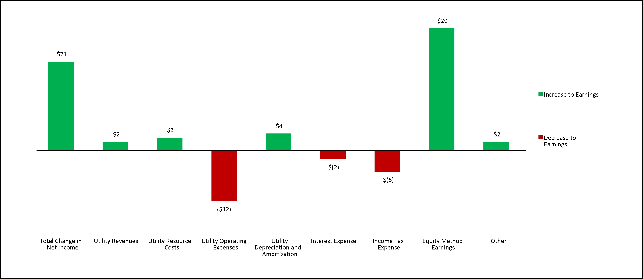
Electric Utility revenues increased due to increases in retail rates associated with our general rate case, which were partially offset by removing the recovery of Colstrip related costs. This increase to revenues was largely offset by decreased wholesale revenues and decreases in volumes sold. The decrease in volumes sold is due to the departure of a large industrial customer in April 2026. Natural gas revenues increased due to rate increases, largely offset by decreases in wholesale revenues and decoupling revenues.
Electric utility resource costs decreased primarily due to decreased fuel for generation costs partially due to the removal of Colstrip from our generation portfolio. This was partially offset by increased purchased power volumes and wholesale prices, as well as increased costs under the ERM. Natural gas utility resource costs decreased due to decreases in volumes of natural gas purchased.
37

Table of Contents

AVISTA CORPORATION

Other utility operating expenses increased due primarily to increased employee salaries and benefit costs, partially offset with decreases from removing Colstrip related expenses.
Utility depreciation and amortization decreased primarily due to our exit from Colstrip in 2026.
Income tax expense increased primarily due to increased pre-tax income from continuing operations (including equity method earnings) compared to the prior year.
Increased equity method earnings were primarily the result of underlying investment appreciation recognized in the second quarter of 2026, compared to losses recognized in the second quarter of 2025. See “Note 5 of the Notes to Condensed Consolidated Financial Statements” for additional information regarding the gain recorded in the second quarter of 2026.
Six months ended June 30, 2026 compared to the six months ended June 30, 2025
The following graph shows the total change in net income for the six months ended June 30, 2026 compared to the six months ended June 30, 2025, as well as the factors that caused such change (dollars in millions):
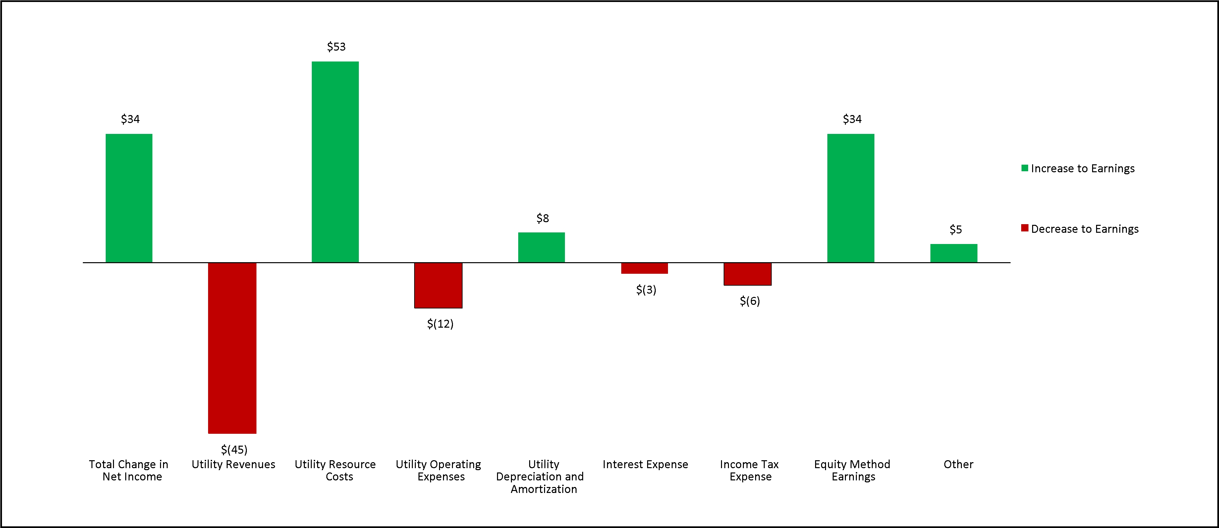
Electric utility revenues decreased primarily as a result of decreased wholesale revenues associated with lower market prices, a reduction of revenues associated with the recovery of Colstrip costs, and the departure of a large industrial customer in April 2026, which were partially offset by other increases in retail rates associated with our general rate cases. Natural gas revenues decreased due to decreased rates associated with the PGAs and the CCA (which do not impact net income), as well as decreased wholesale revenues, transportation revenues and an increased provision for rate refunds associated with overearnings in Washington.
Electric utility resource costs decreased primarily due to decreased fuel for generation costs partially due to the removal of Colstrip from our generation portfolio. These decreases were partially offset by a decrease in deferrals under the ERM. Natural gas utility resource costs decreased due to decreases in the amortization of costs associated with the CCA and net deferrals and amortizations of costs under PGAs, as well as a decrease in volumes of natural gas purchased.
Other utility operating expenses increased due primarily to increased employee salaries and benefit costs, partially offset with decreases from removing Colstrip related expenses.
Utility depreciation and amortization decreased primarily due to our transfer of Colstrip.
Income tax expense increased primarily due to increased pre-tax income from continuing operations (including equity method earnings) compared to the prior year.
38

Table of Contents

AVISTA CORPORATION

Increased equity method earnings were primarily the result of underlying investment appreciation recognized in the first half of 2026, compared to losses recognized in the first half of 2025. See “Note 5 of the Notes to Condensed Consolidated Financial Statements” for additional information regarding the gain recorded in the second quarter of 2026.
Results of Operations - Avista Utilities
Resource Optimization
We engage in resource optimization, which involves the selection from available energy resources to serve our load obligations and the use of these resources to capture economic value through wholesale market transactions; this is ultimately intended to lower net power and natural gas supply costs. Our resource optimization transactions can include physical sales and purchases of electric capacity and energy, fuel for electric generation, natural gas to optimize use of pipeline and storage capacity, as well as financial derivative contracts related to capacity, energy, fuel and fuel transportation. See our 2025 Form 10-K for further discussion of our optimization activities.
We typically enter into multiple transactions simultaneously to capture value. Even though these transactions are considered together when determining the net impact, they are recorded in separate items within components of utility operating revenue and resource costs and can cause fluctuations in each item. Gains and losses on financial derivative contracts are included in certain line items below (such as wholesale sales and purchases of power and natural gas, sales of fuel and other fuel costs). The ERM, PCA and PGAs are based on net supply costs and consider all transactions related to resource procurement and optimization (both physical and financial).
Intercompany Revenues and Resource Costs
Intracompany revenues and resource costs represent purchases and sales of natural gas between our natural gas distribution operations and our electric generation operations (as fuel for our generation plants). These transactions are eliminated in the presentation of total results for Avista Utilities and in the condensed consolidated financial statements but are included in the separate results for electric and natural gas presented below.
39

Table of Contents

AVISTA CORPORATION

Three months ended June 30, 2026 compared to the three months ended June 30, 2025
Utility Operating Revenues
The following graphs present Avista Utilities' electric operating revenues and megawatt-hour (MWh) sales for the three months ended June 30, 2026 and 2025 (dollars in millions and MWhs in thousands):
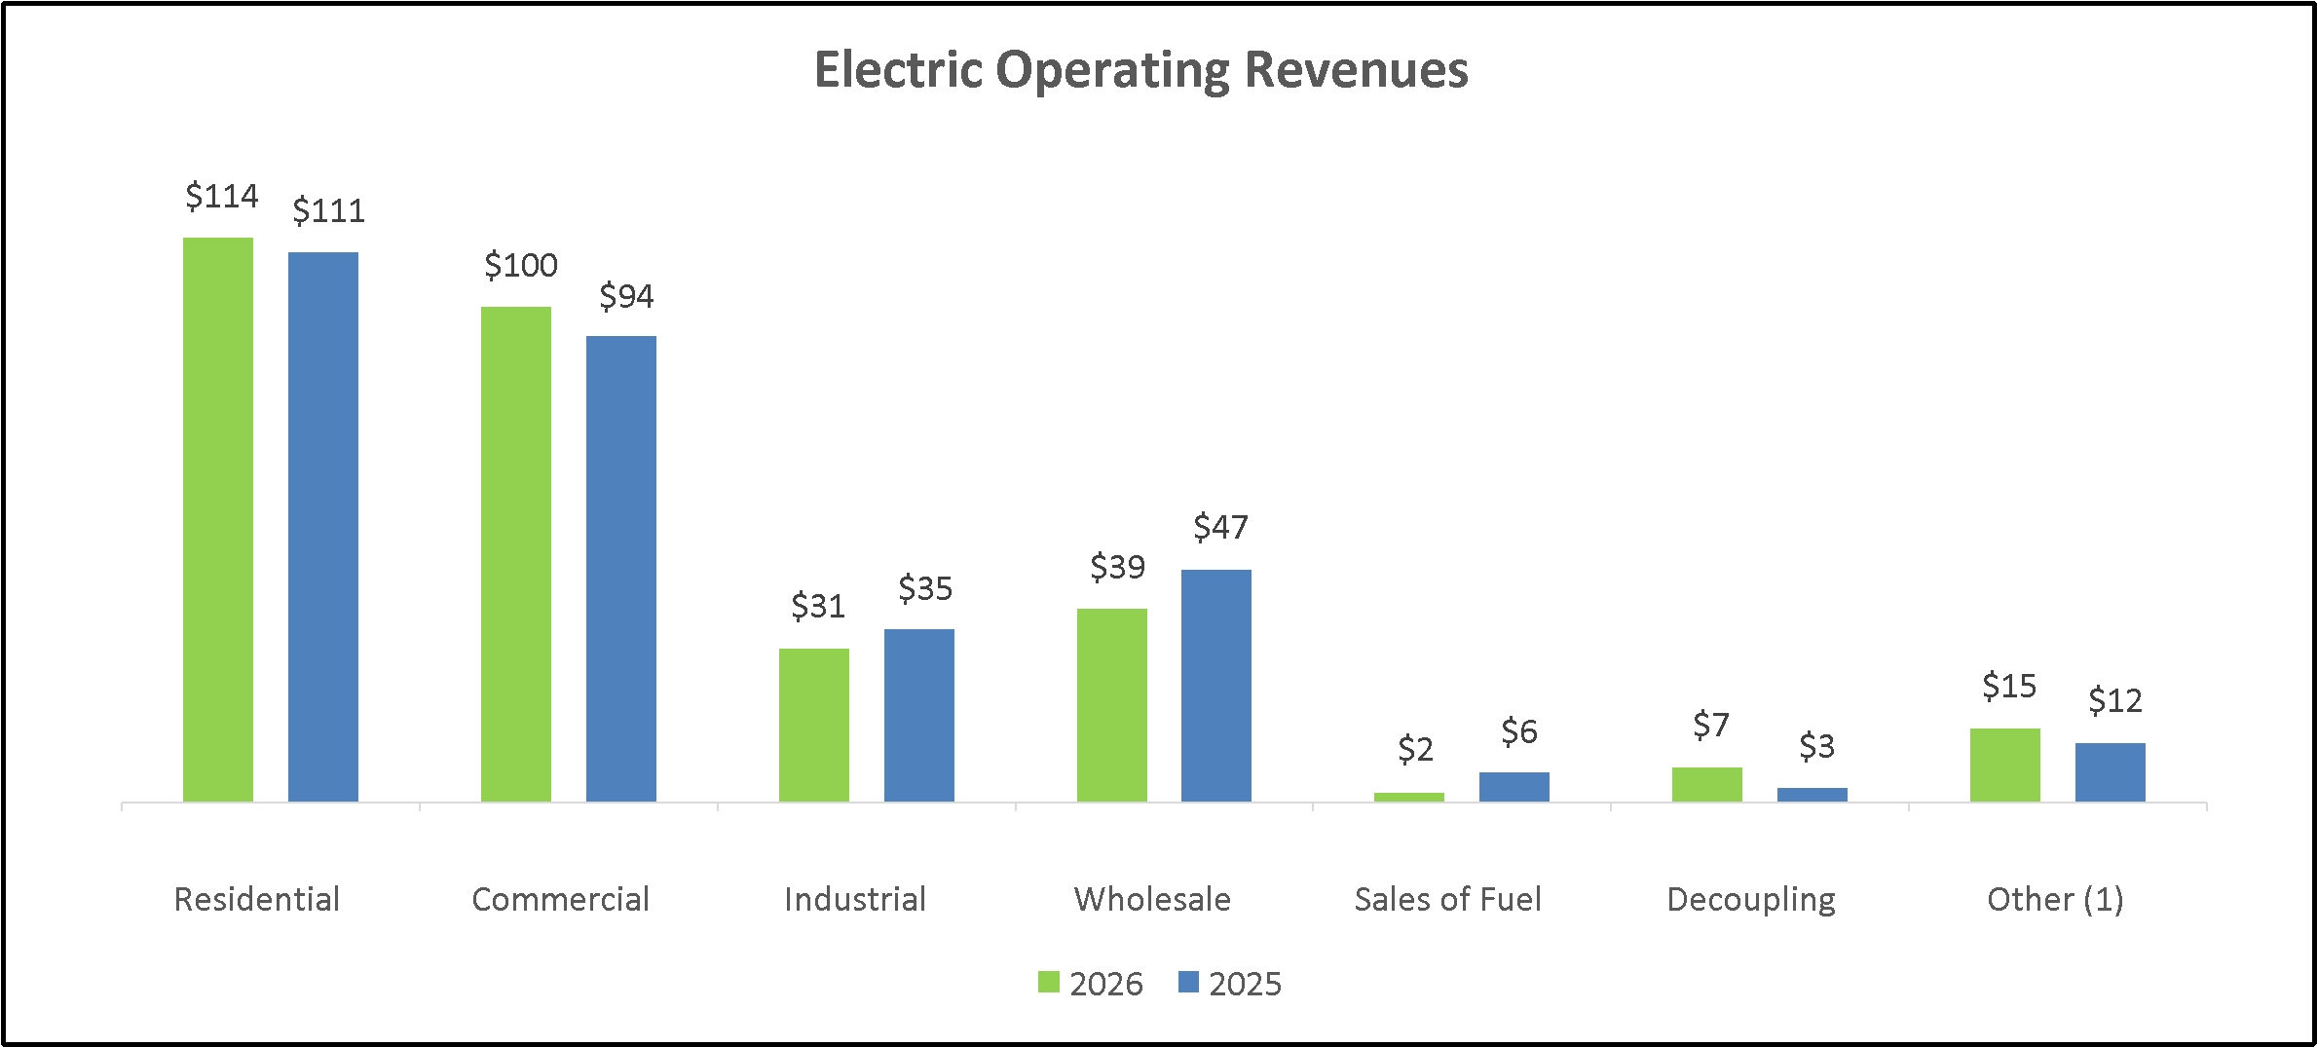
(1)
This balance includes public street and highway lighting, which is considered part of retail electric revenues.
Total electric operating revenues in the graph above include intracompany sales of $1 million for both the three months ended June 30, 2026 and 2025.
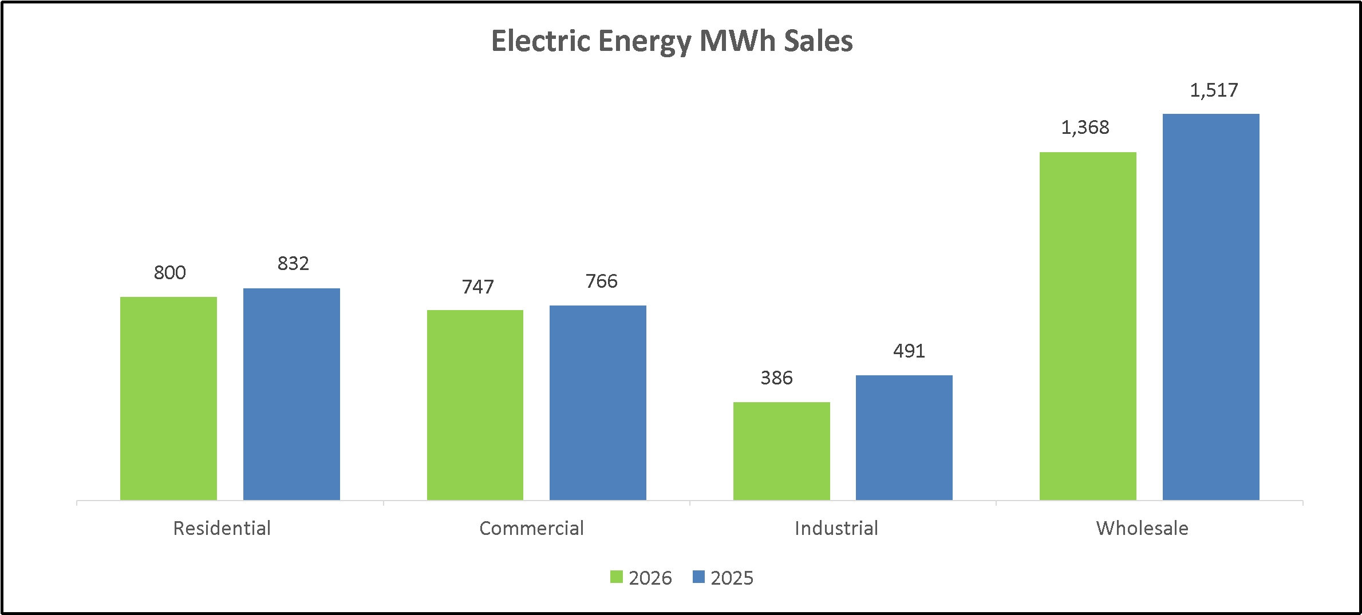
40

Table of Contents

AVISTA CORPORATION

The following table presents the current year decoupling deferrals and the amortization of prior year decoupling deferrals reflected in utility electric operating revenues for the three months ended June 30 (dollars in millions):
 |  | Electric Decoupling Revenues
 |  | 2026 |  |  |  | 2025
Current year decoupling deferrals (a) |  | $ | 9 |  |  | $ | 3
Amortization of prior year decoupling deferrals (b) |  |  | (2 | ) |  |  | —
Total electric decoupling revenue |  | $ | 7 |  |  | $ | 3
(a)
Positive amounts are increases in decoupling revenue in the current year and will be surcharged to customers in future years. Negative amounts are decreases in decoupling revenue in the current year and will be rebated to customers in future years.
(b)
Positive amounts are increases in decoupling revenue in the current year and are related to the amortization of rebate balances that resulted in prior years and are being refunded to customers (causing a corresponding decrease in retail revenue from customers) in the current year. Negative amounts are decreases in decoupling revenue in the current year and are related to the amortization of surcharge balances that resulted in prior years and are being surcharged to customers (causing a corresponding increase in retail revenue from customers) in the current year.
Total electric revenues did not change materially for the second quarter of 2026 as compared to the second quarter of 2025. The primary fluctuations that occurred during the period were as follows:
•
A $5 million increase in retail electric revenue due to an increase in retail rates (increased revenues by $25 million) offset by a decrease in MWhs sold (decreased revenues by $20 million).
o
Retail rates increased mainly due to the effects of our general rate cases, including base rate increases associated with higher authorized power supply expenses resulting from removing Colstrip from our generation portfolio. These increases to base rates were partially offset by the removal of revenues related to recovery of Colstrip related costs other than power supply costs.
o
Retail sales volumes decreased due to a 21 percent decrease in industrial electric sales volumes, partially due to the departure of a large industrial customer in April 2026. Additionally, milder weather reduced customer usage. Residential and commercial use per customer decreased 5 percent and 3 percent, respectively.
•
An $8 million decrease in wholesale electric revenues due to a decrease in sales volumes (decreased revenues $4 million) and a decrease in sales prices (decreased revenues $4 million).
•
A $4 million increase in electric decoupling revenue primarily due to increased current year surcharge deferrals associated with decreased customer usage compared to the second quarter of 2025.
41

Table of Contents

AVISTA CORPORATION

The following graphs present Avista Utilities' natural gas operating revenues and therms delivered for the three months ended June 30, 2026 and 2025 (dollars in millions and therms in thousands):
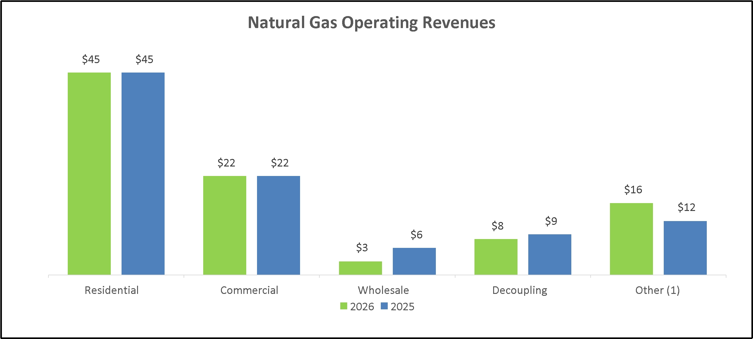
(1)
This balance includes interruptible and industrial revenues, which are considered part of retail natural gas revenues.
Total natural gas operating revenues in the graph above include intracompany sales of $0 million and $1 million for the three months ended June 30, 2026 and 2025.
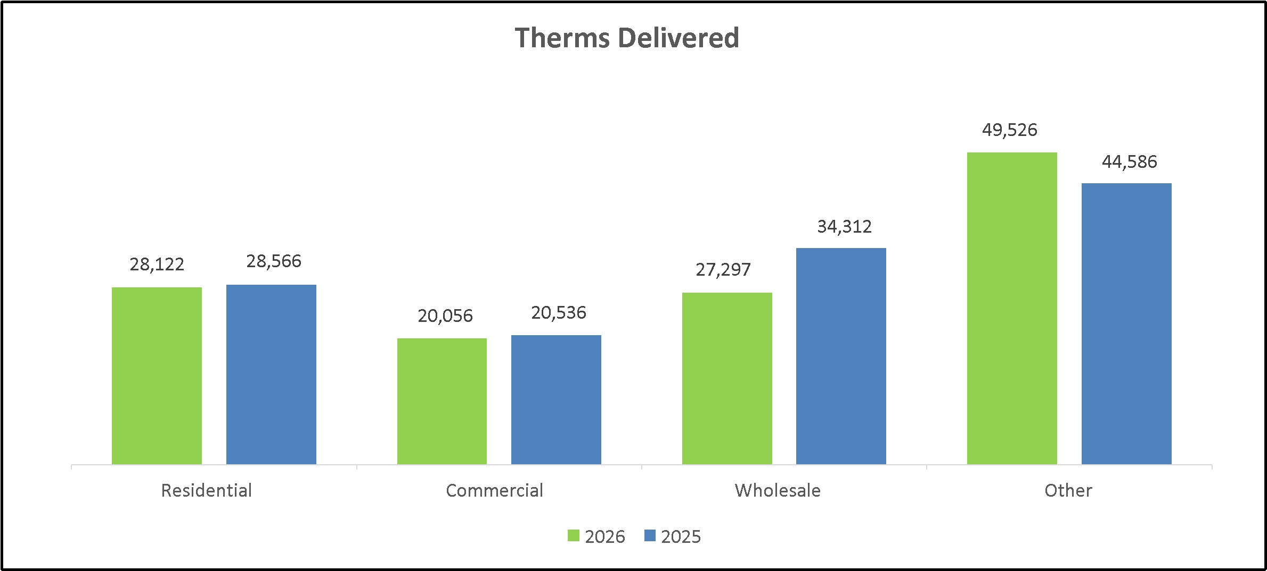
42

Table of Contents

AVISTA CORPORATION

The following table presents the current year decoupling deferrals and the amortization of prior year decoupling deferrals reflected in utility natural gas operating revenues for the three months ended June 30 (dollars in millions):
 |  | Natural Gas Decoupling Revenues
 |  | 2026 |  |  |  | 2025
Current year decoupling deferrals (a) |  | $ | 10 |  |  | $ | 9
Amortization of prior year decoupling deferrals (b) |  |  | (2 | ) |  |  | —
Total natural gas decoupling revenue |  | $ | 8 |  |  | $ | 9
(a)
Positive amounts are increases in decoupling revenue in the current year and will be surcharged to customers in future years. Negative amounts are decreases in decoupling revenue in the current year and will be rebated to customers in future years.
(b)
Positive amounts are increases in decoupling revenue in the current year and are related to the amortization of rebate balances that resulted in prior years and are being refunded to customers (causing a corresponding decrease in retail revenue from customers) in the current year. Negative amounts are decreases in decoupling revenue in the current year and are related to the amortization of surcharge balances that resulted in prior years and are being surcharged to customers (causing a corresponding increase in retail revenue from customers) in the current year.
Total natural gas revenues did not change materially for the second quarter of 2026 as compared to the second quarter of 2025. The primary fluctuations that occurred during the period were as follows:
•
A $3 million decrease in wholesale natural gas revenues due to a decrease in prices (decreased revenues $2 million) and a decrease in volumes (decreased revenues $1 million).
•
A $4 million increase in other gas revenues primarily due to the amortization of previously deferred revenues associated with the sale of CCA emissions credits. We amortize the deferred revenues as they are passed on to customers through decreases in retail rates. The increase in other revenues was offset by decreased retail revenues, resulting in no impact on net income.
Customers
The following table presents Avista Utilities' average number of electric and natural gas retail customers for the three months ended June 30, 2026 and 2025:
 |  | Electric Customers |  |  |  |  |  |  |  | Natural Gas Customers
 |  | 2026 |  |  |  | 2025 |  |  |  | 2026 |  |  |  | 2025
Residential |  |  | 380,516 |  |  |  | 375,572 |  |  |  | 347,951 |  |  |  | 345,685
Commercial |  |  | 46,410 |  |  |  | 46,119 |  |  |  | 37,696 |  |  |  | 37,527
Interruptible |  |  | — |  |  |  | — |  |  |  | 52 |  |  |  | 51
Industrial |  |  | 1,144 |  |  |  | 1,171 |  |  |  | 181 |  |  |  | 184
Public street and highway lighting |  |  | 849 |  |  |  | 802 |  |  |  | — |  |  |  | —
Total retail customers |  |  | 428,919 |  |  |  | 423,664 |  |  |  | 385,880 |  |  |  | 383,447

43

Table of Contents

AVISTA CORPORATION

Utility Resource Costs
The following graph presents Avista Utilities' electric resource costs for the three months ended June 30, 2026 and 2025 (dollars in millions):
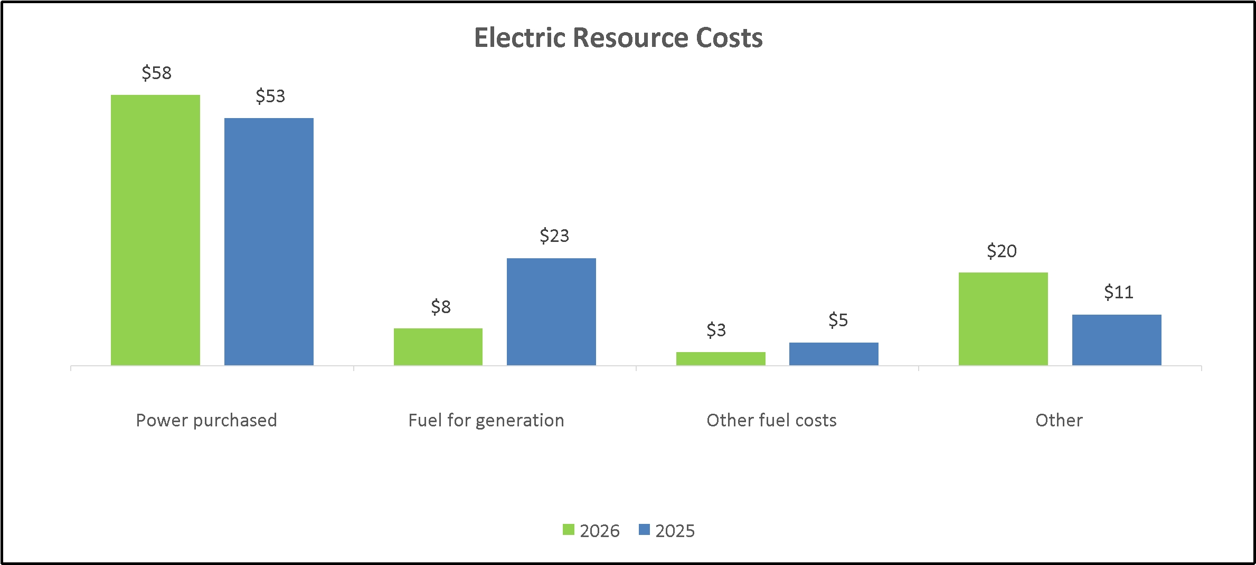
Total electric resource costs in the graph above include intracompany resource costs of $0 million and $1 million for the three months ended June 30, 2026 and 2025.
Total electric resource costs decreased $3 million for the second quarter of 2026 as compared to the second quarter of 2025. The primary changes that occurred during the period were as follows:
•
A $5 million increase in power purchased due to an increase in the volume of power purchases (increased costs $3 million) and an increase in wholesale prices (increased costs $2 million).
•
A $15 million decrease in fuel for generation due to decreased thermal generation due to increased hydroelectric generation. Thermal generation decreased due to the removal of Colstrip from our generation portfolio, as well as major maintenance at the Coyote Springs 2 facility in 2026.
•
A $9 million increase in other electric resource costs primarily related to a decrease in deferred costs under the ERM. The decrease in deferred costs was due to an increase in authorized power supply costs primarily due to the removal of Colstrip from our generation portfolio. There were also increased costs related to our customer assistance payment programs (low-income rate assistance and demand side management).
In the second quarter of 2026, we had a pre-tax expense of $6 million under the ERM in Washington compared to a pre-tax expense of $1 million in the second quarter of 2025.

44

Table of Contents

AVISTA CORPORATION

The following graph presents Avista Utilities' natural gas resource costs for the three months ended June 30, 2026 and 2025 (dollars in millions):
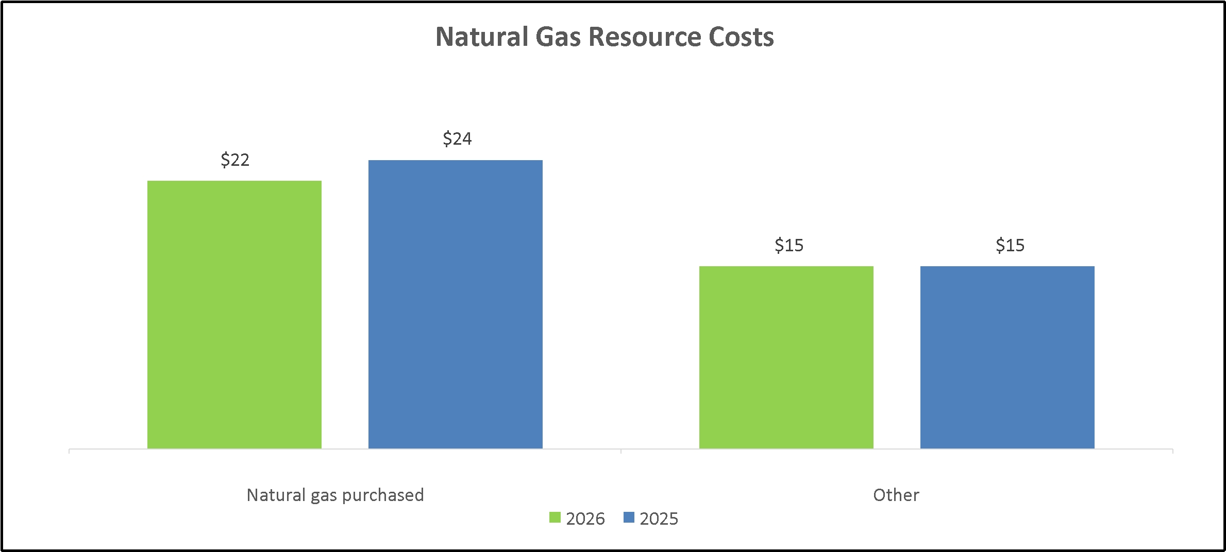
Total natural gas resource costs in the graph above include intracompany resource costs of $1 million for both the three months ended June 30, 2026 and 2025.
Total natural gas resource costs decreased $2 million for the second quarter of 2026 as compared to the second quarter of 2025 due to a $2 million decrease in natural gas purchased from a decrease in volumes, consistent with a decrease in retail and wholesale sales volumes.
45

Table of Contents

AVISTA CORPORATION

Six months ended June 30, 2026 compared to the six months ended June 30, 2025
Utility Operating Revenues
The following graphs present Avista Utilities' electric operating revenues and megawatt-hour (MWh) sales for the six months ended June 30, 2026 and 2025 (dollars in millions and MWhs in thousands):
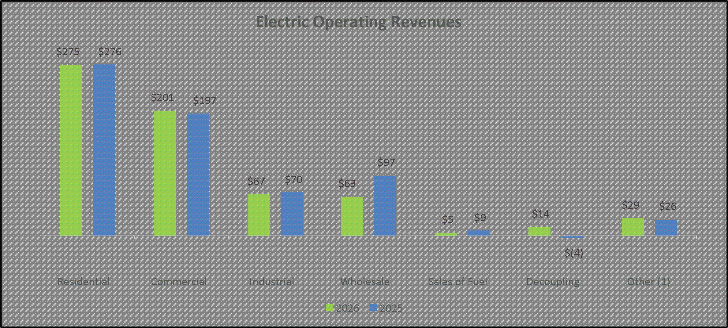
(1)
This balance includes public street and highway lighting, which is considered part of retail electric revenues.
Total electric operating revenues in the graph above include intracompany sales of $1 million for both the six months ended June 30, 2026 and 2025.
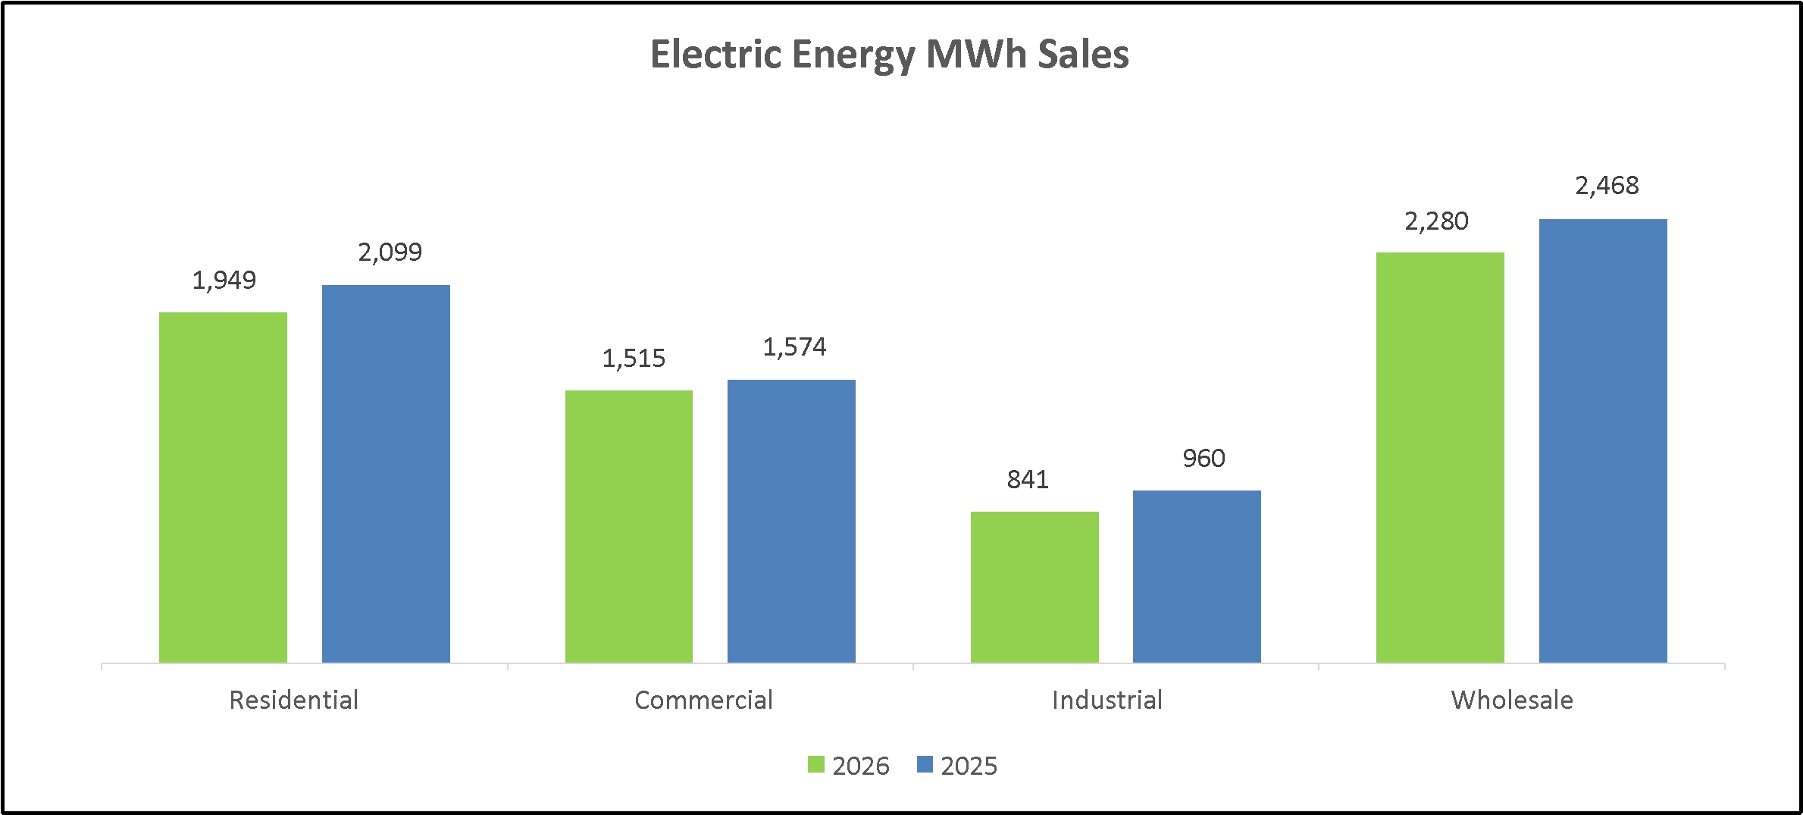
46

Table of Contents

AVISTA CORPORATION

The following table presents the current year decoupling deferrals and the amortization of prior year decoupling deferrals reflected in utility electric operating revenues for the six months ended June 30 (dollars in millions):
 |  | Electric Decoupling Revenues
 |  | 2026 |  |  |  | 2025
Current year decoupling deferrals (a) |  | $ | 17 |  |  | $ | (4 | )
Amortization of prior year decoupling deferrals (b) |  |  | (3 | ) |  |  | —
Total electric decoupling revenue |  | $ | 14 |  |  | $ | (4 | )
(a)
Positive amounts are increases in decoupling revenue in the current year due to lower customer usage and will be surcharged to customers in future years. Negative amounts are decreases in decoupling revenue in the current year due to higher customer usage and will be rebated to customers in future years.
(b)
Positive amounts are increases in decoupling revenue in the current year and are related to the amortization of rebate balances that resulted in prior years due to higher customer usage and are being refunded to customers (causing a corresponding decrease in retail revenue from customers) in the current year. Negative amounts are decreases in decoupling revenue in the current year and are related to the amortization of surcharge balances that resulted in prior years due to lower customer usage and are being surcharged to customers (causing a corresponding increase in retail revenue from customers) in the current year.
Total electric revenues decreased $17 million for the first half of 2026 as compared to the first half of 2025. The primary changes that occurred during the period were as follows:
•
A $1 million decrease in retail electric revenue due to a decrease in MWhs sold (decreased revenues by $42 million), offset by an increase in retail rates (increased revenues by $41 million).
o
Retail rates increased mainly due to the effects of our general rate cases, including base rate increases associated with higher authorized power supply expenses resulting from removing Colstrip from our generation portfolio. These increases to base rates were partially offset by the removal of revenues related to recovery of Colstrip related costs other than power supply costs.
o
Retail sales volumes decreased due to a 12 percent decrease in industrial electric sales volumes, partially due to the departure of a large industrial customer in April 2026. Additionally, milder weather led to reduced customer usage. Residential and commercial use per customer decreased 8 percent and 4 percent, respectively. Heating degree days in Spokane were 87 percent of the historical average during the first half of 2026, while they were 94 percent of the historical average during the first half of 2025.
•
A $34 million decrease in wholesale electric revenues due to a decrease in sales prices (decreased revenues $29 million) and a decrease in sales volumes (decreased revenues $5 million).
•
An $18 million increase in electric decoupling revenue primarily due to current year surcharge deferrals associated with decreased customer usage compared to rebate deferrals in the first half of 2025.
47

Table of Contents

AVISTA CORPORATION

The following graphs present Avista Utilities' natural gas operating revenues and therms delivered for the six months ended June 30, 2026 and 2025 (dollars in millions and therms in thousands):
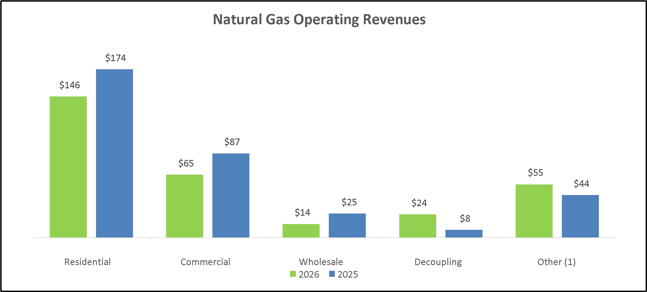
(1)
This balance includes interruptible and industrial revenues, which are considered part of retail natural gas revenues.
Total natural gas operating revenues in the graph above include intracompany sales of $1 million and $4 million for the six months ended June 30, 2026 and 2025, respectively.
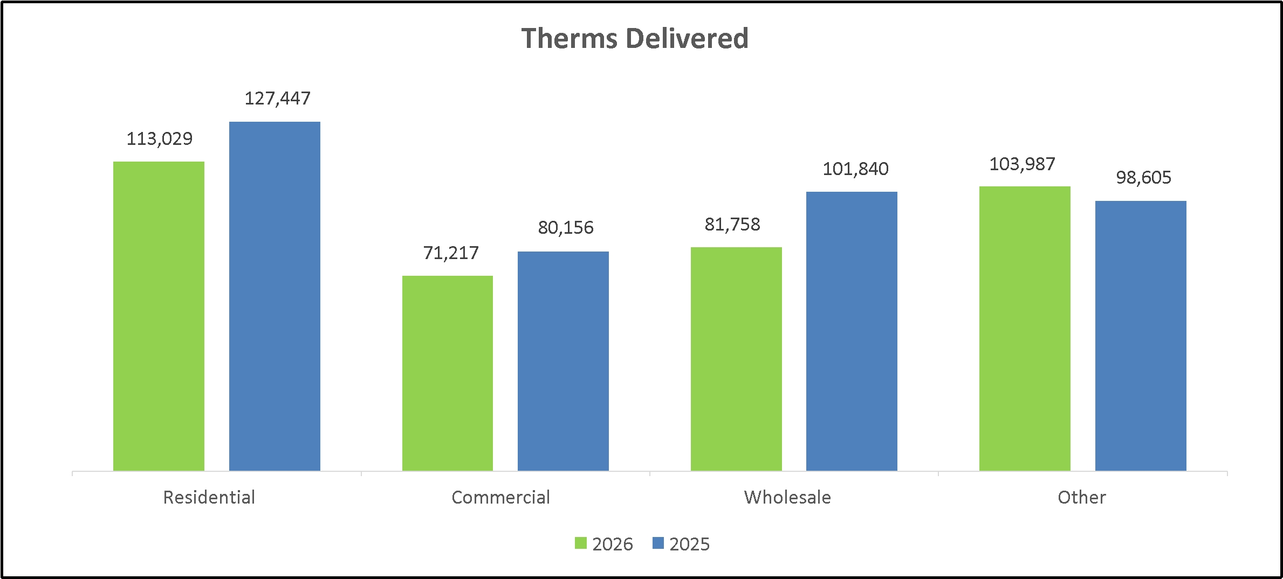
48

Table of Contents

AVISTA CORPORATION

The following table presents the current year decoupling deferrals and the amortization of prior year decoupling deferrals reflected in utility natural gas operating revenues for the six months ended June 30 (dollars in millions):
 |  | Natural Gas Decoupling Revenues
 |  | 2026 |  |  |  | 2025
Current year decoupling deferrals (a) |  | $ | 31 |  |  | $ | 10
Amortization of prior year decoupling deferrals (b) |  |  | (7 | ) |  |  | (2 | )
Total natural gas decoupling revenue |  | $ | 24 |  |  | $ | 8
(a)
Positive amounts are increases in decoupling revenue in the current year due to lower customer usage and will be surcharged to customers in future years. Negative amounts are decreases in decoupling revenue in the current year due to higher customer usage and will be rebated to customers in future years.
(b)
Positive amounts are increases in decoupling revenue in the current year and are related to the amortization of rebate balances that resulted in prior years due to higher customer usage and are being refunded to customers (causing a corresponding decrease in retail revenue from customers) in the current year. Negative amounts are decreases in decoupling revenue in the current year and are related to the amortization of surcharge balances that resulted in prior years due to lower customer usage and are being surcharged to customers (causing a corresponding increase in retail revenue from customers) in the current year.
Total natural gas revenues decreased $34 million for the first half of 2026 as compared to the first half of 2025. The primary changes that occurred during the period were as follows:
•
A $50 million decrease in natural gas retail revenues (including industrial, which is included in other) due to a decrease in retail rates (decreased revenues $26 million) and decreased sales volumes (decreased revenues $24 million).
o
Retail rates decreased mainly due to PGA rate decreases and rebates to Washington customers for revenues related to the sale of CCA emissions credits, neither of which impact net income. These decreases were partially offset by increases to base rates resulting from our general rate cases.
o
Retail sales volumes decreased due to milder weather, which reduced customer usage. Residential and commercial use per customer each decreased 12 percent. Heating degree days in Spokane were 87 percent of the historical average during the first half of 2026, while they were 94 percent of the historical average in the first half of 2025.
•
An $11 million decrease in wholesale natural gas revenues due to a decrease in prices (decreased revenues $8 million) and a decrease in volumes (decreased revenues $3 million).
•
A $16 million increase in natural gas decoupling revenues primarily due to increased surcharge deferrals in the current year associated with lower customer usage.
•
An $11 million increase in other gas revenues primarily due to the amortization of previously deferred revenues associated with the sale of CCA emissions credits. We amortize the deferred revenues as they are passed on to customers through decreases in retail rates. The increase in other revenues was offset by decreased retail rates as discussed above, resulting in no impact on net income. This increase was partially offset by a decrease in transportation revenue, as well as a provision for rate refunds associated with overearnings in Washington recorded in the first half of 2026.
49

Table of Contents

AVISTA CORPORATION

Customers
The following table presents Avista Utilities' average number of electric and natural gas retail customers for the six months ended June 30, 2026 and 2025:
 |  | Electric Customers |  |  |  |  |  |  |  | Natural Gas Customers
 |  | 2026 |  |  |  | 2025 |  |  |  | 2026 |  |  |  | 2025
Residential |  |  | 379,953 |  |  |  | 375,210 |  |  |  | 347,857 |  |  |  | 345,698
Commercial |  |  | 46,169 |  |  |  | 45,848 |  |  |  | 37,599 |  |  |  | 37,462
Interruptible |  |  | — |  |  |  | — |  |  |  | 51 |  |  |  | 52
Industrial |  |  | 1,133 |  |  |  | 1,162 |  |  |  | 181 |  |  |  | 184
Public street and highway lighting |  |  | 769 |  |  |  | 760 |  |  |  | — |  |  |  | —
Total retail customers |  |  | 428,024 |  |  |  | 422,980 |  |  |  | 385,688 |  |  |  | 383,396

Utility Resource Costs
The following graph presents Avista Utilities' electric resource costs for the six months ended June 30, 2026 and 2025 (dollars in millions):
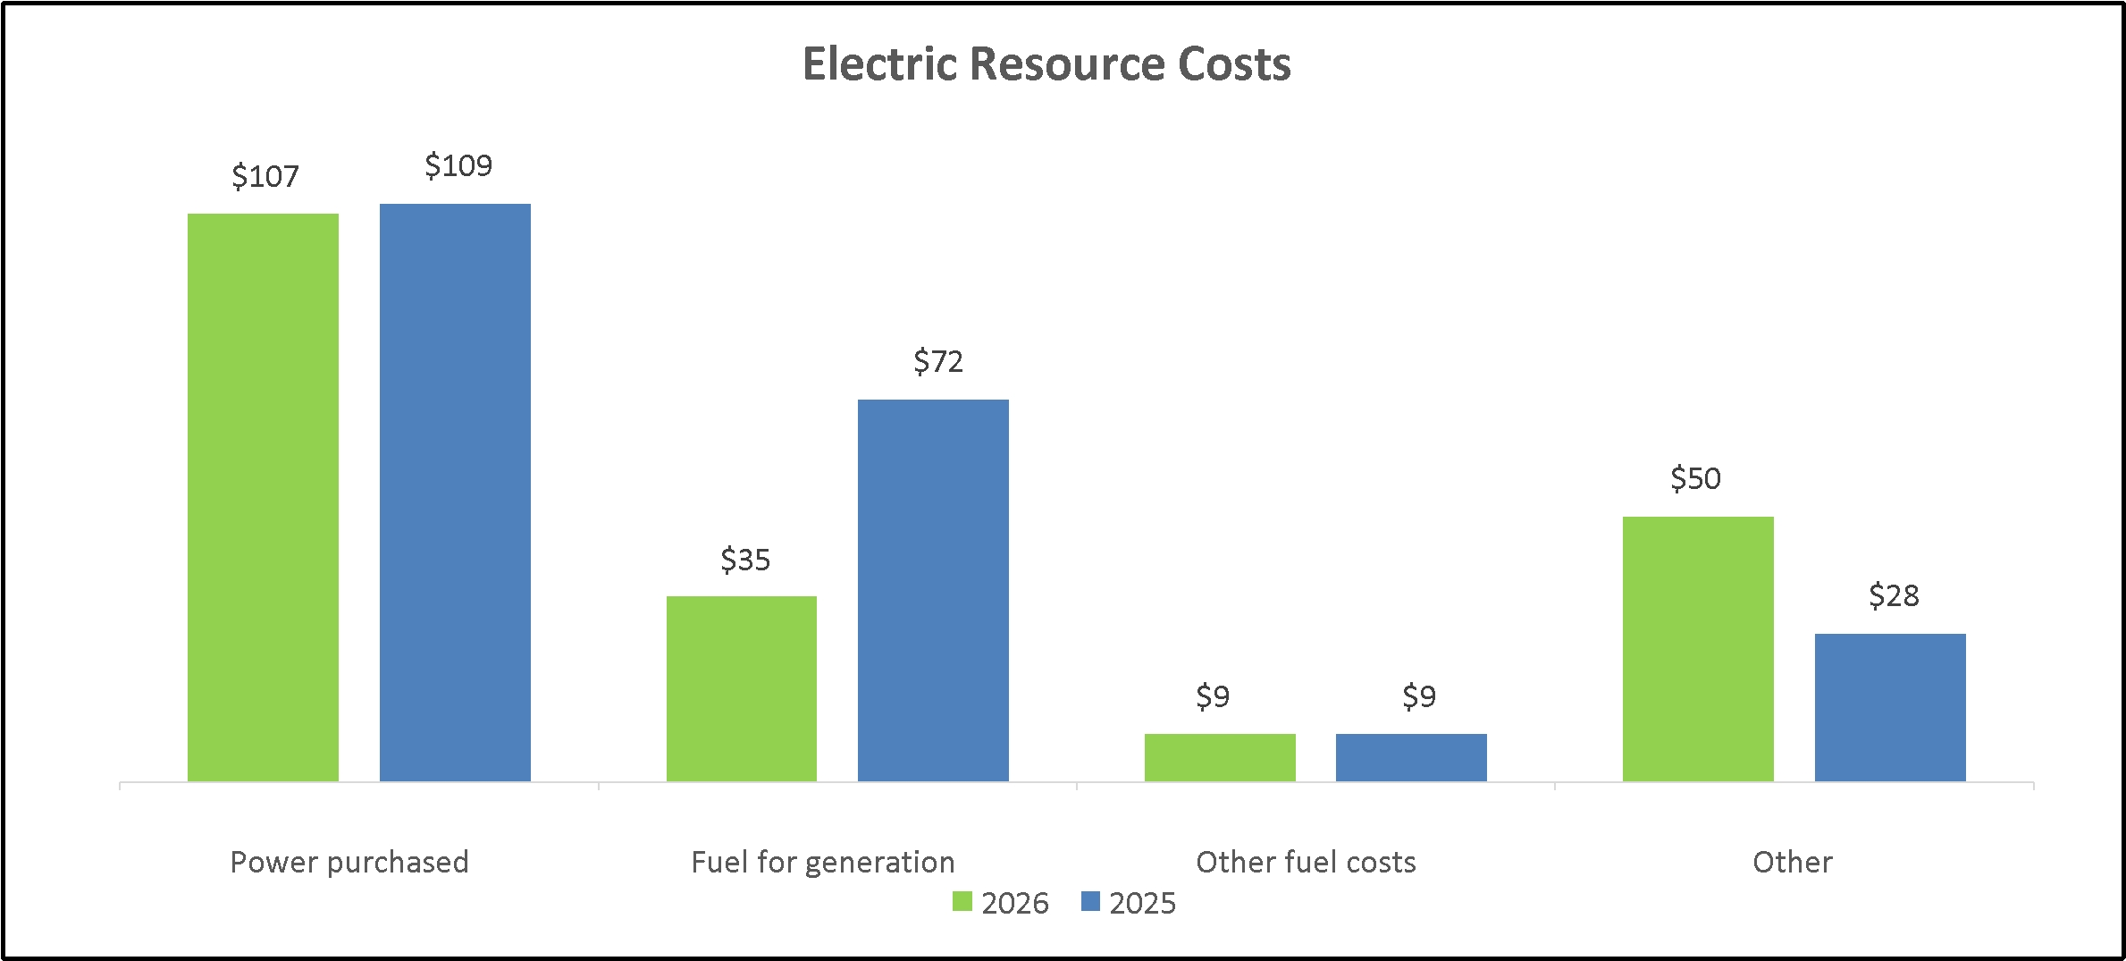
Total electric resource costs in the graph above include intracompany resource costs of $1 million and $4 million for the six months ended June 30, 2026 and 2025, respectively.
Total electric resource costs decreased $17 million for the first half of 2026 as compared to the first half of 2025. The primary changes that occurred during the period were as follows:
•
A $2 million decrease in power purchased due to a decrease in wholesale prices (decreased costs $6 million), partially offset by an increase in the volume of power purchases (increased costs $4 million).
•
A $37 million decrease in fuel for generation due to decreased thermal generation due to increased hydroelectric generation. Thermal generation decreased due to the removal of Colstrip from our generation portfolio, as well as major maintenance at the Coyote Springs 2 facility in 2026.
•
A $22 million increase in other electric resource costs primarily related to a decrease in deferred costs under the ERM. The decrease in deferred costs was due to an increase in authorized power supply costs primarily due to the removal of
50

Table of Contents

AVISTA CORPORATION

Colstrip from our generation portfolio. There were also increased costs related to our customer assistance payment programs (low-income rate assistance and demand side management).
In the first half of 2026, we had a pre-tax expense of $7 million under the ERM in Washington compared to a pre-tax expense of $9 million in the first half of 2025.
The following graph presents Avista Utilities' natural gas resource costs for the six months ended June 30, 2026 and 2025 (dollars in millions):
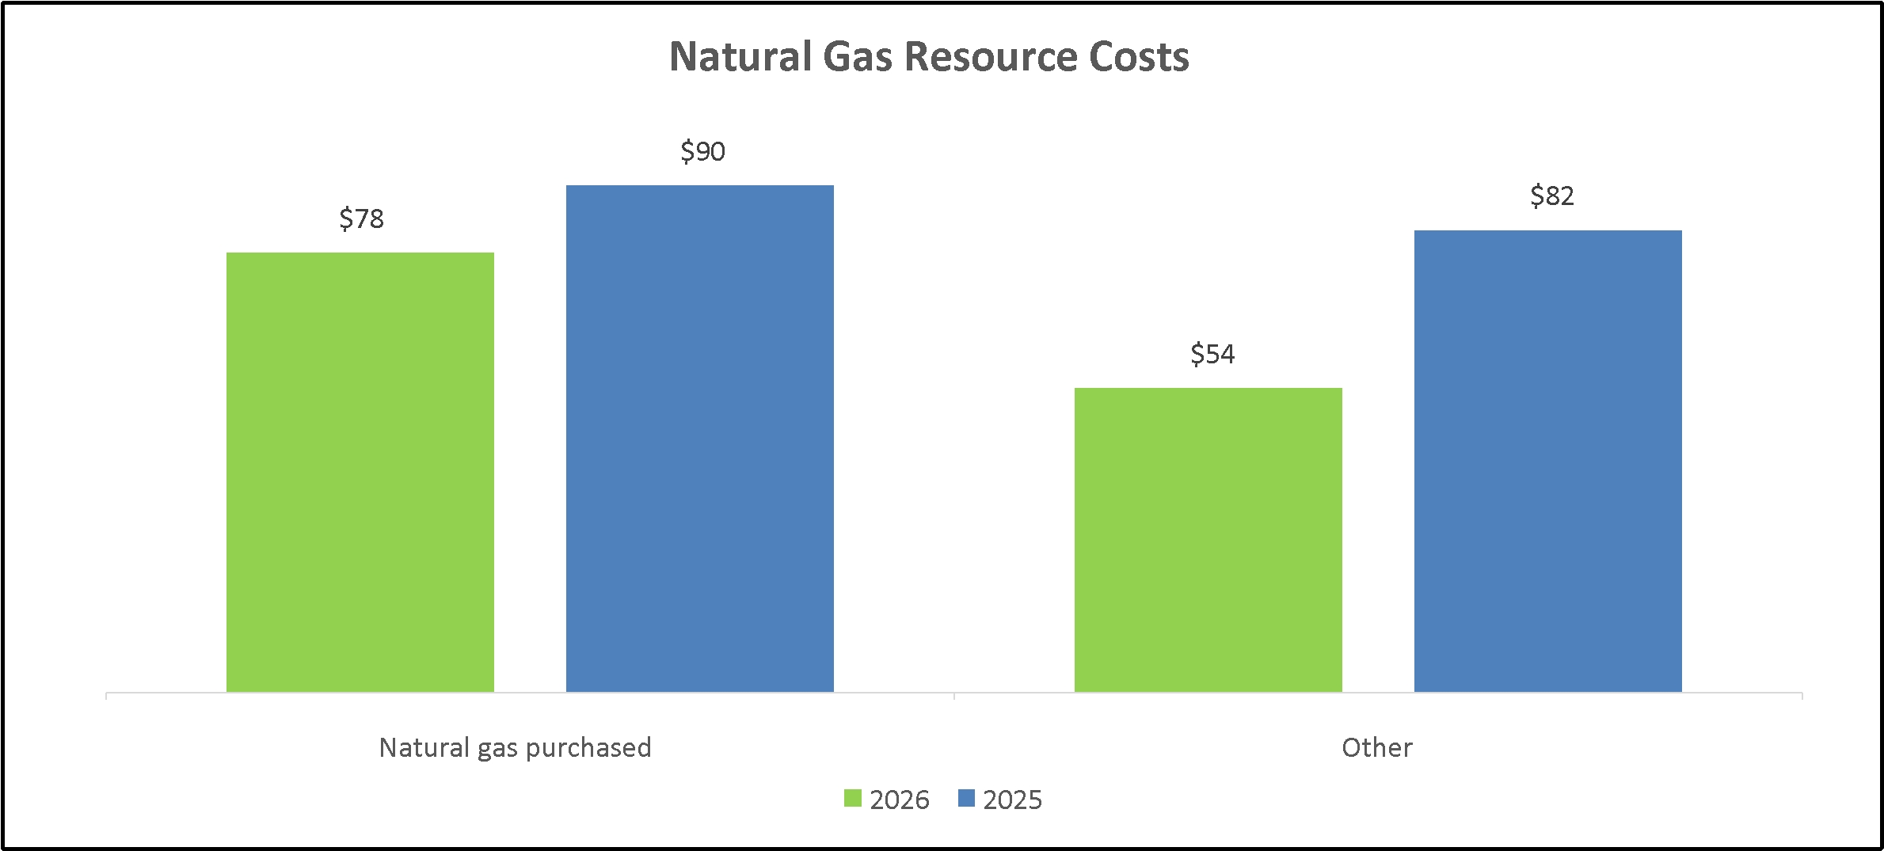
Total natural gas resource costs in the graph above include intracompany resource costs of $1 million for both the six months ended June 30, 2026 and 2025.
Total natural gas resource costs decreased $40 million for the first half of 2026 as compared to the first half of 2025 due to the following:
•
A $12 million decrease in natural gas purchased due to a decrease in the volumes purchased.
•
A $28 million decrease in other costs primarily related to a decrease in the amortization of costs associated with the CCA that were recovered from customers, resulting in no impact on net income, as well as a decrease in net deferrals and amortizations of previously deferred costs under our PGAs.
Results of Operations - Alaska Electric Light and Power Company
Net income for AEL&P was $1 million for both the second quarter of 2026 and 2025. For the first half of 2026 and 2025, net income for AEL&P was $5 million and $4 million, respectively.
Results of Operations - Other Businesses
Our other businesses had net income of $12 million for the three months ended June 30, 2026 compared to a net loss of $10 million for the three months ended June 30, 2025. For the first half of 2026, net income at our other businesses was $13 million compared to a net loss of $12 million for the first half of 2025.
51

Table of Contents

AVISTA CORPORATION

The fluctuation in results is primarily related to recognizing our portion of earnings at our equity method investments, compared to losses in the first quarter of 2025. See “Note 5 of the Notes to Condensed Consolidated Financial Statements” for additional information regarding our equity method investments.
Critical Accounting Policies and Estimates
The preparation of our condensed consolidated financial statements in conformity with GAAP requires us to make estimates and assumptions that affect amounts reported in the condensed consolidated financial statements. Changes in these estimates and assumptions are considered reasonably possible and may have a material effect on our condensed consolidated financial statements and thus, actual results could differ from the amounts reported and disclosed herein. Our critical accounting policies that require the use of estimates and assumptions were discussed in detail in the 2025 Form 10-K and have not changed materially.
Liquidity and Capital Resources
Overall Liquidity
Our sources of overall liquidity and the requirements for liquidity have not materially changed in the six months ended June 30, 2026, with the exception of the following:
We have experienced increased regulatory deferrals (such as decoupling surcharges and ERM costs), as well as delayed recovery of deferrals. As such, we are evaluating the need for up to $100 million of additional short-term liquidity by the end of the fourth quarter of 2026.
See the 2025 Form 10-K for further discussion of our liquidity requirements.
As of June 30, 2026, we had $199 million of available liquidity under the Avista Corp. committed line of credit, $59 million of available liquidity under our letter of credit facility, and $25 million under the AEL&P committed line of credit. With our existing credit facilities and the expected issuances of common stock, long-term debt and contemplated short-term loan within the next year, we believe we have adequate liquidity to meet our needs for the next 12 months.
Review of Condensed Consolidated Cash Flow Statement
Operating Activities
Net cash provided by operating activities was $301 million for the six months ended June 30, 2026, compared to $224 million for the six months ended June 30, 2025. Net income increased $33 million; however, the majority of the increase was related to non-cash realized and unrealized gains on investments, compared to losses in the first half of 2025. The change in other current assets increased operating cash flows by $43 million compared to the prior year, and is primarily associated with increases to prepaid insurance proceeds receivable and prepayments in the first half of 2025. The change in accounts receivable also increased operating cash flows by $34 million, and the change in income taxes receivable increased operating cash flows by $26 million, primarily resulting from a refund received in the first half of 2026. These increases were partially offset by a larger portion of our revenues being from decoupling surcharges in the first half of 2026, which will be recovered from customers in future periods.
Investing Activities
Net cash used in investing activities was $334 million for the six months ended June 30, 2026, compared to $248 million for the six months ended June 30, 2025. We paid $326 million for utility capital expenditures in 2026, compared to $246 million in 2025.
Financing Activities
Net cash provided by financing activities was $39 million for the six months ended June 30, 2026, compared to $3 million for the six months ended June 30, 2025. We issued $160 million of long-term debt in the first half of 2026, with no long-term debt issuances in the first half of 2025. In the first half of 2026, we repaid $92 million in short term borrowings, compared to increasing our borrowings $51 million in the first half of 2025. We issued $58 million of common stock and paid $82 million in dividends in the six months
52

Table of Contents

AVISTA CORPORATION

ended June 30, 2026, compared to issuing $35 million of common stock and paying $79 million in dividends in the six months ended June 30, 2025.
Capital Resources
Capital Structure
Our consolidated capital structure, including the current portion of long-term debt and short-term borrowings consisted of the following as of June 30, 2026 and December 31, 2025 (dollars in millions):
 |  | June 30, 2026 |  |  |  |  |  |  |  | December 31, 2025
 |  | Amount |  |  |  | Percent  of total |  |  |  | Amount |  |  |  | Percent  of total
Current portion of long-term debt and leases |  | $ | 9 |  |  |  | 0.2 | % |  | $ | 9 |  |  |  | 0.1 | %
Short-term borrowings |  |  | 226 |  |  |  | 3.7 |  |  |  | 388 |  |  |  | 6.5
Long-term debt to affiliated trusts |  |  | 52 |  |  |  | 0.8 |  |  |  | 52 |  |  |  | 0.9
Long-term debt and leases |  |  | 3,073 |  |  |  | 49.7 |  |  |  | 2,846 |  |  |  | 47.4
Total debt |  |  | 3,360 |  |  |  | 54.4 |  |  |  | 3,295 |  |  |  | 54.9
Total shareholders’ equity |  |  | 2,821 |  |  |  | 45.6 |  |  |  | 2,709 |  |  |  | 45.1
Total |  | $ | 6,181 |  |  |  | 100.0 | % |  | $ | 6,004 |  |  |  | 100.0 | %
Our shareholders’ equity increased $112 million during the first half of 2026 primarily due to net income and the issuance of common stock, which was partially offset by dividends paid.
See “Note 10 of the Notes to Condensed Consolidated Financial Statements” for additional information regarding long-term debt and “Note 13 of the Notes to Condensed Consolidated Financial Statements” for additional information regarding common stock.
Short Term Borrowings
Avista Corp.
Avista Corp. has a committed line of credit with various financial institutions in the total amount of $500 million with an expiration date of June 2029. We may request that the lenders extend their commitments for an additional one-year period (subject to customary conditions).
We also have a continuing letter of credit agreement in the aggregate amount of $65 million, which was increased from $50 million in June 2026. Either party may terminate the agreement at any time.
The following table summarizes the balances outstanding and available liquidity as of June 30, 2026 (dollars in millions):
 |  | Amount of Facility |  |  |  | Borrowings Outstanding (1) |  |  |  | Letters of Credit Outstanding (2) |  |  |  | Available Liquidity
Line of Credit expiring June 2029 |  | $ | 500 |  |  | $ | 296 |  |  | $ | 5 |  |  | $ | 199
Letter of Credit Facility |  |  | 65 |  |  | N/A |  |  |  |  | 6 |  |  |  | 59
Total |  | $ | 565 |  |  | $ | 296 |  |  | $ | 11 |  |  | $ | 258

(1)
As of June 30, 2026, there was $296 million outstanding under the committed line of credit; however, $226 million was classified as short-term borrowings and $70 million was classified as long-term on the Condensed Consolidated Balance Sheet due to the Company's intention to refinance such amount on a long-term basis. The amount classified as long-term debt will be refinanced through the issuance and sale of first mortgage bonds in August 2026, pursuant to a bond purchase agreement entered into in May 2026.
(2)
Letters of credit are not reflected on the Condensed Consolidated Balance Sheets. If a letter of credit were drawn upon by the holder, we would have an immediate obligation to reimburse the bank that issued that letter.
The Avista Corp. credit facilities contain customary covenant and default provisions, including a change in control (as defined in the agreements). The events of default under each of the credit facilities also include a cross default from other indebtedness (as defined) and, in the case of the letter of credit agreement, other obligations. The committed line of credit agreement also includes a covenant
53

Table of Contents

AVISTA CORPORATION

which does not permit our ratio of “consolidated total debt” to “consolidated total capitalization” to be greater than 65 percent at any time. As of June 30, 2026, we complied with this covenant with a ratio of 54.4 percent.
Balances outstanding and interest rates of borrowings (excluding letters of credit) under Avista Corp.'s lines of credit were as follows as of and for the six months ended June 30 (dollars in millions):
 |  | 2026 |  |  |  | 2025
$500 million line of credit, expiring June 2029
Maximum balance outstanding during the period |  | $ | 415 |  |  | $ | 400
Average balance outstanding during the period |  | $ | 352 |  |  | $ | 312
Average interest rate during the period |  |  | 4.79 | % |  |  | 5.44 | %
Average interest rate at end of the period |  |  | 4.74 | % |  |  | 5.42 | %
AEL&P
AEL&P has a $25 million committed line of credit that expires in June 2028. As of June 30, 2026, there was no balance outstanding under this committed line of credit, and $25 million of available liquidity.
The AEL&P credit facility contains customary covenants and default provisions including a covenant which does not permit the ratio of “consolidated total debt at AEL&P” to “consolidated total capitalization at AEL&P” (including the impact of the Snettisham obligation) to be greater than 67.5 percent at any time. As of June 30, 2026, AEL&P complied with this covenant with a ratio of 48.3 percent.
As of June 30, 2026, Avista Corp. and its subsidiaries complied with all of the covenants of their financing agreements, and none of Avista Corp.'s subsidiaries constituted a “significant subsidiary” as defined in Avista Corp.'s committed line of credit.
See “Note 9 of the Notes to Condensed Consolidated Financial Statements” for additional information regarding our short-term borrowing arrangements.
Liquidity Expectations
In 2026, we expect to issue $230 million of long-term debt, including the $160 million issued through June 30, 2026. We expect to issue $90 million of common stock in 2026 (including $58 million issued through June 30, 2026).
In addition, we are evaluating the need for up to $100 million of additional short-term liquidity by the end of the fourth quarter of 2026. See further discussion of liquidity requirements in “Overall Liquidity” above.
Capital Expenditures and Other Investments
We are making capital investments to enhance service and system reliability for our customers and replace aging infrastructure, and expect base Avista Utilities' capital expenditures of the following (dollars in millions):
 |  | 2026 |  |  |  | 2027 |  |  |  | 2028 |  |  |  | 2029 |  |  |  | 2030
Expected base annual capital expenditures |  | $ | 615 |  |  | $ | 635 |  |  | $ | 800 |  |  | $ | 680 |  |  | $ | 710
These planned capital expenditures are subject to continuing review and adjustment. These estimates include expenditures for new projects identified through our 2025 request for proposal process. However, these estimates do not include potential expenditures that could result from integrating a new large load customer, incremental transmission projects like regional grid expansion, or additional generation. See the 2025 Form 10-K for further information on our expected capital expenditures.
Pension Plan
In the six months ended June 30, 2026, we contributed $7 million to the pension plan and we expect contributions to total $10 million in 2026. We expect to contribute a total of $40 million to the pension plan in the period 2027 through 2030, with an annual contribution of $10 million.
54

Table of Contents

AVISTA CORPORATION

The final determination of pension plan contributions for future periods is subject to multiple variables, most of which are beyond our control, including changes to the fair value of pension plan assets, changes in actuarial assumptions (in particular, the discount rate used in determining the benefit obligation), or changes in federal legislation. We may change our pension plan contributions in the future depending on changes to any variables, including those listed above.
See "Note 7 of the Notes to Condensed Consolidated Financial Statements" for additional information regarding the pension plan.
Environmental Issues and Contingencies
Our environmental issues and contingencies disclosures have not materially changed during the six months ended June 30, 2026 except as follows:
Presidential Executive Action
On March 16, 2026, the President of the U.S. issued an Executive Order entitled “Removing Regulatory Barriers to Affordable Home Construction,” with the stated objective of increasing housing supply and affordability by reducing federal, state and local regulatory requirements that the Administration views as increasing construction costs and slowing development. Among other things, the Executive Order directs various federal agencies to incentivize state and local governments to eliminate mandatory green or energy-efficient building codes, review and potentially eliminate “unduly burdensome or costly” federal energy efficiency requirements, revise permitting rules relating to stormwater, wetlands and water pollution controls, and shorten environmental review timelines for housing projects.
On April 20, 2026, the President of the U.S. issued several Executive Orders invoking authority under the Defense Production Act of 1950 (DPA) to (a) designate oil production and storage, coal and natural gas related power generation activities, electric facilities and supply chains, and large scale energy and energy-related infrastructure as critical resources under the DPA and (b) authorize the Department of Energy to use its authority under the DPA to expand and accelerate domestic capacity in each of these areas.
We are evaluating the extent to which potential changes from these Executive Orders may affect our financial results and operations.
Oregon Legislation and Regulatory Actions
Climate Protection Plan
In March 2020, Oregon Governor Kate Brown issued Executive Order No. 20-04, “Directing State Agencies to Take Actions to Reduce and Regulate Greenhouse Gas Emissions.” The Executive Order launched rulemaking proceedings for Oregon agencies with jurisdiction over GHG-related matters, with the aim of reducing Oregon’s overall GHG emissions to 80 percent below 1990 levels by 2050. This Executive Order led to the Oregon Department of Environmental Quality (ODEQ) developing cap and reduce rules known as the CPP. The CPP originally became effective in January 2022, but was subsequently challenged and declared invalid on procedural grounds. Thereafter, the ODEQ reissued the CPP in November 2024 with updated compliance periods.
On April 16, 2026, approximately 30 parties, consisting of businesses, utilities, trade associations and unions, filed a Petition challenging the repromulgated version of the CPP. Avista Corp. is a party to the litigation, which remains pending.
See the 2025 Form 10-K for further discussion of our environmental issues and contingencies.
Enterprise Risk Management
The material risks to our businesses, and our mitigation process and procedures to address these risks, were discussed in our 2025 Form 10-K and have not materially changed during the six months ended June 30, 2026. See the 2025 Form 10-K.
Financial Risk
Our financial risks have not materially changed during the six months ended June 30, 2026. Refer to the 2025 Form 10-K. The financial risks included below are required interim disclosures, even if they have not materially changed from December 31, 2025.
55

Table of Contents

AVISTA CORPORATION

Credit Risk
As of June 30, 2026, we had cash deposited as collateral of $13 million and letters of credit of $6 million outstanding related to our energy contracts. Price movements and/or a downgrade in our credit ratings or other established credit criteria could impact further the amount of collateral required. See “Credit Ratings” in the 2025 Form 10-K for further information. For example, in addition to limiting our ability to conduct transactions, if our credit ratings were lowered to below “investment grade” based on our positions outstanding at June 30, 2026 (including both contracts considered derivatives and those considered non-derivatives), we would potentially be required to post the following additional collateral (dollars in millions):
 |  | June 30, 2026
Additional collateral taking into account contractual thresholds |  | $ | 25
Additional collateral without contractual thresholds |  |  | 36
Energy Commodity Risk
Our energy commodity risks have not materially changed during the six months ended June 30, 2026. See the 2025 Form 10-K. The following table presents energy commodity derivative fair values as a net asset or (liability) as of June 30, 2026 expected to be settled in each respective year (dollars in millions). As of June 30, 2026, there are no energy commodity derivative contracts outstanding with expected settlements after 2028:
 |  | Purchases |  |  |  |  |  |  |  |  |  |  |  |  |  |  |  | Sales
 |  | Electric Derivatives |  |  |  |  |  |  |  | Gas Derivatives |  |  |  |  |  |  |  | Electric Derivatives |  |  |  |  |  |  |  | Gas Derivatives
Year |  | Physical (1) |  |  |  | Financial (1) |  |  |  | Physical (1) |  |  |  | Financial (1) |  |  |  | Physical (1) |  |  |  | Financial (1) |  |  |  | Physical (1) |  |  |  | Financial (1)
Remainder 2026 |  | $ | — |  |  | $ | — |  |  | $ | (13 | ) |  | $ | (8 | ) |  | $ | 5 |  |  | $ | 2 |  |  | $ | (1 | ) |  | $ | —
2027 |  |  | — |  |  |  | — |  |  |  | (11 | ) |  |  | (6 | ) |  |  | — |  |  |  | — |  |  |  | (4 | ) |  |  | —
2028 |  |  | — |  |  |  | — |  |  |  | (3 | ) |  |  | (2 | ) |  |  | — |  |  |  | — |  |  |  | (3 | ) |  |  | —
The following table presents energy commodity derivative fair values as a net asset or (liability) as of December 31, 2025 expected to be settled in each respective year (dollars in millions). As of December 31, 2025, there are no energy commodity derivative contracts outstanding with expected settlements after 2028.
 |  | Purchases |  |  |  |  |  |  |  |  |  |  |  |  |  |  |  | Sales
 |  | Electric Derivatives |  |  |  |  |  |  |  | Gas Derivatives |  |  |  |  |  |  |  | Electric Derivatives |  |  |  |  |  |  |  | Gas Derivatives
Year |  | Physical (1) |  |  |  | Financial (1) |  |  |  | Physical (1) |  |  |  | Financial (1) |  |  |  | Physical (1) |  |  |  | Financial (1) |  |  |  | Physical (1) |  |  |  | Financial (1)
2026 |  | $ | — |  |  | $ | — |  |  | $ | (17 | ) |  | $ | (10 | ) |  | $ | 8 |  |  | $ | 4 |  |  | $ | (3 | ) |  | $ | —
2027 |  |  | — |  |  |  | — |  |  |  | (3 | ) |  |  | (1 | ) |  |  | — |  |  |  | — |  |  |  | (4 | ) |  |  | —
2028 |  |  | — |  |  |  | — |  |  |  | — |  |  |  | — |  |  |  | — |  |  |  | — |  |  |  | (3 | ) |  |  | —
(1)
Physical transactions represent commodity transactions in which we take or make delivery of either electricity or natural gas; financial transactions represent financial derivative instruments that are settled in cash with no physical delivery of the underlying commodity, such as futures, swap derivatives, or options contracts.
The above electric and natural gas derivative contracts will be included in either power supply costs or natural gas supply costs during the period they are settled and will be included in deferral and recovery mechanisms (ERM, PCA, and PGAs), or in the general rate case process, and are expected to eventually be collected through retail rates from customers.
Item 3. Quantitative and Qualitative Disclosures about Market Risk
The information required by this item is set forth in the Enterprise Risk Management section of "Item 2. Management’s Discussion and Analysis of Financial Condition and Results of Operations" and is incorporated herein by reference.
Item 4. Controls and Procedures
Conclusion Regarding the Effectiveness of Disclosure Controls and Procedures
The Company has disclosure controls and procedures (as defined in Rules 13a-15(e) and 15d-15(e) under the Securities Exchange Act of 1934, as amended) (Act) that are designed to ensure that information required to be disclosed in the reports it files or submits under
56

Table of Contents

AVISTA CORPORATION

the Act is recorded, processed, summarized and reported on a timely basis. Disclosure controls and procedures include, without limitation, controls and procedures designed to ensure that information required to be disclosed by the Company in the reports that it files or submits under the Act is accumulated and communicated to the Company’s management, including its principal executive and principal financial officers, as appropriate, to allow timely decisions regarding required disclosure. With the participation of the Company’s principal executive officer and principal financial officer, the Company's management evaluated its disclosure controls and procedures as of the end of the period covered by this report. There are inherent limitations to the effectiveness of any system of disclosure controls and procedures, including the possibility of human error and the circumvention or overriding of the controls and procedures. Accordingly, even effective disclosure controls and procedures can only provide reasonable assurance of achieving their control objectives. Based upon this evaluation, the Company’s principal executive officer and principal financial officer have concluded that the Company’s disclosure controls and procedures are effective at a reasonable assurance level as of June 30, 2026.
There have been no changes in the Company's internal control over financial reporting that occurred during the second quarter of 2026 that have materially affected, or are reasonably likely to materially affect, the Company's internal control over financial reporting.

57

Table of Contents

AVISTA CORPORATION

PART II. Other Information
Item 1. Legal Proceedings
See “Note 15 of Notes to Condensed Consolidated Financial Statements” in “Part I. Financial Information Item 1. Condensed Consolidated Financial Statements.”
Item 1A. Risk Factors
Refer to the 2025 Form 10-K for disclosure of risk factors that could have a significant impact on our results of operations, financial condition or cash flows and could cause actual results or outcomes to differ materially from those discussed in our reports filed with the SEC (including this Quarterly Report on Form 10-Q), and elsewhere. These risk factors have not materially changed from the disclosures provided in the 2025 Form 10-K.
Item 5. Other Information
During the fiscal quarter ended June 30, 2026, none of our directors or officers informed us of the adoption or termination of a "Rule 10b5-1 trading arrangement" or "non-Rule 10b5-1 trading arrangement," as those terms are defined in Regulation S-K, Item 408.

58

Table of Contents

AVISTA CORPORATION

Item 6. Exhibits

15 |  | Letter Re: Unaudited Interim Financial Information (1)
31.1 |  | Certification of Chief Executive Officer (Pursuant to 18 U.S.C. Section 1350, as Adopted Pursuant to Section 302 of the Sarbanes-Oxley Act of 2002) (1)
31.2 |  | Certification of Chief Financial Officer (Pursuant to 18 U.S.C. Section 1350, as Adopted Pursuant to Section 302 of the Sarbanes-Oxley Act of 2002) (1)
32 |  | Certification of Corporate Officers (Furnished Pursuant to 18 U.S.C. Section 1350, as Adopted Pursuant to Section 906 of the Sarbanes-Oxley Act of 2002) (2)
101.INS |  | Inline XBRL Instance Document. The instance document does not appear in the interactive data file because its inline XBRL tags are embedded within the inline XBRL document.
101.SCH |  | Inline XBRL Taxonomy Extension Schema With Embedded Linkbase Documents
104 |  | Cover page formatted as Inline XBRL and contained in Exhibit 101.
(1) |  | Filed herewith.
(2) |  | Furnished herewith.

59

Table of Contents

AVISTA CORPORATION

SIGNATURE
Pursuant to the requirements of the Securities Exchange Act of 1934, the registrant has duly caused this report to be signed on its behalf by the undersigned thereunto duly authorized.

 |  |  | AVISTA CORPORATION
 |  |  | (Registrant)
Date: | July 31, 2026 |  | /s/ Kevin J. Christie
 |  |  | Kevin J. Christie
Senior Vice President, Chief Financial Officer,
Treasurer and Regulatory Affairs Officer
(Principal Financial Officer)

60

Exhibit 15
July 31, 2026

To the Board of Directors and Shareholders of Avista Corporation
1411 East Mission Ave
Spokane, Washington 99202
We are aware that our report dated July 31, 2026, on our review of interim financial information of Avista Corporation and subsidiaries appearing in this Quarterly report on Form 10-Q for the quarter ended June 30, 2026, is incorporated by reference in Registration Statement Nos. 333-33790, 333-179042, 333-208986, and 333-295354 on Form S-8 and in Registration Statement No. 333-287023 on Form S-3.
/s/ Deloitte & Touche LLP

Exhibit 31.1
CERTIFICATION
I, Heather L. Rosentrater, certify that:
1.
I have reviewed this report on Form 10-Q of Avista Corporation;
2.
Based on my knowledge, this report does not contain any untrue statement of a material fact or omit to state a material fact necessary to make the statements made, in light of the circumstances under which such statements were made, not misleading with respect to the period covered by this report;
3.
Based on my knowledge, the financial statements, and other financial information included in this report, fairly present in all material respects the financial condition, results of operations and cash flows of the registrant as of, and for, the periods presented in this report;
4.
The registrant’s other certifying officer and I are responsible for establishing and maintaining disclosure controls and procedures (as defined in Exchange Act Rules 13a-15(e) and 15d-15(e)) and internal control over financial reporting (as defined in Exchange Act Rules 13a-15(f) and 15d-15(f)) for the registrant and have:
a.
Designed such disclosure controls and procedures, or caused such disclosure controls and procedures to be designed under our supervision, to ensure that material information relating to the registrant, including its consolidated subsidiaries, is made known to us by others within those entities, particularly during the period in which this report is being prepared;
b.
Designed such internal control over financial reporting, or caused such internal control over financial reporting to be designed under our supervision, to provide reasonable assurance regarding the reliability of financial reporting and the preparation of financial statements for external purposes in accordance with generally accepted accounting principles;
c.
Evaluated the effectiveness of the registrant’s disclosure controls and procedures and presented in this report our conclusions about the effectiveness of the disclosure controls and procedures, as of the end of the period covered by this report based on such evaluation; and
d.
Disclosed in this report any change in the registrant’s internal control over financial reporting that occurred during the registrant’s most recent fiscal quarter (the registrant’s fourth fiscal quarter in the case of an annual report) that has materially affected, or is reasonably likely to materially affect, the registrant’s internal control over financial reporting; and
5.
The registrant’s other certifying officer and I have disclosed, based on our most recent evaluation of internal control over financial reporting, to the registrant’s auditors and the audit committee of the registrant’s board of directors (or persons performing the equivalent functions):
a.
All significant deficiencies and material weaknesses in the design or operation of internal control over financial reporting which are reasonably likely to adversely affect the registrant's ability to record, process, summarize and report financial information; and
b.
Any fraud, whether or not material, that involves management or other employees who have a significant role in the registrant's internal control over financial reporting.

Date: | July 31, 2026 | /s/ Heather L. Rosentrater
 |  | Heather L. Rosentrater
 |  | President and Chief Executive Officer
 |  | (Principal Executive Officer)

Exhibit 31.2
CERTIFICATION
I, Kevin J. Christie, certify that:
1.
I have reviewed this report on Form 10-Q of Avista Corporation;
2.
Based on my knowledge, this report does not contain any untrue statement of a material fact or omit to state a material fact necessary to make the statements made, in light of the circumstances under which such statements were made, not misleading with respect to the period covered by this report;
3.
Based on my knowledge, the financial statements, and other financial information included in this report, fairly present in all material respects the financial condition, results of operations and cash flows of the registrant as of, and for, the periods presented in this report;
4.
The registrant’s other certifying officer and I are responsible for establishing and maintaining disclosure controls and procedures (as defined in Exchange Act Rules 13a-15(e) and 15d-15(e)) and internal control over financial reporting (as defined in Exchange Act Rules 13a-15(f) and 15d-15(f)) for the registrant and have:
a.
Designed such disclosure controls and procedures, or caused such disclosure controls and procedures to be designed under our supervision, to ensure that material information relating to the registrant, including its consolidated subsidiaries, is made known to us by others within those entities, particularly during the period in which this report is being prepared;
b.
Designed such internal control over financial reporting, or caused such internal control over financial reporting to be designed under our supervision, to provide reasonable assurance regarding the reliability of financial reporting and the preparation of financial statements for external purposes in accordance with generally accepted accounting principles;
c.
Evaluated the effectiveness of the registrant’s disclosure controls and procedures and presented in this report our conclusions about the effectiveness of the disclosure controls and procedures, as of the end of the period covered by this report based on such evaluation; and
d.
Disclosed in this report any change in the registrant’s internal control over financial reporting that occurred during the registrant’s most recent fiscal quarter (the registrant’s fourth fiscal quarter in the case of an annual report) that has materially affected, or is reasonably likely to materially affect, the registrant’s internal control over financial reporting; and
5.
The registrant’s other certifying officer and I have disclosed, based on our most recent evaluation of internal control over financial reporting, to the registrant’s auditors and the audit committee of the registrant’s board of directors (or persons performing the equivalent functions):
a.
All significant deficiencies and material weaknesses in the design or operation of internal control over financial reporting which are reasonably likely to adversely affect the registrant’s ability to record, process, summarize and report financial information; and
b.
Any fraud, whether or not material, that involves management or other employees who have a significant role in the registrant’s internal control over financial reporting.

Date: | July 31, 2026 | /s/ Kevin J. Christie
 |  | Kevin J. Christie
 |  | Senior Vice President, Chief Financial Officer,
 |  | Treasurer and Regulatory Affairs Officer
 |  | (Principal Financial Officer)

Exhibit 32
AVISTA CORPORATION

CERTIFICATION OF CORPORATE OFFICERS
(Furnished Pursuant to 18 U.S.C. Section 1350, as Adopted Pursuant to Section 906 of the
Sarbanes-Oxley Act of 2002)

Each of the undersigned, Heather L. Rosentrater, President and Chief Executive Officer of Avista Corporation (the “Company”), and Kevin J. Christie, Senior Vice President, Chief Financial Officer, Treasurer and Regulatory Affairs Officer of the Company, hereby certifies, pursuant to 18 U.S.C. Section 1350, as adopted pursuant to Section 906 of the Sarbanes-Oxley Act of 2002, that the Company’s Quarterly Report on Form 10-Q for the quarter ended June 30, 2026 fully complies with the requirements of Section 13(a) of the Securities Exchange Act of 1934, as amended, and that the information contained therein fairly presents, in all material respects, the financial condition and results of operations of the Company.
Date: July 31, 2026

/s/ Heather L. Rosentrater
Heather L. Rosentrater
President and Chief Executive Officer
/s/ Kevin J. Christie
Kevin J. Christie
Senior Vice President, Chief Financial Officer,
Treasurer and Regulatory Affairs Officer

