UNITED STATES
SECURITIES AND EXCHANGE COMMISSION
WASHINGTON, D.C. 20549

FORM 8-K

CURRENT REPORT
Pursuant to Section 13 or 15(d) of the Securities Exchange Act of 1934
Date of Report (Date of earliest event reported): August 03, 2026

AVISTA CORPORATION
(Exact name of Registrant as Specified in Its Charter)

Washington |  |  | 001-03701 | 91-0462470
(State or Other Jurisdiction  of Incorporation) |  |  | (Commission File Number) | (IRS Employer  Identification No.)
1411 East Mission Avenue
Spokane, Washington |  |  |  | 99202-2600
(Address of Principal Executive Offices) |  |  |  | (Zip Code)

Registrant’s Telephone Number, Including Area Code: 509 489-0500

(Former Name or Former Address, if Changed Since Last Report)

Check the appropriate box below if the Form 8-K filing is intended to simultaneously satisfy the filing obligation of the registrant under any of the following provisions:
☐Written communications pursuant to Rule 425 under the Securities Act (17 CFR 230.425)
☐Soliciting material pursuant to Rule 14a-12 under the Exchange Act (17 CFR 240.14a-12)
☐Pre-commencement communications pursuant to Rule 14d-2(b) under the Exchange Act (17 CFR 240.14d-2(b))
☐Pre-commencement communications pursuant to Rule 13e-4(c) under the Exchange Act (17 CFR 240.13e-4(c))
Securities registered pursuant to Section 12(b) of the Act:
Title of each class |  | Trading  Symbol(s) |  | Name of each exchange on which registered
Common Stock |  | AVA |  | The New York Stock Exchange
Indicate by check mark whether the registrant is an emerging growth company as defined in Rule 405 of the Securities Act of 1933 (§ 230.405 of this chapter) or Rule 12b-2 of the Securities Exchange Act of 1934 (§ 240.12b-2 of this chapter).
Emerging growth company ☐
If an emerging growth company, indicate by check mark if the registrant has elected not to use the extended transition period for complying with any new or revised financial accounting standards provided pursuant to Section 13(a) of the Exchange Act. ☐

Section 2 – Financial Information

Item 2.02 Results of Operations and Financial Condition.
On August 3, 2026, Avista Corporation (Avista Corp.) will issue a press release reporting financial results for the quarter ended June 30, 2026. A copy of the press release is furnished as Exhibit 99.1 to this report.

Section 7 – Regulation FD

Item 7.01 Regulation FD Disclosure.
On August 3, 2026, Avista Corp. will hold a webcast conference call with securities analysts to discuss financial results for the second quarter of 2026, during and after which an illustrative slide presentation will be available on Avista Corp.'s internet website. A copy of this slide presentation is furnished as Exhibit 99.2 to this report.

Section 9 – Financial Statements and Exhibits

Item 9.01 Financial Statements and Exhibits.
(d) | Exhibits
99.1 | Press release dated August 3, 2026, which is being furnished pursuant to Item 2.02.
99.2 | Slide presentation dated August 3, 2026, which is being furnished pursuant to Item 7.01
104 | Cover Page Interactive Data File (formatted as inline XBRL with applicable taxonomy extension information contained in Exhibits 101.)

Note to Sections 2 and 7 – The information contained in Items 2.02 and 7.01, as well as Exhibits 99.1 and 99.2, is “furnished” pursuant to General Instruction B2 to Form 8-K, shall not be considered “filed” for purposes of Section 18 of the Securities Exchange Act of 1934 (“Exchange Act”) and shall not be incorporated by reference into any filing under the Securities Act of 1933 (“Securities Act”) or the Exchange Act. Accordingly, such information shall not be subject to the liabilities of Section 18 of the Exchange Act or Section 11 or 12(a)(2) of the Securities Act.
Neither the references to Avista Corp.’s internet website in this Current Report nor the posting of any press release or financial presentation on such website shall, under any circumstances, be deemed to incorporate any information available on such website into this Current Report. The information available on Avista Corp.’s internet website is not part of this Current Report or any other report or other document furnished or filed by Avista Corp. with the Securities and Exchange Commission.

SIGNATURES
Pursuant to the requirements of the Securities Exchange Act of 1934, the registrant has duly caused this report to be signed on its behalf by the undersigned thereunto duly authorized.
 |  | AVISTA CORPORATION
 |  | (Registrant)
Date: | July 31, 2026 | /s/ Kevin J. Christie
Senior Vice President, Chief Financial Officer,
Treasurer and Regulatory Affairs Officer

Exhibit 99.1

Contact:
Investors: Stacey Walters (509) 495-2046 stacey.walters@avistacorp.com
Media: Lena Funston (509) 495-8090 lena.funston@avistacorp.com
Avista 24/7 Media Access (509) 495-4174
Avista Corp. Reports Q2 2026 Financial Results, Confirms 2026 Utility Earnings Guidance
SPOKANE, Wash. – Aug. 3, 2026, 4:05 a.m. PDT: Avista Corp. (NYSE: AVA) today reported the following results for the second quarter of 2026 and the six months ended June 30, 2026 as compared to the respective periods in 2025 (dollars in millions, except per-share amounts):1
 |  | Second Quarter |  |  |  |  |  |  |  | Year-to-Date
 |  | 2026 |  |  |  | 2025 |  |  |  | 2026 |  |  |  | 2025
Net income based on GAAP |  | $ | 35 |  |  | $ | 14 |  |  | $ | 127 |  |  | $ | 93
Earnings per diluted share based on GAAP |  | $ | 0.43 |  |  | $ | 0.17 |  |  | $ | 1.54 |  |  | $ | 1.15
Non-GAAP utility earnings1 |  | $ | 23 |  |  | $ | 24 |  |  | $ | 114 |  |  | $ | 105
Non-GAAP utility earnings per diluted share1 |  | $ | 0.29 |  |  | $ | 0.29 |  |  | $ | 1.38 |  |  | $ | 1.30
Avista Corp. is confirming its 2026 non-GAAP utility earnings guidance2 with a range of $2.52 to $2.72 per diluted share.
CEO Perspective
“Strong execution of our operational priorities and disciplined cost management reinforce confidence in our outlook and long-term strategy. Results for the quarter also benefited from the recovery of non-utility investment losses recognized in 2025. By maintaining a balanced approach to investments in our system and affordability, we continue to position the company to deliver value for both our customers and shareholders,” said Heather Rosentrater, President and CEO of Avista.
Analysis of 2026 GAAP Earnings
Net income for the three and six months ended June 30, 2026 increased compared to the respective periods in 2025 primarily due to investment performance at our other businesses. We recognized net

1 See reconciliations to GAAP measures and further information in the "Non-GAAP Financial Measures" section within this press release.

2Avista Corp. is unable to provide GAAP earnings guidance or present a quantitative reconciliation of forward-looking non-GAAP utility earnings and utility growth guidance without unreasonable effort because certain reconciling items are not estimable. For instance, investment gains and losses, which have historically made up the majority of our non-regulated other business earnings and can be significant to our overall results, are difficult to predict due to various factors outside of management's control. These items are uncertain, depend on various factors, and may have a material impact on our future GAAP results.

1

investment gains in 2026, compared to net investment losses in 2025. For the six months ended June 30, 2026, net income also increased as a result of the impacts of our general rate cases.

Analysis of 2026 Non-GAAP Utility Earnings
The following table presents the changes in non-GAAP utility earnings and non-GAAP utility earnings per diluted share for the second quarter and year-to-date 2026, as compared to the same periods of 2025. It also outlines the various after-tax factors that contributed to these changes (dollars in millions, except per-share data):
 |  | Second Quarter |  |  |  |  |  |  |  | Year-to-Date
 |  | Net  Income (a) |  |  |  | Earnings  per Share |  |  |  | Net  Income (a) |  |  |  | Earnings  per Share
2025 utility earnings |  | $ | 24 |  |  | $ | 0.29 |  |  | $ | 105 |  |  | $ | 1.30
Changes in net income and diluted earnings per share:
Avista Utilities
Electric revenues (b) |  |  | — |  |  |  | — |  |  |  | (13 | ) |  |  | (0.16 | )
Natural gas revenues (c) |  |  | — |  |  |  | 0.01 |  |  |  | (27 | ) |  |  | (0.32 | )
Electric resource costs (d) |  |  | 2 |  |  |  | 0.02 |  |  |  | 13 |  |  |  | 0.16
Natural gas resource costs (e) |  |  | 2 |  |  |  | 0.03 |  |  |  | 33 |  |  |  | 0.40
Other operating expenses (f) |  |  | (9 | ) |  |  | (0.11 | ) |  |  | (9 | ) |  |  | (0.11 | )
Depreciation and amortization (g) |  |  | 3 |  |  |  | 0.04 |  |  |  | 6 |  |  |  | 0.08
Interest expense |  |  | (2 | ) |  |  | (0.02 | ) |  |  | (3 | ) |  |  | (0.04 | )
Other (h) |  |  | 4 |  |  |  | 0.04 |  |  |  | 7 |  |  |  | 0.08
Income tax at effective rate (i) |  |  | (1 | ) |  |  | — |  |  |  | 1 |  |  |  | 0.02
Dilution on earnings |  | n/a |  |  |  |  | (0.01 | ) |  | n/a |  |  |  |  | (0.04 | )
Total Avista Utilities |  |  | (1 | ) |  |  | 0.00 |  |  |  | 8 |  |  |  | 0.07
AEL&P |  |  | — |  |  |  | — |  |  |  | 1 |  |  |  | 0.01
2026 utility earnings |  | $ | 23 |  |  | $ | 0.29 |  |  | $ | 114 |  |  | $ | 1.38

(a)
The tax impact of each line item was calculated using Avista Corp.'s federal statutory tax rate of 21 percent.
(b)
Electric revenues decreased year-to-date as a result of decreased wholesale revenues, the removal of revenues related to the recovery of Colstrip costs, and decreased industrial sales volumes associated with the departure of a large industrial customer. These decreases were partially offset by other effects of our general rate cases.
(c)
Natural gas revenues decreased year-to-date due to purchased gas adjustments (PGAs) and Climate Commitment Act (CCA) related revenues, with corresponding decreases to natural gas resource costs.
(d)
Electric resource costs decreased due to decreased fuel costs, consistent with lower thermal generation, as well as decreased expense recognized under the Energy Recovery Mechanism (ERM). For the second quarter, the ERM resulted in a $6 million pre-tax expense in 2026, compared to a $1 million pre-tax expense in 2025. The ERM resulted in a $7 million pre-tax expense for the first half of 2026, compared to a $9 million pre-tax expense in the same period in 2025.
2

(e)
Natural gas resource costs decreased due to decreased volumes purchased, decreased net deferrals and amortizations of previously deferred costs under our PGAs, as well as decreased costs associated with the CCA.
(f)
Other operating expenses increased primarily due to increased employee salaries and benefit costs, partially offset by a decrease from the removal of Colstrip related costs.
(g)
Depreciation and amortization decreased primarily due to our exit from Colstrip in 2026. This decrease was partially offset by increases from additions to plant.
(h)
Other increases to earnings include increased interest income compared to the prior year and decreased taxes other than income taxes.
(i)
Our effective tax rate in the first half of 2026 was 12% compared to 14% in the same period of 2025.
Analysis of Non-Regulated Other Business Income
Income at our non-regulated other businesses was $13 million in the first half of 2026, compared to losses of $12 million in the first half of 2025. The fluctuation in results is primarily related to net investment gains in the second quarter of 2026 from our equity method investments, compared to net investment losses in the second quarter of 2025.
In June 2026, an underlying investment held by one of the funds in which we are invested completed an initial public offering and is now publicly traded. We estimate our portion of the fair value increase associated with this underlying investment in the second quarter of 2026 to be $17 million, which we will recognize in the third quarter as we record our activity related to this fund on a quarter lag. While actual results for the fourth quarter will reflect the fair value on Sept. 30, we estimate a loss of $13 million based on the fair value of the underlying investment on July 31. We will recognize valuation changes for other investments held, as appropriate.
Liquidity and Capital Resources
Liquidity
As of June 30, 2026, we had $199 million of available liquidity under the Avista Corp. committed line of credit and $59 million of available liquidity under our letter of credit facility.
We expect to issue up to $90 million of common stock in 2026, including $58 million issued in the first half of 2026.
We also expect to issue $230 million of long-term debt during 2026 (including $160 million issued in the first half of 2026). Due to increased regulatory deferrals and delayed recovery, we are evaluating the need for up to $100 million of additional short-term liquidity by the end of the fourth quarter of 2026.
3

Capital Expenditures
In the first half of 2026, Avista Utilities' capital expenditures were $314 million.
For Avista Utilities, we expect base capital expenditures as follows through 2030 (dollars in millions):
 |  | 2026 |  |  |  | 2027 |  |  |  | 2028 |  |  |  | 2029 |  |  |  | 2030
Expected base annual capital expenditures |  | $ | 615 |  |  | $ | 635 |  |  | $ | 800 |  |  | $ | 680 |  |  | $ | 710
These estimates include expenditures for the projects selected through our 2025 request for proposal. These estimates do not include incremental transmission projects, like regional grid expansion, or additional generation. Potential additional capital expenditures associated with integrating new large load customers, if any, are also excluded.
2026 Utility Earnings Guidance and Outlook
Avista Corp. is confirming its 2026 non-GAAP utility earnings guidance with a range of $2.52 to $2.72 per diluted share.
This non-GAAP utility earnings guidance is based on the following assumptions:
•
Normal weather for the remainder of the year
•
A negative impact from the ERM of ($0.10) cents per diluted share within the 90% customer, 10% company sharing band
•
An effective tax rate of 12 percent
•
Capital expenditures of $615 million for the year
Over the long term, we expect non-GAAP utility earnings to grow 4 to 6 percent from the midpoint of our 2025 earnings guidance.
Our guidance does not include the effect of unusual or non-recurring items until the effects are probable. Various factors could cause actual results to differ materially from our expectations. Please refer to our 10-K for 2025, our 10-Q for the second quarter of 2026, and the cautionary statements below for a full discussion of these factors.
Non-GAAP Financial Measures
This press release includes non-GAAP financial measures, including utility earnings and utility earnings per diluted share. We present these non-GAAP measures in order to facilitate meaningful evaluation of our operating performance across periods, and we utilize these non-GAAP measures to assess current and forecast performance, as well as for communications with shareholders, analysts and investors. Non-GAAP measures are supplementary information that should be considered in addition to, but not as a substitute for, the information prepared in accordance with GAAP.
Non-GAAP utility earnings and utility earnings per diluted share exclude non-regulated other business activity, primarily consisting of realized and unrealized investment gains and losses. The presentation
4

of utility earnings is intended to enhance the understanding of the Company's utility-specific operating performance.
The following table reconciles GAAP net income to non-GAAP utility earnings, and GAAP earnings per diluted share to non-GAAP utility earnings per diluted share for the three and six months ended June 30 (dollars in millions, except per share amounts):
 |  | Second Quarter |  |  |  |  |  |  |  | Year-to-Date
 |  | 2026 |  |  |  | 2025 |  |  |  | 2026 |  |  |  | 2025
GAAP net income as reported |  | $ | 35 |  |  | $ | 14 |  |  | $ | 127 |  |  | $ | 93
Non-GAAP adjustments:
Non-regulated other business (income) loss |  |  | (12 | ) |  |  | 10 |  |  |  | (13 | ) |  |  | 12
Non-GAAP utility earnings |  | $ | 23 |  |  | $ | 24 |  |  | $ | 114 |  |  | $ | 105
GAAP earnings per diluted share as reported |  | $ | 0.43 |  |  | $ | 0.17 |  |  | $ | 1.54 |  |  | $ | 1.15
Non-GAAP adjustments:
Non-regulated other business (income) loss per diluted share |  |  | (0.14 | ) |  |  | 0.12 |  |  |  | (0.16 | ) |  |  | 0.15
Non-GAAP utility earnings per diluted share |  | $ | 0.29 |  |  | $ | 0.29 |  |  | $ | 1.38 |  |  | $ | 1.30
NOTE: We will host a conference call with financial analysts and investors on Aug. 3, 2026 at 10:30 a.m. ET to discuss this news release. This call can be accessed on Avista’s website at investor.avistacorp.com. You must register for the call via the link at Avista’s website (investor.avistacorp.com) to access the call-in details for the webcast. A replay of the webcast will be available for one year on the Avista Corp. web site at investor.avistacorp.com.
Avista Corp. is an energy company involved in the production, transmission and distribution of energy as well as other energy-related businesses. Avista Utilities is our operating division that provides electric service to approximately 429,000 customers and natural gas to 386,000 customers. Our service territory covers 34,000 square miles in eastern Washington, northern Idaho and parts of southern and eastern Oregon, with a population of 1.5 million. AERC is an Avista subsidiary that, through its subsidiary AEL&P, provides retail electric service to 18,000 customers in the city and borough of Juneau, Alaska. Our stock is traded under the ticker symbol “AVA”. For more information about Avista, please visit www.avistacorp.com.
Avista Corp. and the Avista Corp. logo are trademarks of Avista Corporation.
This news release contains forward-looking statements, including statements regarding our current expectations for future financial performance and cash flows, capital expenditures, financing plans, our current plans or objectives for future operations and other factors, which may affect the company in the future. Such statements are subject to a variety of risks, uncertainties and other factors, most of which are beyond our control and many of which could have significant impact on our operations, results of operations, financial condition or cash flows and could cause actual results to differ materially from those anticipated in such statements.
The following are among the important factors that could cause actual results to differ materially from the forward-looking statements:
Utility Regulatory Risk
state and federal regulatory decisions or related judicial decisions that affect our ability to recover costs and earn a reasonable return, including, but not limited to, disallowance or delay in the recovery of capital investments, operating costs, commodity costs, the ordering of refunds to customers and discretion over allowed return on investment; the loss of regulatory accounting treatment, which could require the write-off of regulatory assets and the loss of regulatory deferral and recovery mechanisms;
5

Operational Risk
weather conditions, which affect both energy demand and electric generating capability, including the impact of precipitation and temperature on hydroelectric resources, the impact of wind patterns on wind-generated power, weather-sensitive customer demand, and similar impacts on supply and demand in the wholesale energy markets; wildfires ignited, or allegedly ignited, by our equipment or facilities could cause significant loss of life and property or result in liability for resulting fire suppression costs and/or damages, thereby causing serious operational, reputational and financial harm; severe weather or natural disasters, including, but not limited to, avalanches, wind storms, wildfires, earthquakes, floods, extreme temperature events, snow and ice storms that could disrupt energy generation, transmission and distribution, as well as the availability and costs of fuel, materials, equipment, supplies and support services; political unrest and/or conflicts between foreign nation-states, which could disrupt the global, national and local economy, result in increases in operating and capital costs, impact energy commodity prices or our ability to access energy resources, create disruption in supply chains, disrupt, weaken or create volatility in capital markets, and increase cyber and physical security risks. In addition, any of these factors could negatively impact our liquidity and limit our access to capital, among other implications; explosions, fires, accidents, mechanical breakdowns or other incidents that could impair assets and may disrupt operations of our generation facilities, transmission, and electric and natural gas distribution systems or other operations and may require us to purchase replacement power or incur costs to repair our facilities; interruptions in the delivery of natural gas by our suppliers, including physical problems with pipelines themselves, can disrupt our service of natural gas to our customers and/or impair our ability to operate gas-fired electric generating facilities; explosions, fires, accidents or other incidents arising from or allegedly arising from our operations that could cause injuries to the public or property damage; dam failure at a company-owned hydroelectric facility; blackouts or disruptions of interconnected transmission systems (the regional power grid); terrorist attacks, cyberattacks or other malicious acts that could disrupt or cause damage to our utility assets or to the national or regional economy in general, including effects of terrorism, cyberattacks, ransomware, or vandalism that damage or disrupt information technology systems; pandemics, which could disrupt our business, as well as the global, national and local economy, resulting in a decline in customer demand, deterioration in the creditworthiness of our customers, increases in operating and capital costs, workforce shortages, losses or disruptions in our workforce due to vaccine mandates, delays in capital projects, disruption in supply chains, and disruption, weakness and volatility in capital markets. In addition, any of these factors could negatively impact our liquidity and limit our access to capital, among other implications; work-force issues, including changes in collective bargaining unit agreements, strikes, work stoppages, the loss of key executives, availability of workers in a variety of skill areas, and our ability to recruit and retain employees; changes in the availability and price of purchased power, fuel and natural gas, as well as transmission capacity; increasing costs of insurance, more restrictive coverage terms and our ability to obtain insurance; delays or changes in construction costs, and/or our ability to obtain required permits and materials for present or prospective facilities; increasing health care costs and cost of health insurance provided to our employees and retirees; increasing operating costs, including effects of inflationary pressures; third party construction of buildings, billboard signs, towers or other structures within our rights of way, or placement of fuel containers within close proximity to our transformers or other equipment, including overbuilding atop natural gas distribution lines; the loss of key suppliers for materials or services or other disruptions to the supply chain; adverse impacts to our Alaska electric utility (AEL&P) that could result from an extended outage of its hydroelectric generating resources or their inability to deliver energy, due to their lack of interconnectivity to other electrical grids and the availability or cost of replacement power (diesel); changing river or reservoir regulation or operations at hydroelectric facilities not owned by us, which could impact our hydroelectric facilities downstream;
Climate Change Risk
increasing frequency and intensity of severe weather or natural disasters resulting from climate change that could disrupt energy generation, transmission and distribution, as well as the availability and costs of fuel, materials, equipment, supplies and support services; change in the use, availability or abundancy of water resources and/or rights needed for operation of our hydroelectric facilities, including impacts resulting from climate change; changes in the long-term climate and weather could materially affect, among other things, customer demand, the volume and timing of streamflows required for hydroelectric generation, costs of generation, transmission and distribution. Increased or new risks may arise from severe weather or natural disasters, including wildfires as well as their increased occurrence and intensity related to changes in climate;
Cybersecurity Risk
cyberattacks on the operating systems used in the operation of our electric generation, transmission and distribution facilities and our natural gas distribution facilities, and cyberattacks on such systems of other energy companies with which we are interconnected, which could damage or destroy facilities or systems or disrupt operations for extended periods of time and result in the incurrence of liabilities and costs; cyberattacks on the administrative systems used in the administration of our business, including customer billing and customer service, accounting, communications, compliance and other administrative functions, and cyberattacks on such systems of our vendors and other companies with which we do business, resulting in the disruption of business operations, the release of private information and the incurrence of liabilities and costs;
Technology Risk
changes in technologies, possibly making some of the current technology we utilize obsolete or introducing new cybersecurity risks and other new risks inherent in the use, by either us or our counterparties, of new technologies in the developmental stage including,
6

without limitation, generative artificial intelligence; changes in the use, perception, or regulation of generative artificial intelligence technologies, which could limit our ability to utilize such technology, create risk of enhanced regulatory scrutiny, generate uncertainty around intellectual property ownership, licensing or use, or which could otherwise result in risk of damage to our business, reputation or financial results; changes in costs that impede our ability to implement new information technology systems or to operate and maintain current production technology; insufficient technology skills, which could lead to the inability to develop, modify or maintain our information systems;
Strategic Risk
growth or decline of our customer base due to new uses for our services or decline in existing services, including, but not limited to, the effect of the trend toward distributed generation at customer sites; the potential effects of negative publicity regarding our business practices, whether true or not, which could hurt our reputation and result in litigation or a decline in our common stock price; changes in our strategic business plans, which could be affected by any or all of the foregoing, including the entry into new businesses and/or the exit from existing businesses and the extent of our business development efforts where potential future business is uncertain; wholesale and retail competition including alternative energy sources, growth in customer-owned power resource technologies that displace utility-supplied energy or may be sold back to the utility, and alternative energy suppliers and delivery arrangements; non-regulated activities may increase earnings volatility and result in investment losses; the risk of municipalization or other forms of service territory reduction;
External Mandates Risk
changes in environmental laws, regulations, decisions and policies, including, but not limited to, regulatory responses to concerns regarding climate change, efforts to restore anadromous fish in areas currently blocked by dams, more stringent requirements related to air quality, water quality and waste management, present and potential environmental remediation costs and our compliance with these matters; the potential effects of initiatives, legislation or administrative rulemaking at the federal, state or local levels, including possible effects on our generating resources, prohibitions or restrictions on new or existing services, or restrictions on greenhouse gas emissions to mitigate concerns over climate changes, including future limitations on the usage and distribution of natural gas; restrictions or changes in government grant programs and/or availability of other public funding used for capital projects; political pressures or regulatory practices that could constrain or place additional cost burdens on our distribution systems through accelerated adoption of distributed generation or electric-powered transportation or on our energy supply sources, such as campaigns to halt fossil fuel-fired power generation and opposition to other thermal generation, wind turbines or hydroelectric facilities; failure to identify changes in legislation, taxation and regulatory issues that could be detrimental or beneficial to our overall business; policy and/or legislative changes in various regulated areas, including, but not limited to, environmental regulation, healthcare regulations and import/export regulations; increasing costs due to potential tariffs applied to energy commodities and/or equipment and materials;
Financial Risk
our ability to obtain financing through the issuance of debt and/or equity securities and access to our funds held with financial institutions, which could be affected by various factors including our credit ratings, interest rates, other capital market conditions and global economic conditions; changes in interest rates that affect borrowing costs, variable interest rate borrowing and the extent to which we recover interest costs through retail rates collected from customers; volatility in energy commodity markets that affects our ability to effectively hedge energy commodity risks, including cash flow impacts and requirements for collateral; volatility in the carbon emissions allowances market that could result in increased compliance costs; changes in actuarial assumptions, interest rates and the actual return on plan assets for our pension and other postretirement benefit plans, which could affect future funding obligations, pension and other postretirement benefit expense and the related liabilities; the outcome of legal proceedings and other contingencies; economic conditions in our service areas, including the economy's effects on customer demand for utility services; economic conditions nationally may affect the valuation of our unregulated portfolio companies; declining electricity demand related to customer energy efficiency, conservation measures and/or increased distributed generation and declining natural gas demand related to customer energy efficiency, conservation measures and/or increased electrification; industry and geographic concentrations which could increase our exposure to credit risks due to counterparties, suppliers and customers being similarly affected by changing conditions; deterioration in the creditworthiness of our customers; activist shareholders may result in additional costs and resources required in response to activist actions;
Energy Commodity Risk
volatility and illiquidity in wholesale energy markets, including exchanges, the availability of willing buyers and sellers, changes in wholesale energy prices that could affect operating income, cash requirements to purchase electricity and natural gas, value received for wholesale sales, collateral required of us by individual counterparties and/or exchanges in wholesale energy transactions and credit risk from such transactions, and the market value of derivative assets and liabilities; default or nonperformance on the part of parties from whom we purchase and/or sell capacity or energy; potential environmental regulations or lawsuits affecting our ability to utilize or resulting in the obsolescence of our power supply resources; explosions, fires, accidents, pipeline ruptures or other incidents that could limit energy supply to our facilities or our surrounding territory, which could result in a shortage of commodities in the market that could increase the cost of replacement commodities from other sources;
7

Compliance Risk
changes in laws, regulations, decisions and policies at the federal, state or local levels, which could impact both our electric and gas operations and costs of operations; the ability to comply with the terms of the licenses and permits for our hydroelectric or thermal generating facilities at cost-effective levels;
Resource Adequacy Risk
the ability to source and deliver adequate energy to meet customer demand in periods of high demand or unplanned events; and the potential effects of regional wholesale market strains, including during extreme weather events.
For a further discussion of these factors and other important factors, please refer to our Quarterly Report on Form 10-Q for the quarter ended June 30, 2026. The forward-looking statements contained in this news release speak only as of the date hereof. We undertake no obligation to update any forward-looking statement or statements to reflect events or circumstances that occur after the date on which such statement is made or to reflect the occurrence of unanticipated events. New risks, uncertainties and other factors emerge from time to time, and it is not possible for management to predict all of such factors, nor can it assess the impact of each such factor on our business or the extent to which any such factor, or combination of factors, may cause actual results to differ materially from those contained in any forward-looking statement.
To unsubscribe from Avista’s news release distribution, send reply message to lena.funston@avistacorp.com.
Issued by: Avista Corporation
8


August 3, 2026 Q2 2026 Earnings


Call Participants Heather Rosentrater President and Chief Executive Officer Kevin Christie Senior VP, Chief Financial Officer, Treasurer, and Regulatory Affairs Officer

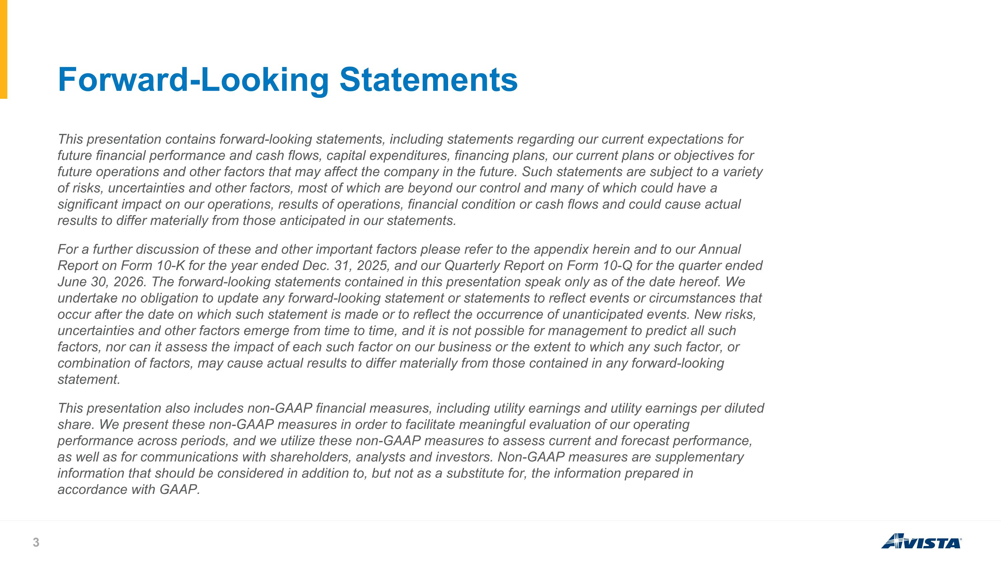
Forward-Looking Statements This presentation contains forward-looking statements, including statements regarding our current expectations for future financial performance and cash flows, capital expenditures, financing plans, our current plans or objectives for future operations and other factors that may affect the company in the future. Such statements are subject to a variety of risks, uncertainties and other factors, most of which are beyond our control and many of which could have a significant impact on our operations, results of operations, financial condition or cash flows and could cause actual results to differ materially from those anticipated in our statements. For a further discussion of these and other important factors please refer to the appendix herein and to our Annual Report on Form 10-K for the year ended Dec. 31, 2025, and our Quarterly Report on Form 10-Q for the quarter ended June 30, 2026. The forward-looking statements contained in this presentation speak only as of the date hereof. We undertake no obligation to update any forward-looking statement or statements to reflect events or circumstances that occur after the date on which such statement is made or to reflect the occurrence of unanticipated events. New risks, uncertainties and other factors emerge from time to time, and it is not possible for management to predict all such factors, nor can it assess the impact of each such factor on our business or the extent to which any such factor, or combination of factors, may cause actual results to differ materially from those contained in any forward-looking statement. This presentation also includes non-GAAP financial measures, including utility earnings and utility earnings per diluted share. We present these non-GAAP measures in order to facilitate meaningful evaluation of our operating performance across periods, and we utilize these non-GAAP measures to assess current and forecast performance, as well as for communications with shareholders, analysts and investors. Non-GAAP measures are supplementary information that should be considered in addition to, but not as a substitute for, the information prepared in accordance with GAAP.

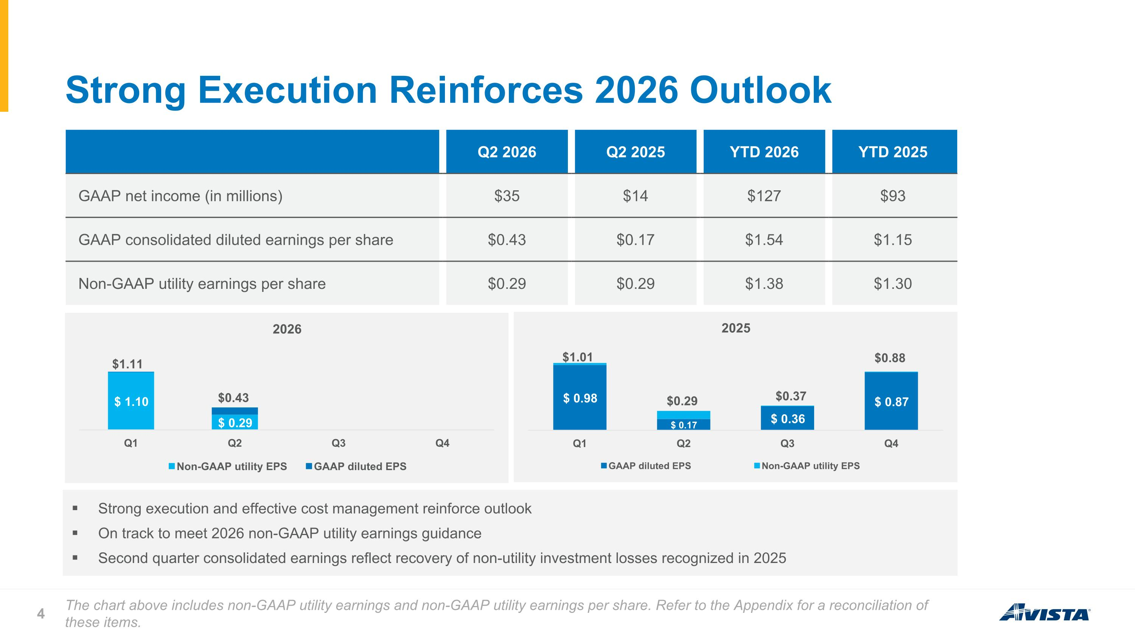
Strong execution and effective cost management reinforce outlook On track to meet 2026 non-GAAP utility earnings guidance Second quarter consolidated earnings reflect recovery of non-utility investment losses recognized in 2025 Strong Execution Reinforces 2026 Outlook The chart above includes non-GAAP utility earnings and non-GAAP utility earnings per share. Refer to the Appendix for a reconciliation of these items. $0.88 $0.37 $0.29 $1.01 $1.11 Q2 2026 Q2 2025 YTD 2026 YTD 2025 GAAP net income (in millions) $35 $14 $127 $93 GAAP consolidated diluted earnings per share $0.43 $0.17 $1.54 $1.15 Non-GAAP utility earnings per share $0.29 $0.29 $1.38 $1.30 $0.43 $1.11

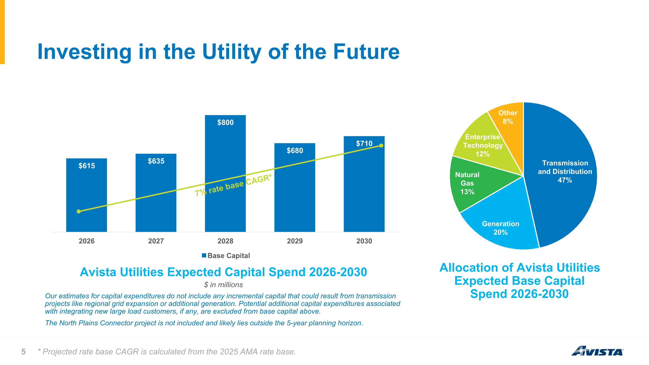
Investing in the Utility of the Future Avista Utilities Expected Capital Spend 2026-2030 Allocation of Avista Utilities Expected Base Capital Spend 2026-2030 $ in millions Our estimates for capital expenditures do not include any incremental capital that could result from transmission projects like regional grid expansion or additional generation. Potential additional capital expenditures associated with integrating new large load customers, if any, are excluded from base capital above. The North Plains Connector project is not included and likely lies outside the 5-year planning horizon. 7% rate base CAGR* * Projected rate base CAGR is calculated from the 2025 AMA rate base.

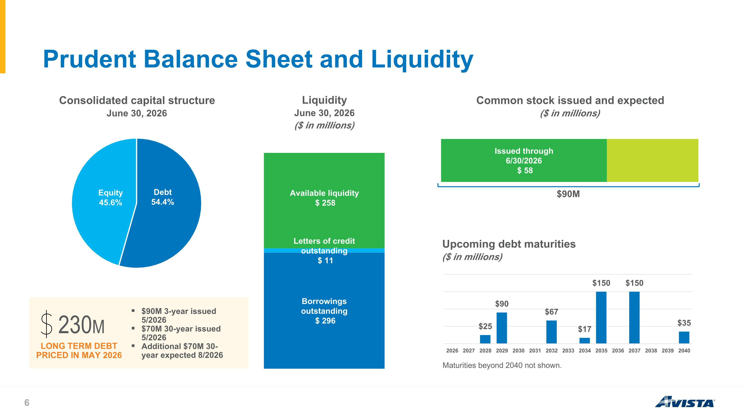
Prudent Balance Sheet and Liquidity Maturities beyond 2040 not shown. LONG TERM DEBT PRICED IN MAY 2026 230M $90M $90M 3-year issued 5/2026 $70M 30-year issued 5/2026 Additional $70M 30-year expected 8/2026

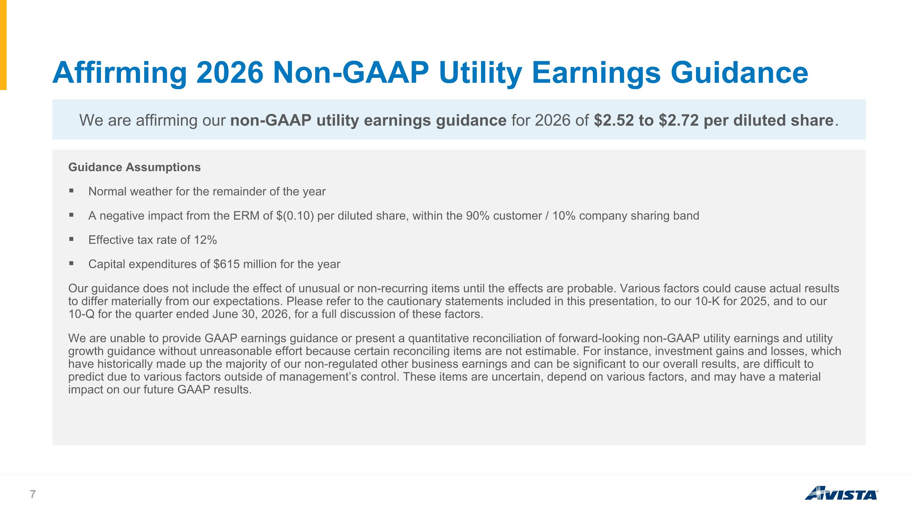
Affirming 2026 Non-GAAP Utility Earnings Guidance Guidance Assumptions Normal weather for the remainder of the year A negative impact from the ERM of $(0.10) per diluted share, within the 90% customer / 10% company sharing band Effective tax rate of 12% Capital expenditures of $615 million for the year Our guidance does not include the effect of unusual or non-recurring items until the effects are probable. Various factors could cause actual results to differ materially from our expectations. Please refer to the cautionary statements included in this presentation, to our 10-K for 2025, and to our 10-Q for the quarter ended June 30, 2026, for a full discussion of these factors. We are unable to provide GAAP earnings guidance or present a quantitative reconciliation of forward-looking non-GAAP utility earnings and utility growth guidance without unreasonable effort because certain reconciling items are not estimable. For instance, investment gains and losses, which have historically made up the majority of our non-regulated other business earnings and can be significant to our overall results, are difficult to predict due to various factors outside of management’s control. These items are uncertain, depend on various factors, and may have a material impact on our future GAAP results. We are affirming our non-GAAP utility earnings guidance for 2026 of $2.52 to $2.72 per diluted share.



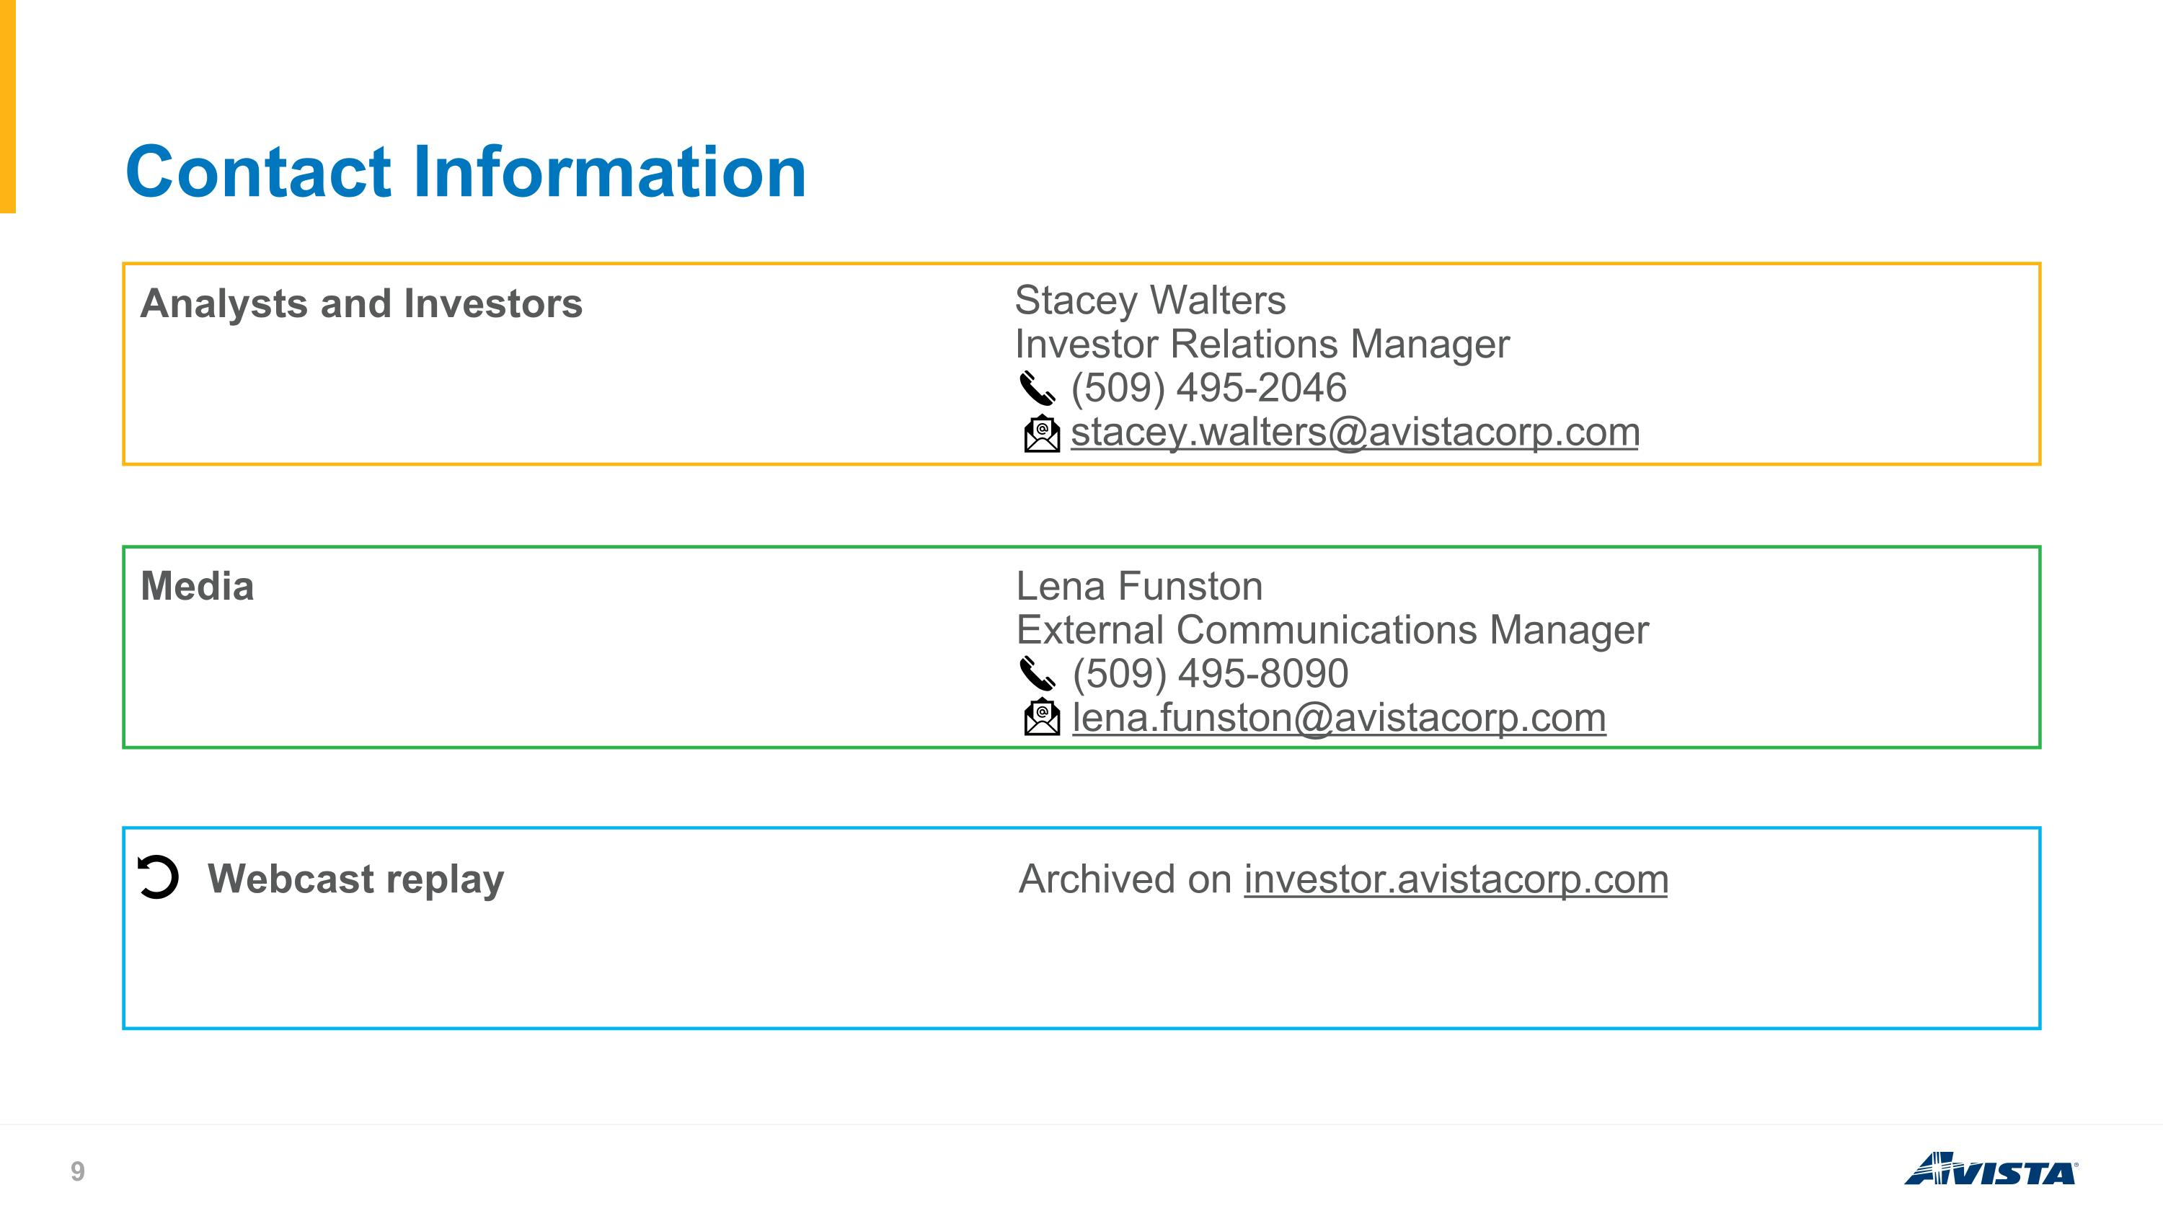
Contact Information Analysts and Investors Stacey Walters Investor Relations Manager (509) 495-2046 stacey.walters@avistacorp.com Media Lena Funston External Communications Manager (509) 495-8090 lena.funston@avistacorp.com Webcast replay Archived on investor.avistacorp.com

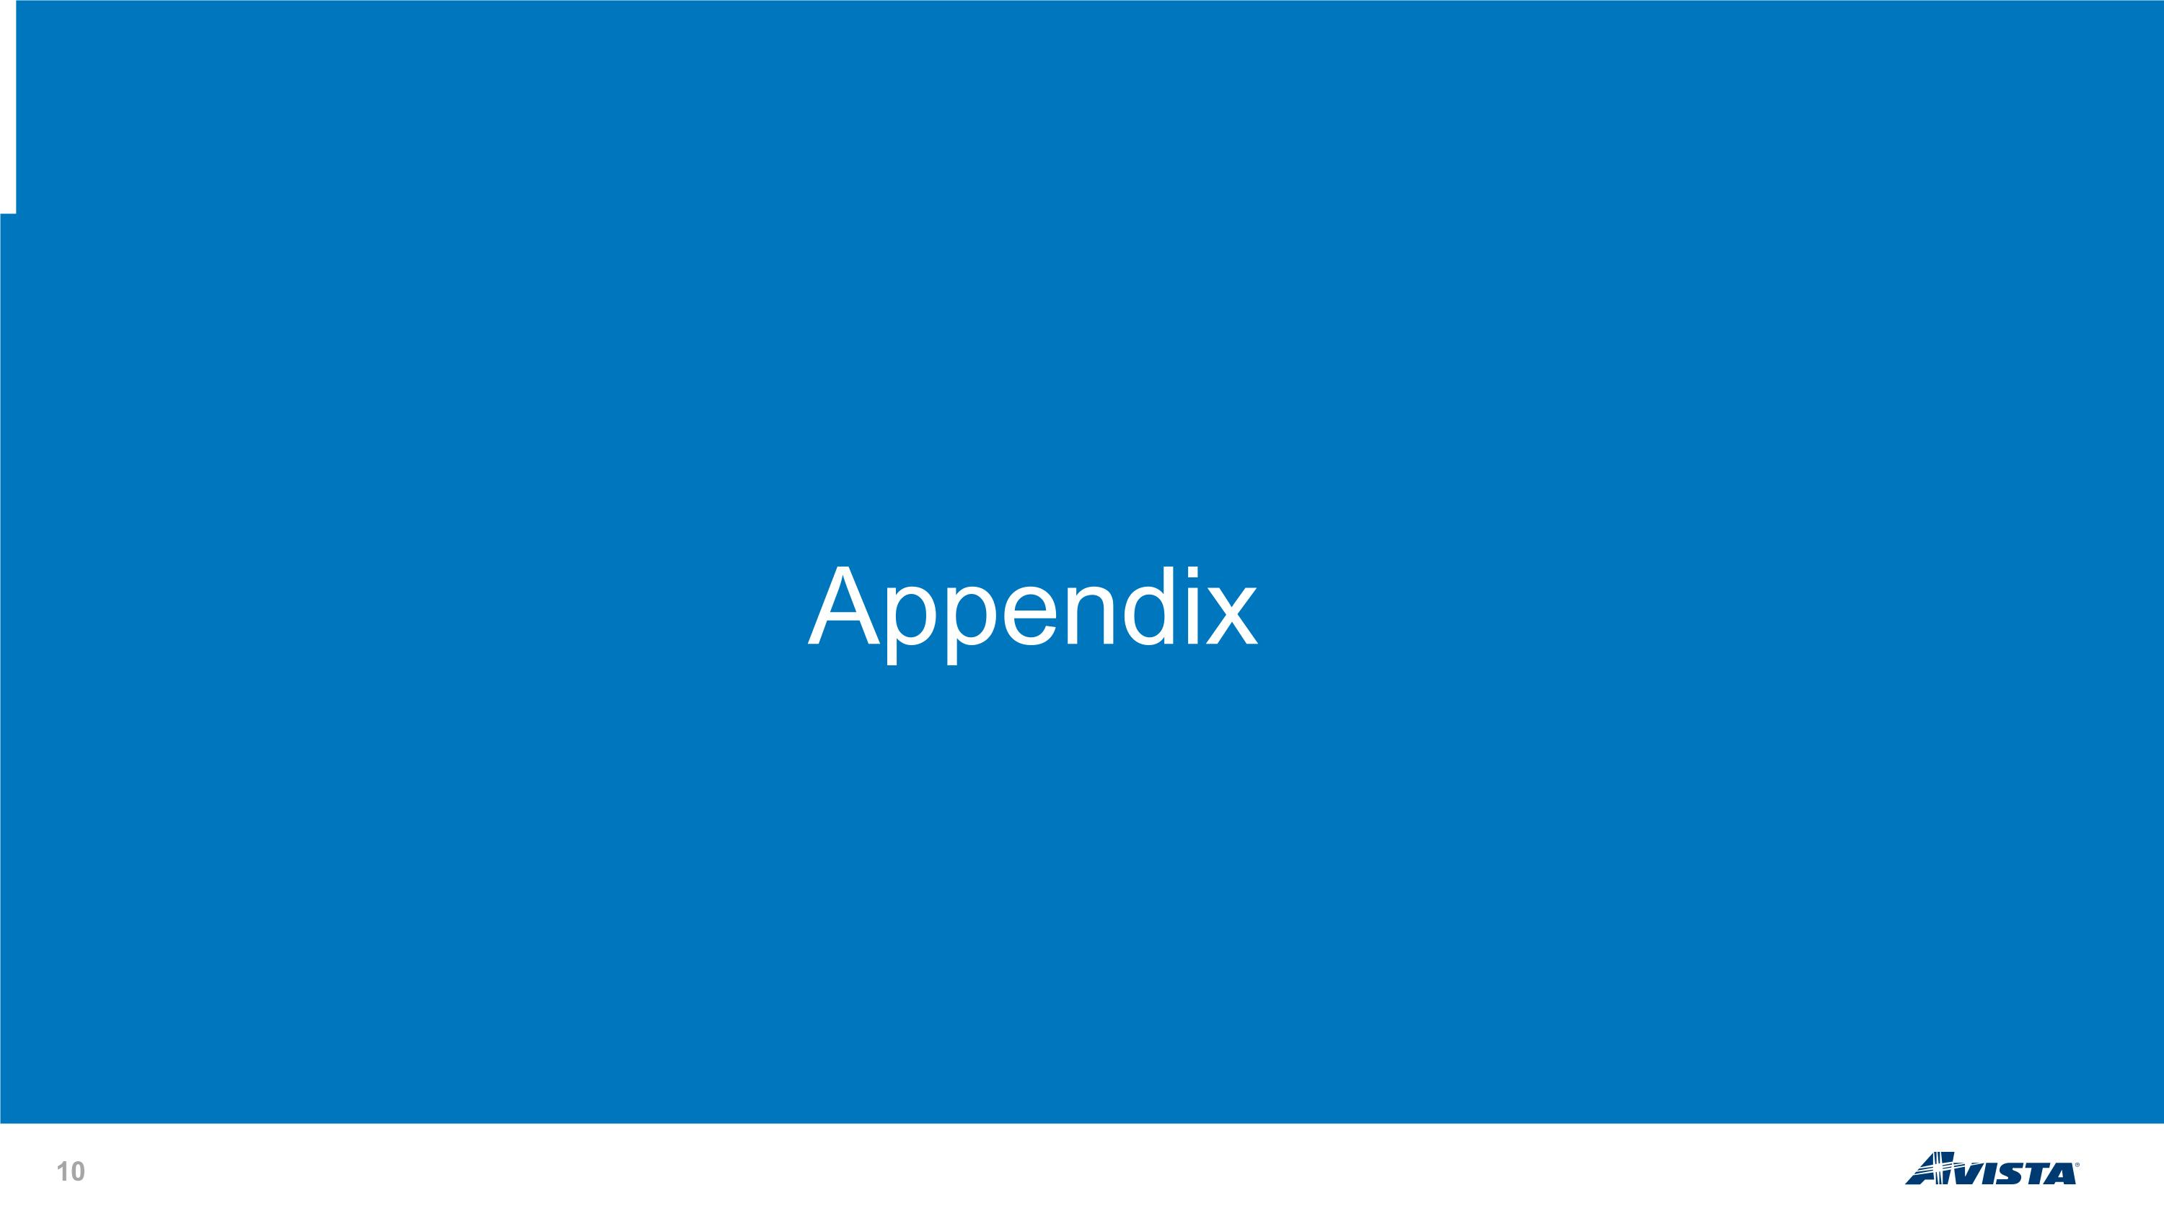
Appendix

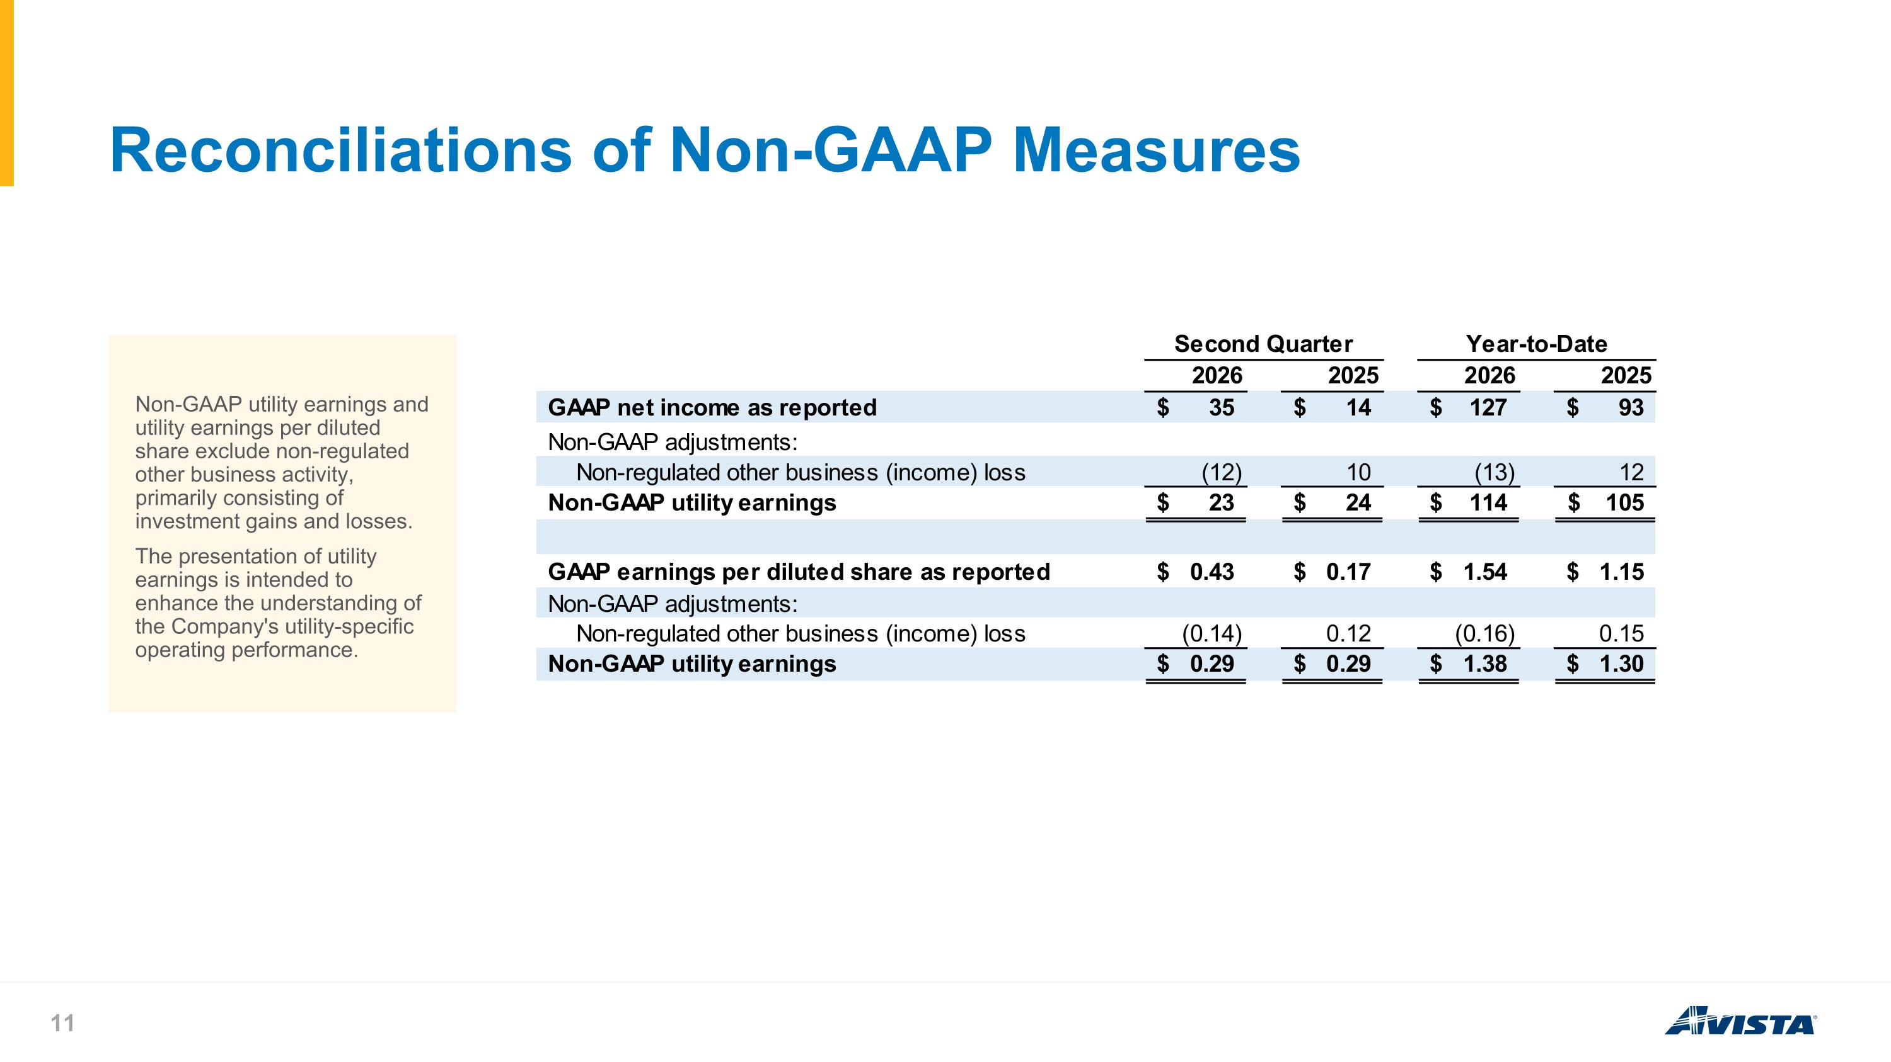
Reconciliations of Non-GAAP Measures Non-GAAP utility earnings and utility earnings per diluted share exclude non-regulated other business activity, primarily consisting of investment gains and losses. The presentation of utility earnings is intended to enhance the understanding of the Company's utility-specific operating performance.

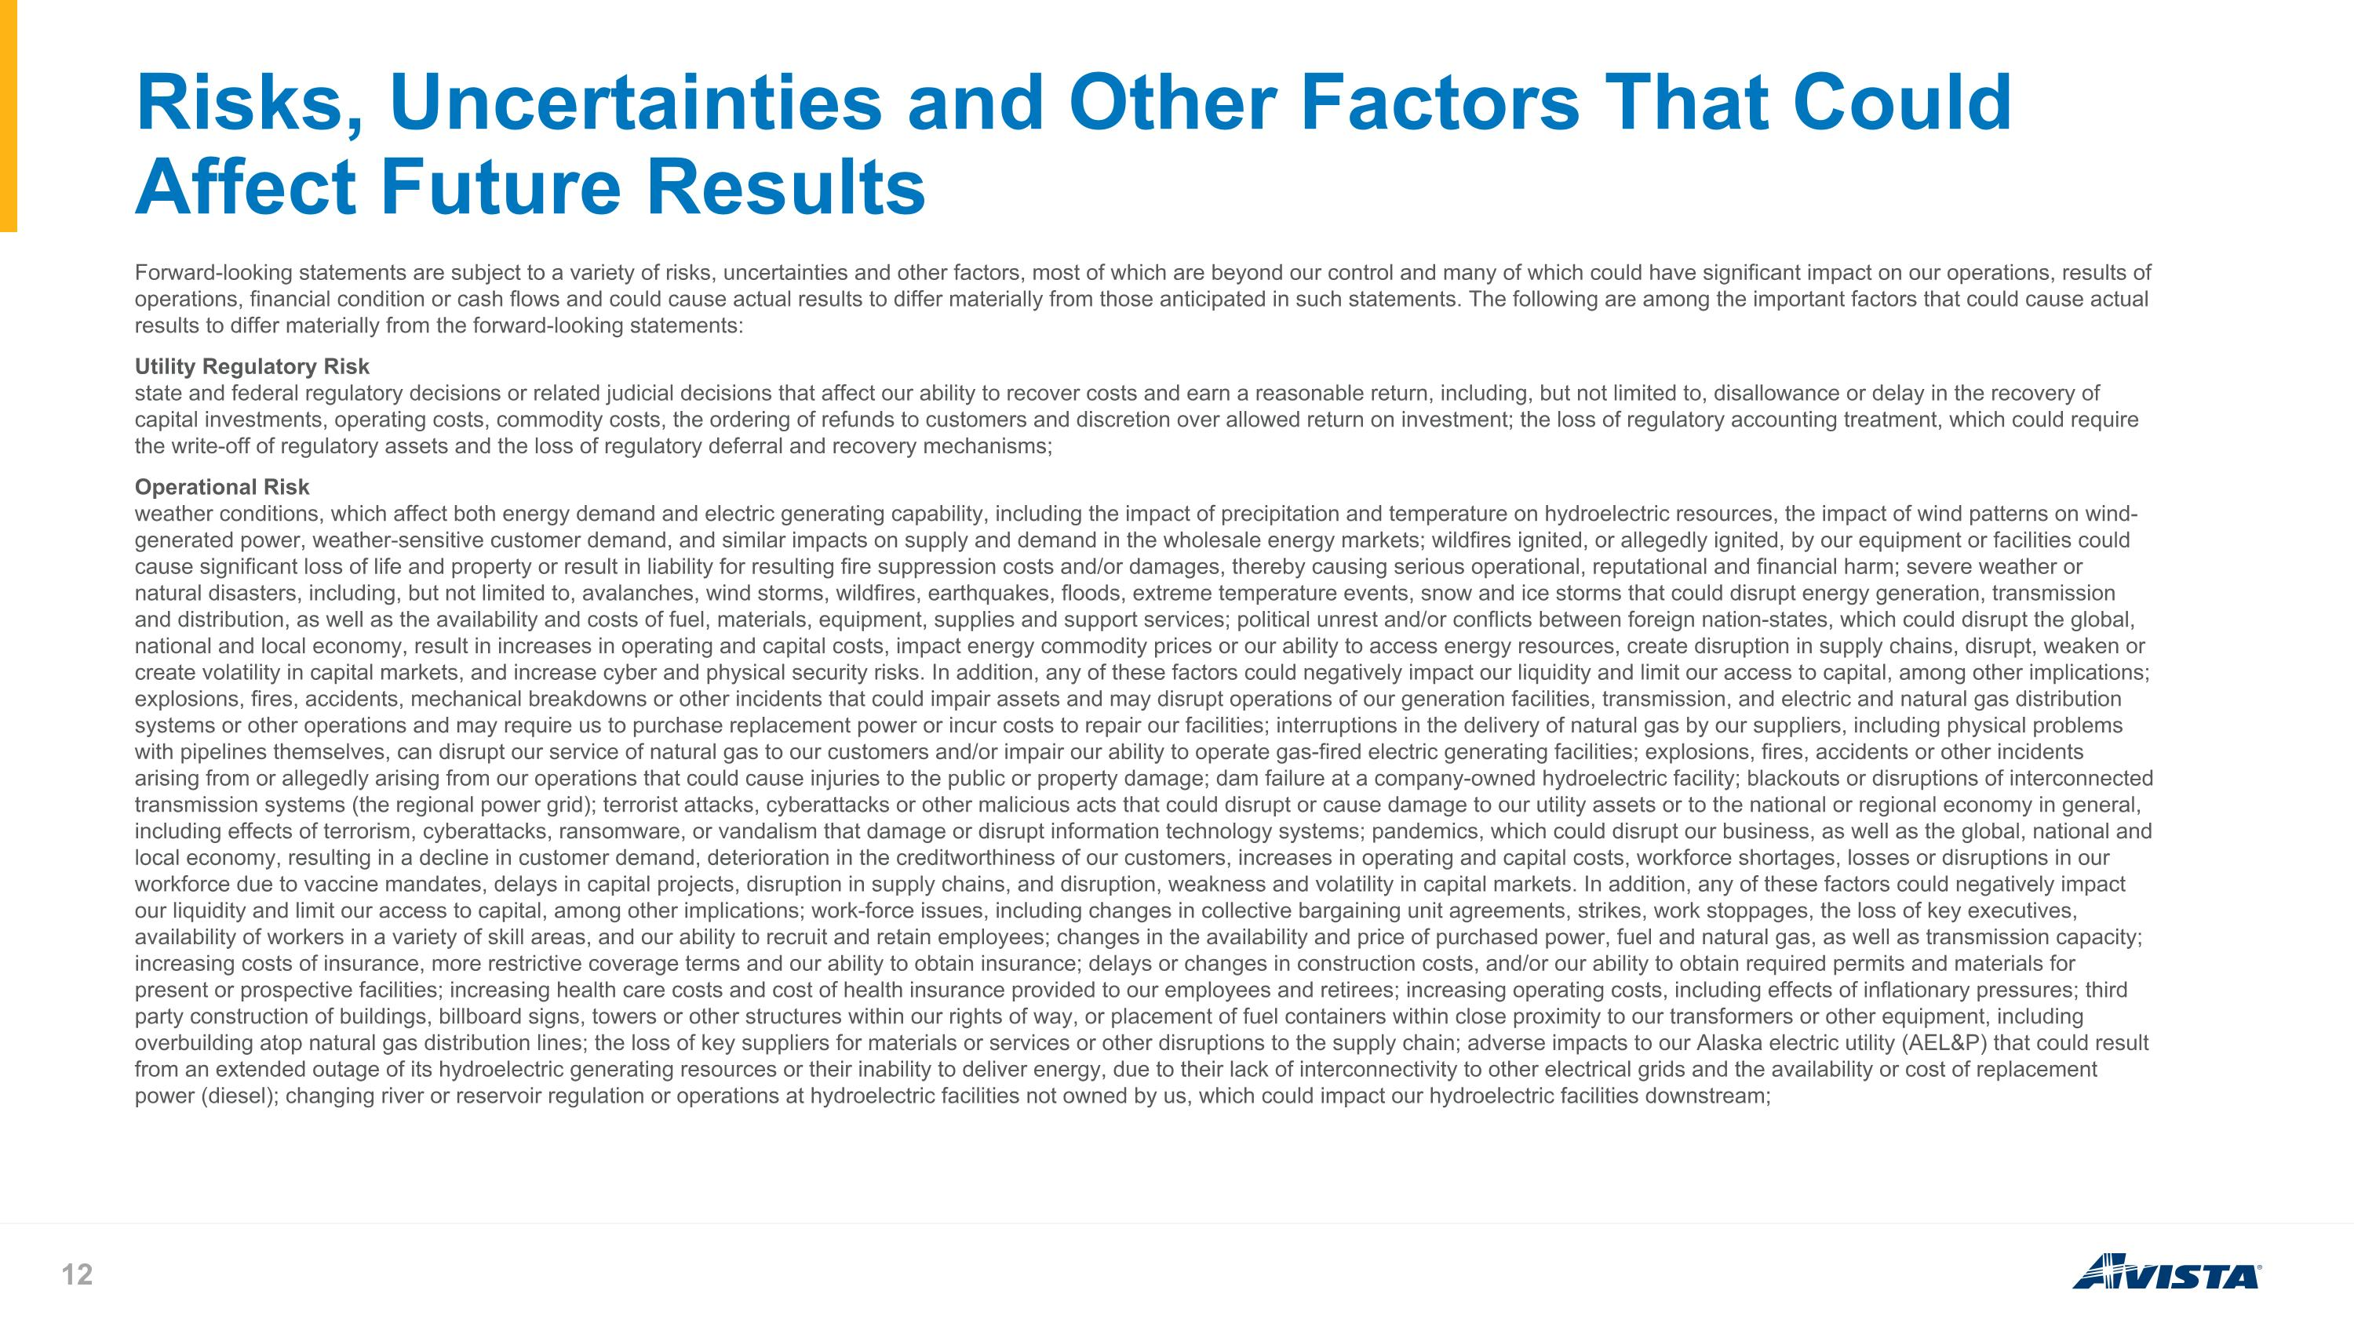
Risks, Uncertainties and Other Factors That Could Affect Future Results Forward-looking statements are subject to a variety of risks, uncertainties and other factors, most of which are beyond our control and many of which could have significant impact on our operations, results of operations, financial condition or cash flows and could cause actual results to differ materially from those anticipated in such statements. The following are among the important factors that could cause actual results to differ materially from the forward-looking statements: Utility Regulatory Risk state and federal regulatory decisions or related judicial decisions that affect our ability to recover costs and earn a reasonable return, including, but not limited to, disallowance or delay in the recovery of capital investments, operating costs, commodity costs, the ordering of refunds to customers and discretion over allowed return on investment; the loss of regulatory accounting treatment, which could require the write-off of regulatory assets and the loss of regulatory deferral and recovery mechanisms; Operational Risk weather conditions, which affect both energy demand and electric generating capability, including the impact of precipitation and temperature on hydroelectric resources, the impact of wind patterns on wind-generated power, weather-sensitive customer demand, and similar impacts on supply and demand in the wholesale energy markets; wildfires ignited, or allegedly ignited, by our equipment or facilities could cause significant loss of life and property or result in liability for resulting fire suppression costs and/or damages, thereby causing serious operational, reputational and financial harm; severe weather or natural disasters, including, but not limited to, avalanches, wind storms, wildfires, earthquakes, floods, extreme temperature events, snow and ice storms that could disrupt energy generation, transmission and distribution, as well as the availability and costs of fuel, materials, equipment, supplies and support services; political unrest and/or conflicts between foreign nation-states, which could disrupt the global, national and local economy, result in increases in operating and capital costs, impact energy commodity prices or our ability to access energy resources, create disruption in supply chains, disrupt, weaken or create volatility in capital markets, and increase cyber and physical security risks. In addition, any of these factors could negatively impact our liquidity and limit our access to capital, among other implications; explosions, fires, accidents, mechanical breakdowns or other incidents that could impair assets and may disrupt operations of our generation facilities, transmission, and electric and natural gas distribution systems or other operations and may require us to purchase replacement power or incur costs to repair our facilities; interruptions in the delivery of natural gas by our suppliers, including physical problems with pipelines themselves, can disrupt our service of natural gas to our customers and/or impair our ability to operate gas-fired electric generating facilities; explosions, fires, accidents or other incidents arising from or allegedly arising from our operations that could cause injuries to the public or property damage; dam failure at a company-owned hydroelectric facility; blackouts or disruptions of interconnected transmission systems (the regional power grid); terrorist attacks, cyberattacks or other malicious acts that could disrupt or cause damage to our utility assets or to the national or regional economy in general, including effects of terrorism, cyberattacks, ransomware, or vandalism that damage or disrupt information technology systems; pandemics, which could disrupt our business, as well as the global, national and local economy, resulting in a decline in customer demand, deterioration in the creditworthiness of our customers, increases in operating and capital costs, workforce shortages, losses or disruptions in our workforce due to vaccine mandates, delays in capital projects, disruption in supply chains, and disruption, weakness and volatility in capital markets. In addition, any of these factors could negatively impact our liquidity and limit our access to capital, among other implications; work-force issues, including changes in collective bargaining unit agreements, strikes, work stoppages, the loss of key executives, availability of workers in a variety of skill areas, and our ability to recruit and retain employees; changes in the availability and price of purchased power, fuel and natural gas, as well as transmission capacity; increasing costs of insurance, more restrictive coverage terms and our ability to obtain insurance; delays or changes in construction costs, and/or our ability to obtain required permits and materials for present or prospective facilities; increasing health care costs and cost of health insurance provided to our employees and retirees; increasing operating costs, including effects of inflationary pressures; third party construction of buildings, billboard signs, towers or other structures within our rights of way, or placement of fuel containers within close proximity to our transformers or other equipment, including overbuilding atop natural gas distribution lines; the loss of key suppliers for materials or services or other disruptions to the supply chain; adverse impacts to our Alaska electric utility (AEL&P) that could result from an extended outage of its hydroelectric generating resources or their inability to deliver energy, due to their lack of interconnectivity to other electrical grids and the availability or cost of replacement power (diesel); changing river or reservoir regulation or operations at hydroelectric facilities not owned by us, which could impact our hydroelectric facilities downstream;

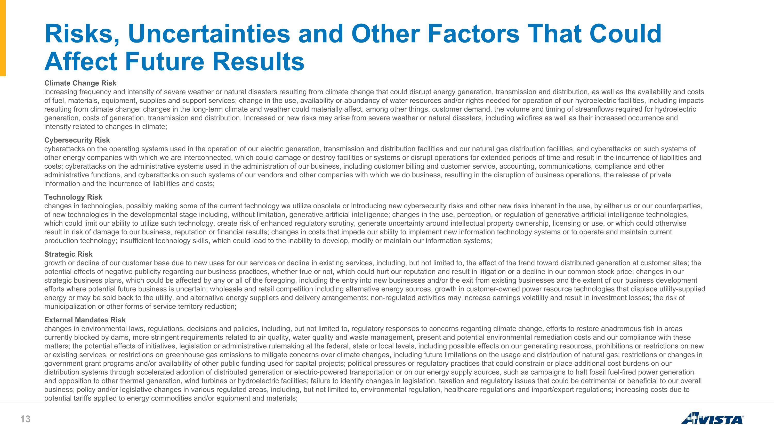
Risks, Uncertainties and Other Factors That Could Affect Future Results Climate Change Risk increasing frequency and intensity of severe weather or natural disasters resulting from climate change that could disrupt energy generation, transmission and distribution, as well as the availability and costs of fuel, materials, equipment, supplies and support services; change in the use, availability or abundancy of water resources and/or rights needed for operation of our hydroelectric facilities, including impacts resulting from climate change; changes in the long-term climate and weather could materially affect, among other things, customer demand, the volume and timing of streamflows required for hydroelectric generation, costs of generation, transmission and distribution. Increased or new risks may arise from severe weather or natural disasters, including wildfires as well as their increased occurrence and intensity related to changes in climate; Cybersecurity Risk cyberattacks on the operating systems used in the operation of our electric generation, transmission and distribution facilities and our natural gas distribution facilities, and cyberattacks on such systems of other energy companies with which we are interconnected, which could damage or destroy facilities or systems or disrupt operations for extended periods of time and result in the incurrence of liabilities and costs; cyberattacks on the administrative systems used in the administration of our business, including customer billing and customer service, accounting, communications, compliance and other administrative functions, and cyberattacks on such systems of our vendors and other companies with which we do business, resulting in the disruption of business operations, the release of private information and the incurrence of liabilities and costs; Technology Risk changes in technologies, possibly making some of the current technology we utilize obsolete or introducing new cybersecurity risks and other new risks inherent in the use, by either us or our counterparties, of new technologies in the developmental stage including, without limitation, generative artificial intelligence; changes in the use, perception, or regulation of generative artificial intelligence technologies, which could limit our ability to utilize such technology, create risk of enhanced regulatory scrutiny, generate uncertainty around intellectual property ownership, licensing or use, or which could otherwise result in risk of damage to our business, reputation or financial results; changes in costs that impede our ability to implement new information technology systems or to operate and maintain current production technology; insufficient technology skills, which could lead to the inability to develop, modify or maintain our information systems; Strategic Risk growth or decline of our customer base due to new uses for our services or decline in existing services, including, but not limited to, the effect of the trend toward distributed generation at customer sites; the potential effects of negative publicity regarding our business practices, whether true or not, which could hurt our reputation and result in litigation or a decline in our common stock price; changes in our strategic business plans, which could be affected by any or all of the foregoing, including the entry into new businesses and/or the exit from existing businesses and the extent of our business development efforts where potential future business is uncertain; wholesale and retail competition including alternative energy sources, growth in customer-owned power resource technologies that displace utility-supplied energy or may be sold back to the utility, and alternative energy suppliers and delivery arrangements; non-regulated activities may increase earnings volatility and result in investment losses; the risk of municipalization or other forms of service territory reduction; External Mandates Risk changes in environmental laws, regulations, decisions and policies, including, but not limited to, regulatory responses to concerns regarding climate change, efforts to restore anadromous fish in areas currently blocked by dams, more stringent requirements related to air quality, water quality and waste management, present and potential environmental remediation costs and our compliance with these matters; the potential effects of initiatives, legislation or administrative rulemaking at the federal, state or local levels, including possible effects on our generating resources, prohibitions or restrictions on new or existing services, or restrictions on greenhouse gas emissions to mitigate concerns over climate changes, including future limitations on the usage and distribution of natural gas; restrictions or changes in government grant programs and/or availability of other public funding used for capital projects; political pressures or regulatory practices that could constrain or place additional cost burdens on our distribution systems through accelerated adoption of distributed generation or electric-powered transportation or on our energy supply sources, such as campaigns to halt fossil fuel-fired power generation and opposition to other thermal generation, wind turbines or hydroelectric facilities; failure to identify changes in legislation, taxation and regulatory issues that could be detrimental or beneficial to our overall business; policy and/or legislative changes in various regulated areas, including, but not limited to, environmental regulation, healthcare regulations and import/export regulations; increasing costs due to potential tariffs applied to energy commodities and/or equipment and materials;

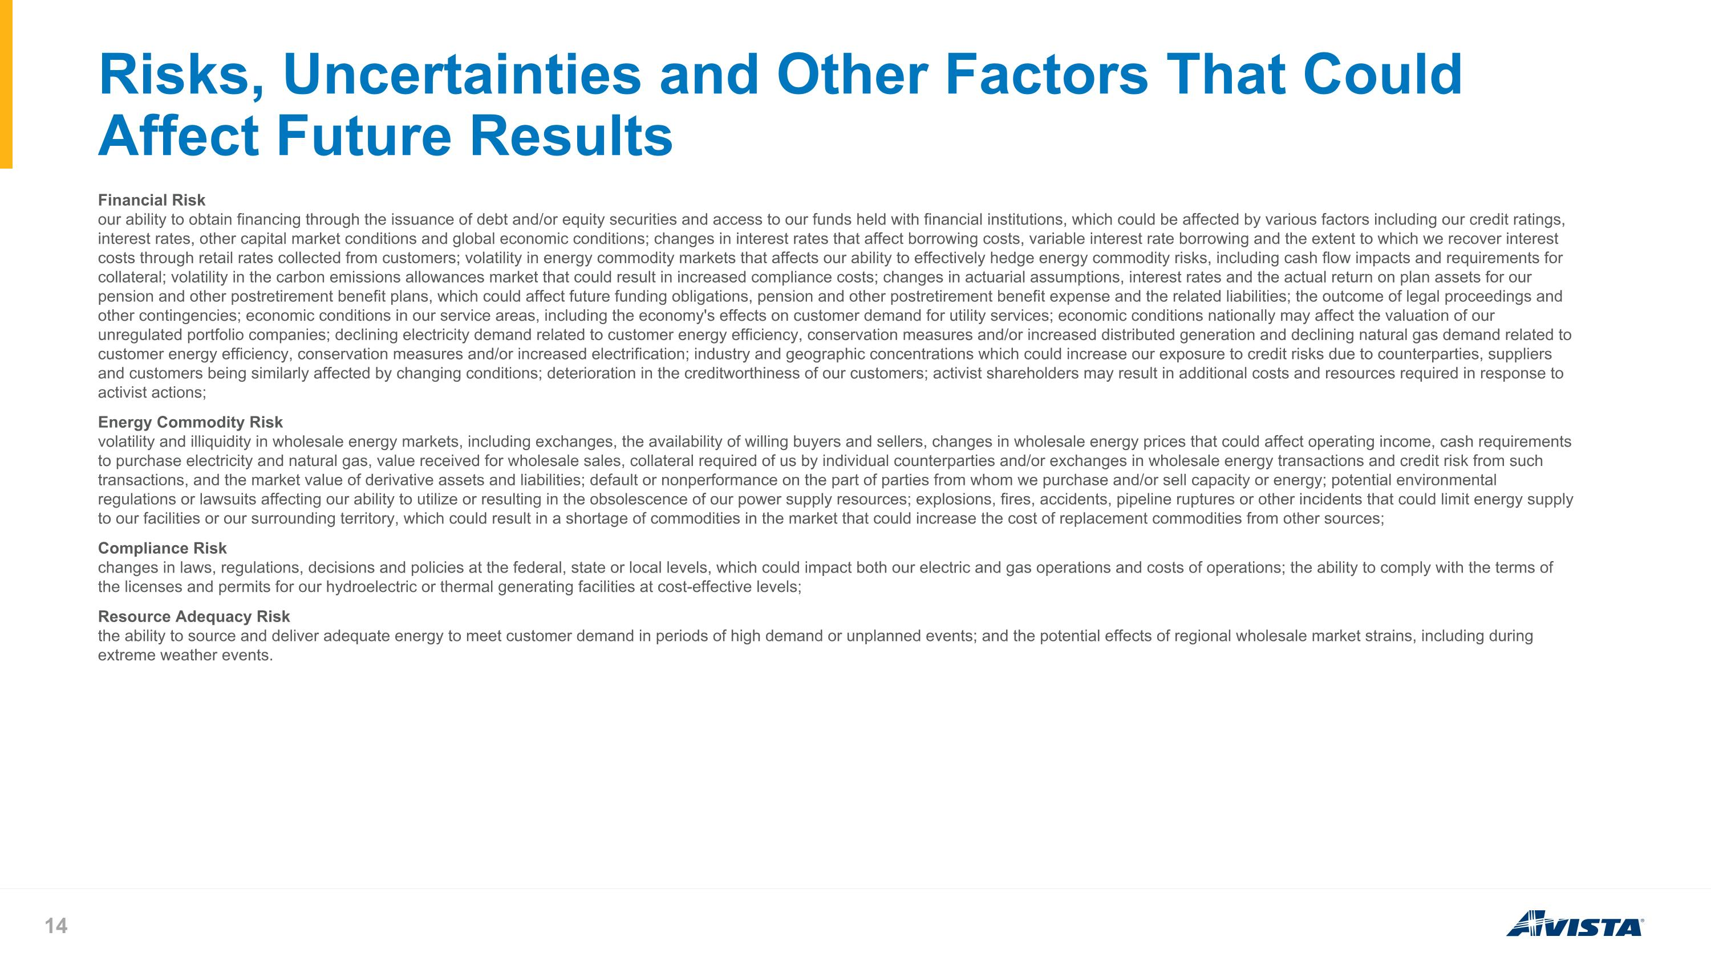
Risks, Uncertainties and Other Factors That Could Affect Future Results Financial Risk our ability to obtain financing through the issuance of debt and/or equity securities and access to our funds held with financial institutions, which could be affected by various factors including our credit ratings, interest rates, other capital market conditions and global economic conditions; changes in interest rates that affect borrowing costs, variable interest rate borrowing and the extent to which we recover interest costs through retail rates collected from customers; volatility in energy commodity markets that affects our ability to effectively hedge energy commodity risks, including cash flow impacts and requirements for collateral; volatility in the carbon emissions allowances market that could result in increased compliance costs; changes in actuarial assumptions, interest rates and the actual return on plan assets for our pension and other postretirement benefit plans, which could affect future funding obligations, pension and other postretirement benefit expense and the related liabilities; the outcome of legal proceedings and other contingencies; economic conditions in our service areas, including the economy's effects on customer demand for utility services; economic conditions nationally may affect the valuation of our unregulated portfolio companies; declining electricity demand related to customer energy efficiency, conservation measures and/or increased distributed generation and declining natural gas demand related to customer energy efficiency, conservation measures and/or increased electrification; industry and geographic concentrations which could increase our exposure to credit risks due to counterparties, suppliers and customers being similarly affected by changing conditions; deterioration in the creditworthiness of our customers; activist shareholders may result in additional costs and resources required in response to activist actions; Energy Commodity Risk volatility and illiquidity in wholesale energy markets, including exchanges, the availability of willing buyers and sellers, changes in wholesale energy prices that could affect operating income, cash requirements to purchase electricity and natural gas, value received for wholesale sales, collateral required of us by individual counterparties and/or exchanges in wholesale energy transactions and credit risk from such transactions, and the market value of derivative assets and liabilities; default or nonperformance on the part of parties from whom we purchase and/or sell capacity or energy; potential environmental regulations or lawsuits affecting our ability to utilize or resulting in the obsolescence of our power supply resources; explosions, fires, accidents, pipeline ruptures or other incidents that could limit energy supply to our facilities or our surrounding territory, which could result in a shortage of commodities in the market that could increase the cost of replacement commodities from other sources; Compliance Risk changes in laws, regulations, decisions and policies at the federal, state or local levels, which could impact both our electric and gas operations and costs of operations; the ability to comply with the terms of the licenses and permits for our hydroelectric or thermal generating facilities at cost-effective levels; Resource Adequacy Risk the ability to source and deliver adequate energy to meet customer demand in periods of high demand or unplanned events; and the potential effects of regional wholesale market strains, including during extreme weather events.

